**Angular - 2014**

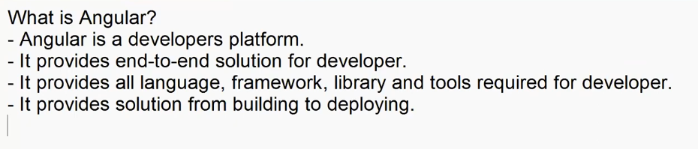

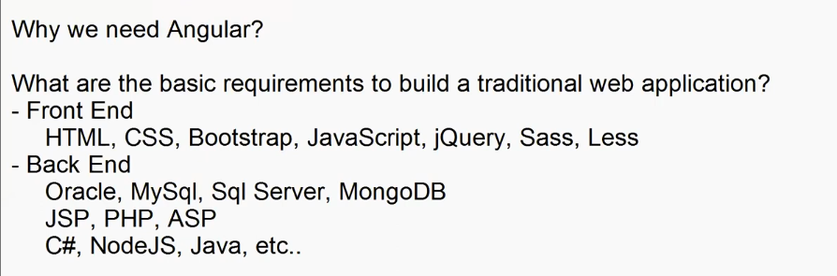

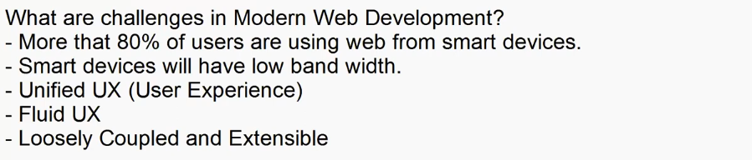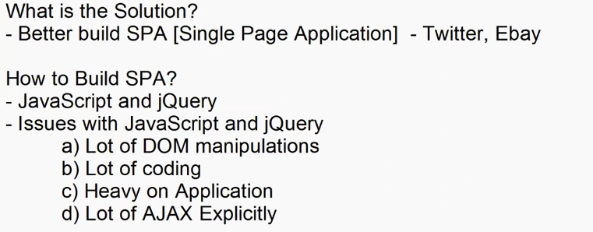

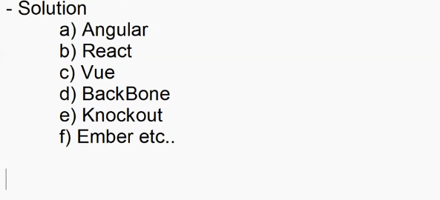

+

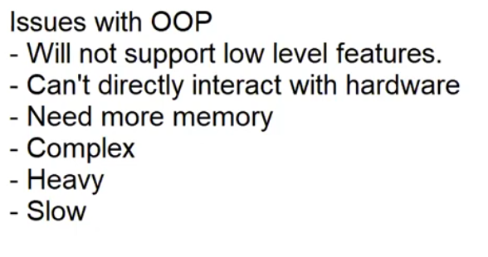

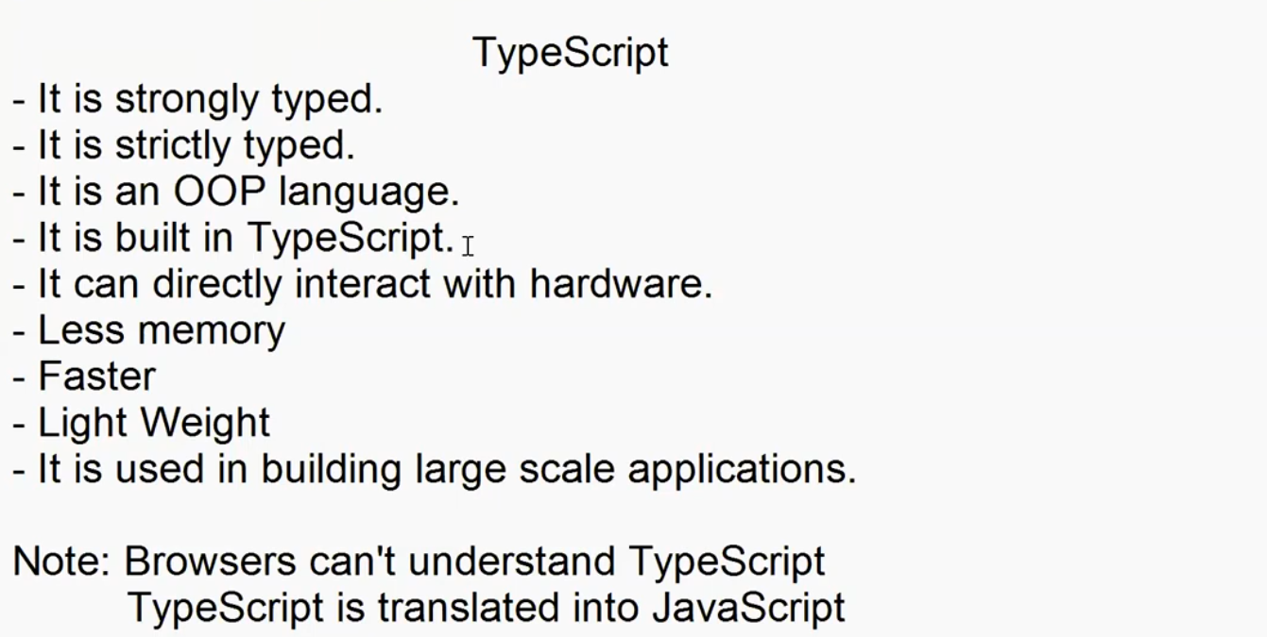

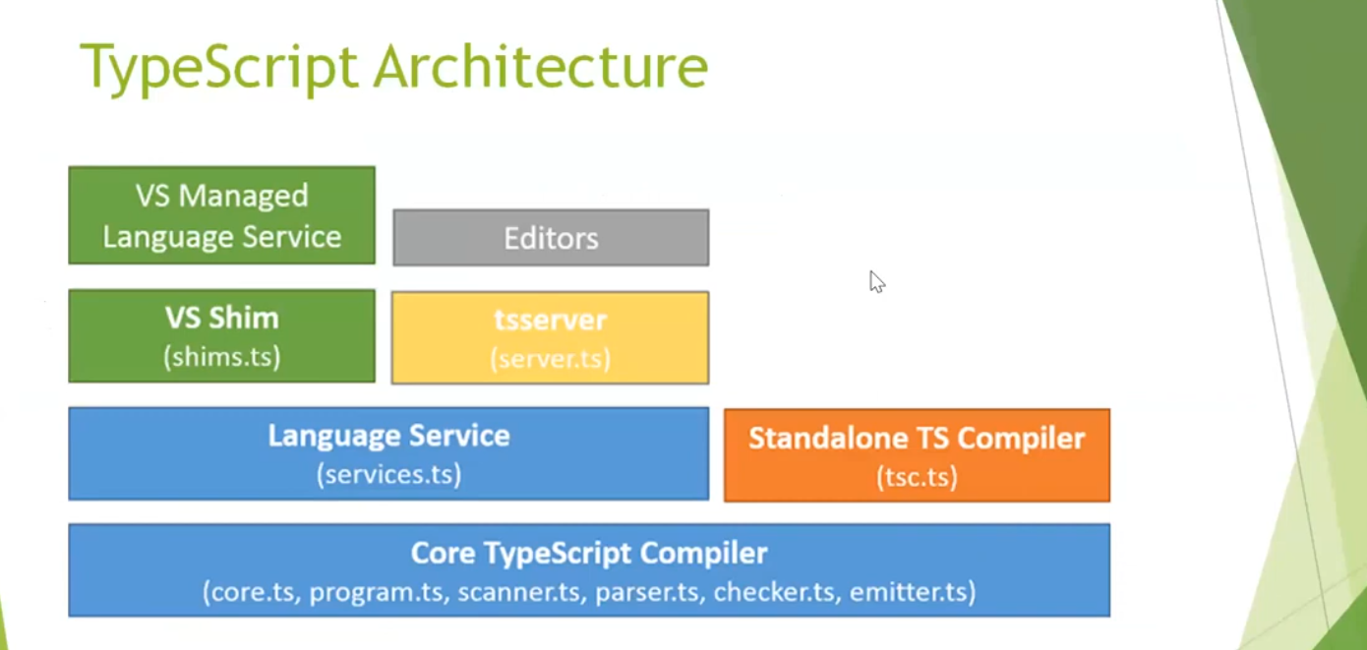

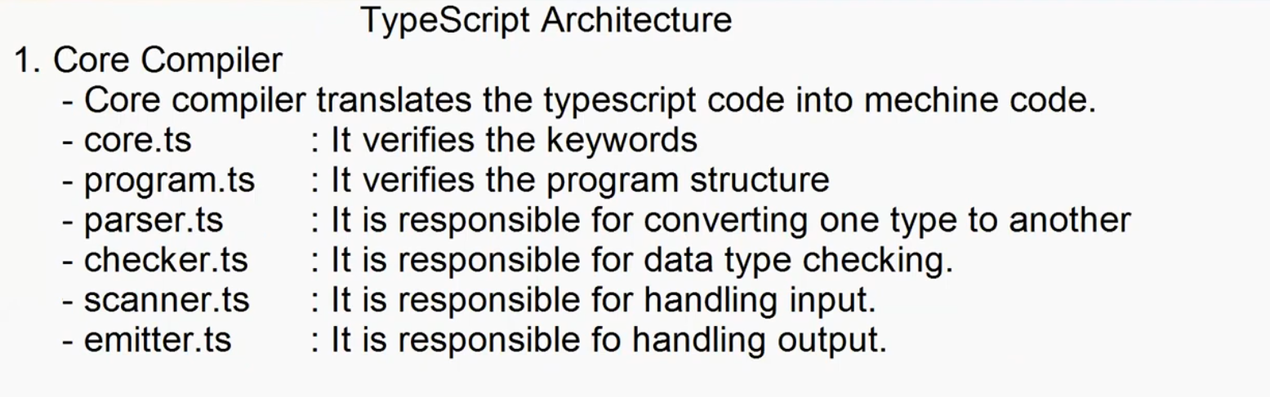

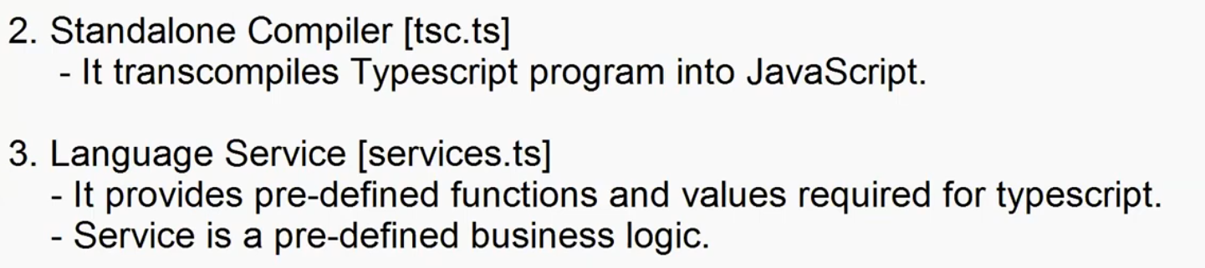

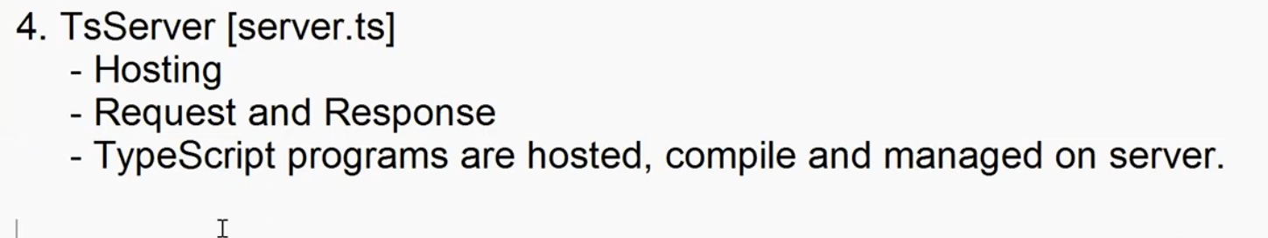

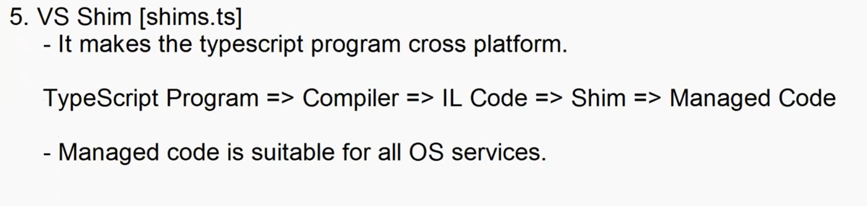

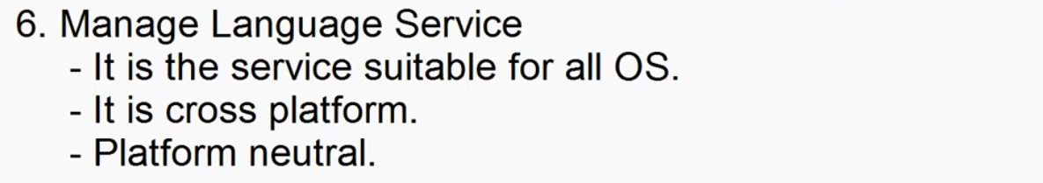

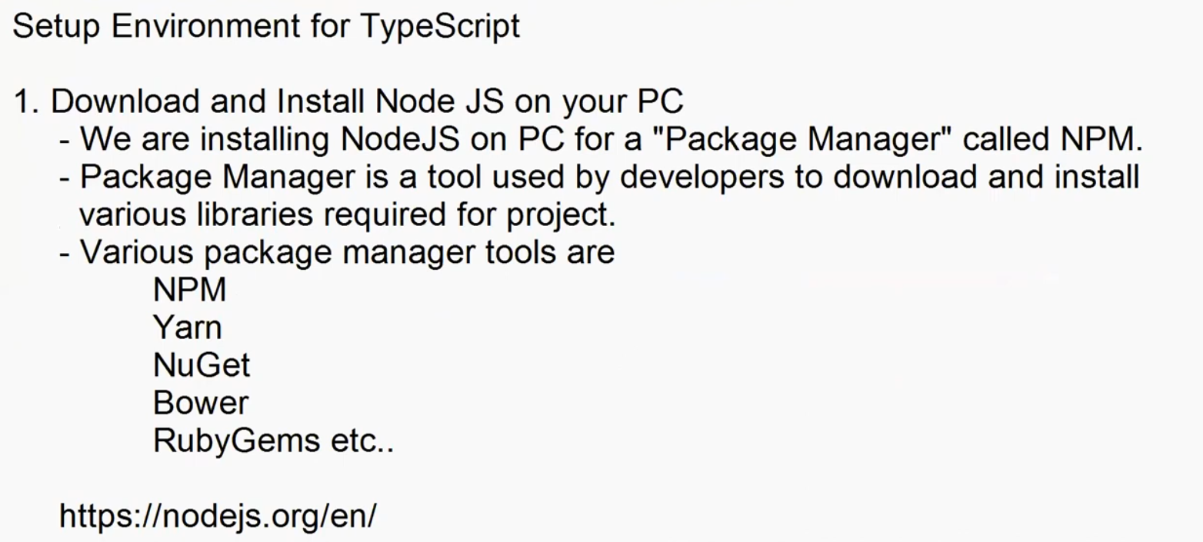

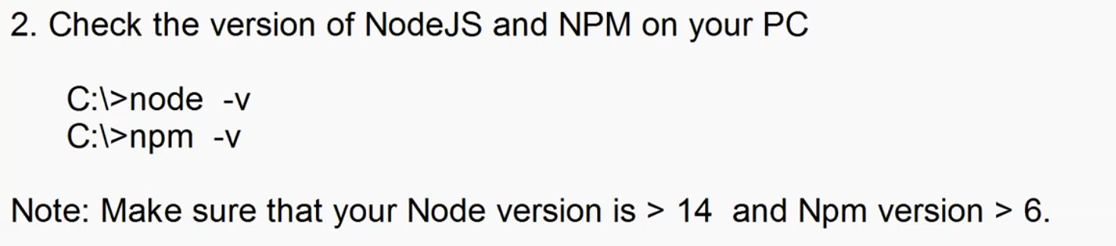

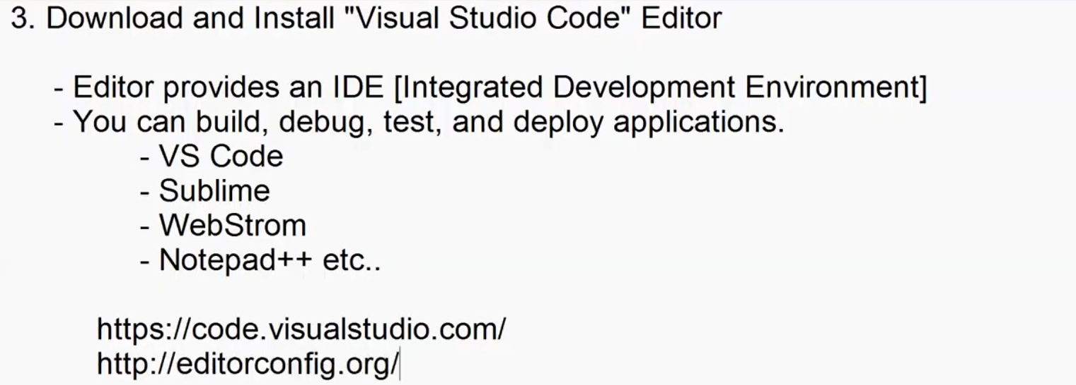

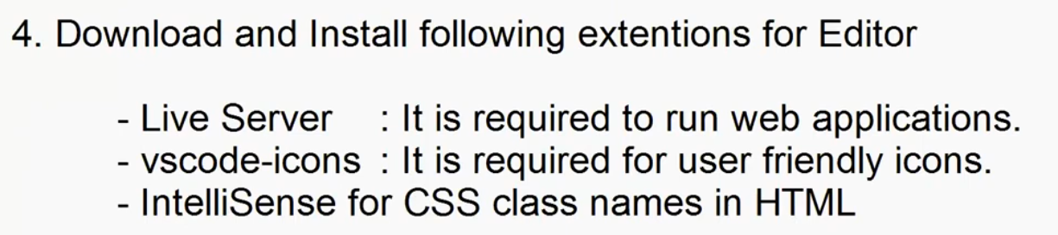

-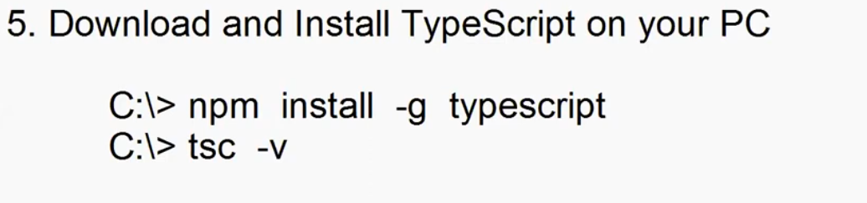

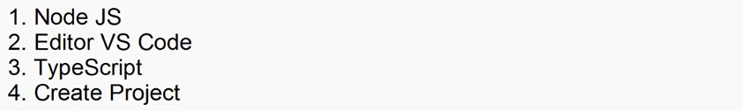

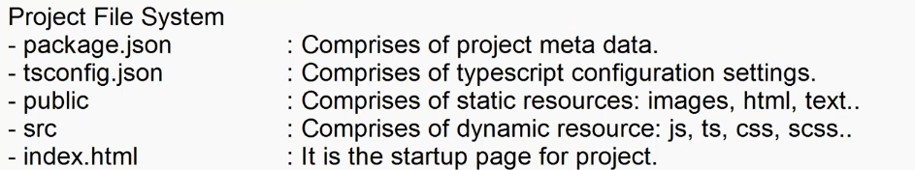

TypeScrips Language Basics

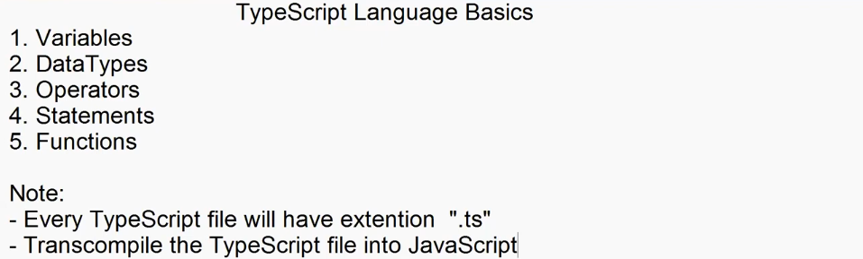

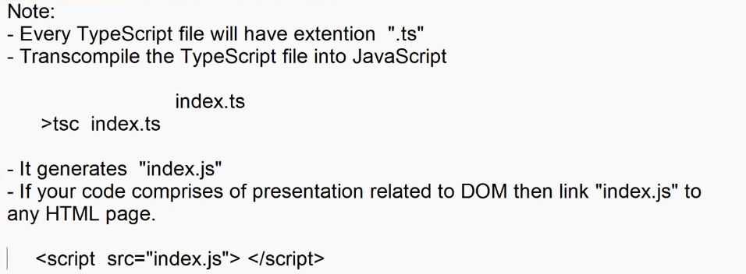

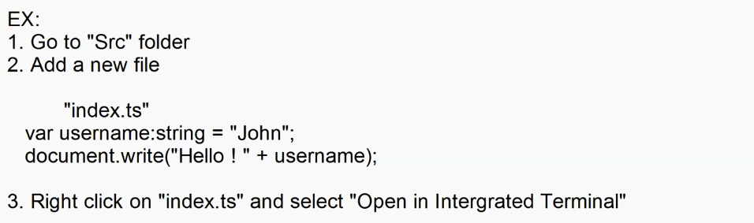

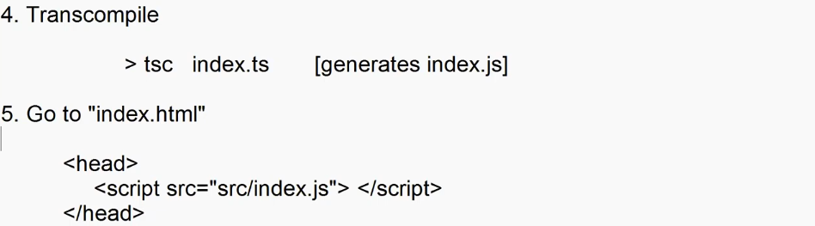

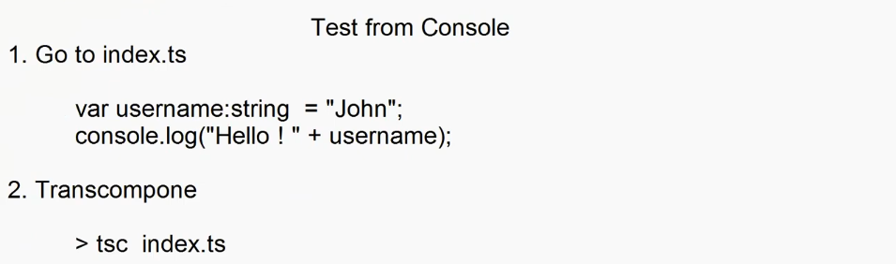

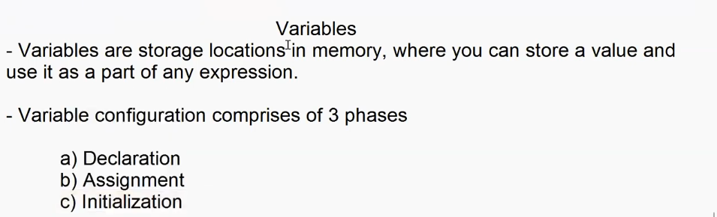

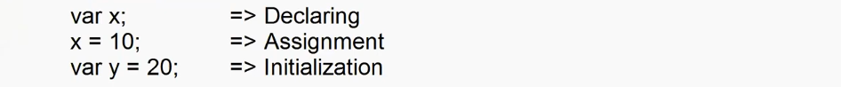

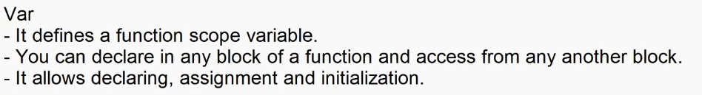

function Demo()

{

    var x;

    x=10;

    if(x==10)

    {

        var y = 20;

var y = 30;//shadowing

    }

    console.log("x = "+x +"\ny= "+y);//can access var outide the function

}

Demo();

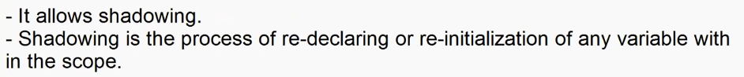

function Demo(){

    x=10;

    console.log("x= "+ x);

    var x; // hoisting

}

Demo();



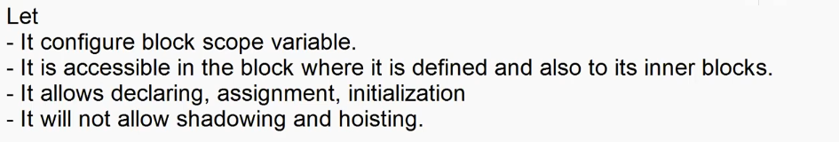

function Demo()

{

    let x;

    x=10;

    if(x==10)

    {

        let y = 20;

        console.log("x = "+x +"\n y= "+y);//can access let inside the function/block

    }

    console.log("x = "+x +"\n y= "+y);//cannot access let outside the function/block

}

Demo();

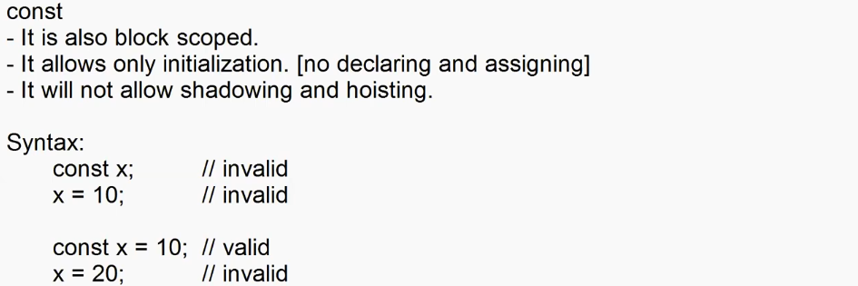

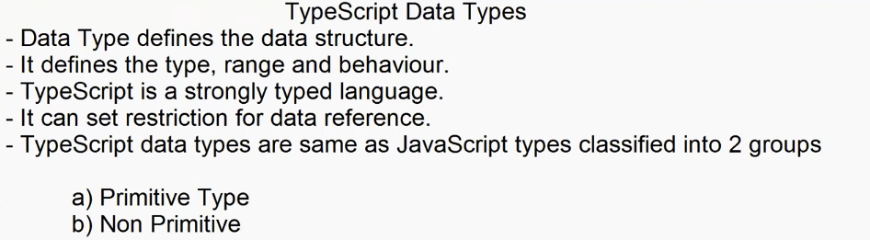

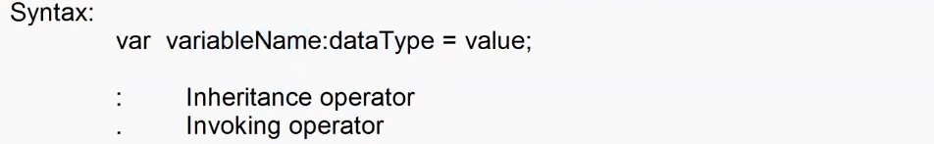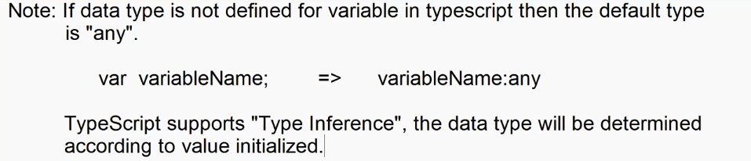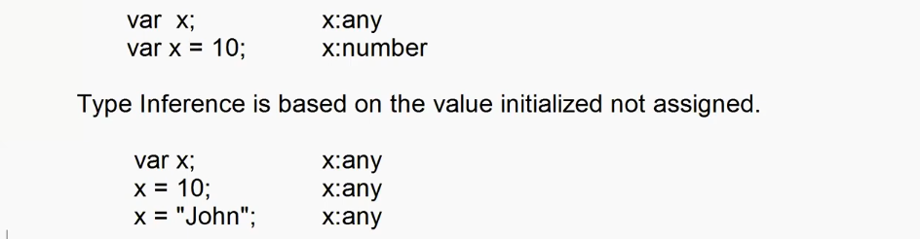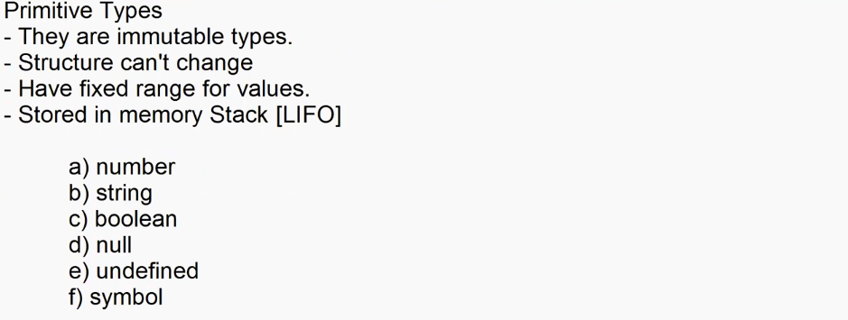

**Number**

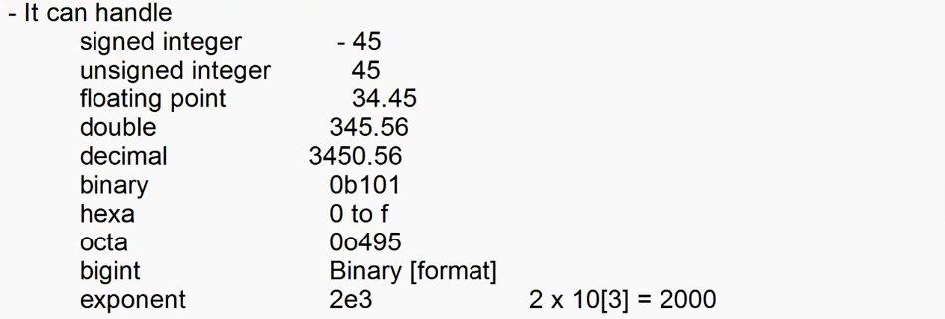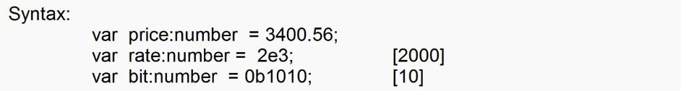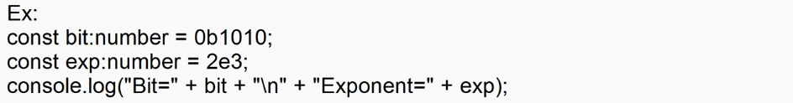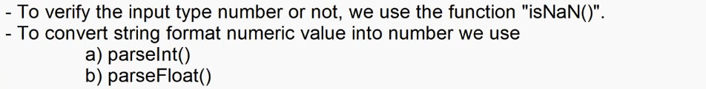

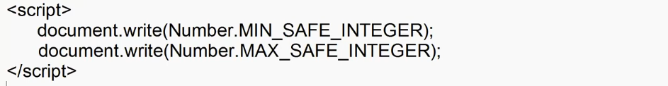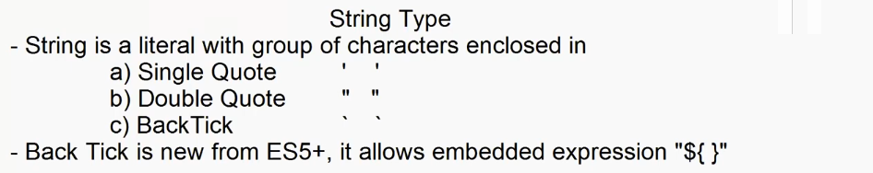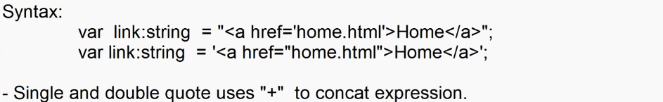

var username:String = "Adesh";

var age:number = 23;

var msg1 = "Hello ! "+ username + " you will be "+age+" next year.";

var msg2 = `Hello ! ${username} you will be ${age} next year.`;

console.log(msg1);

console.log(msg2);

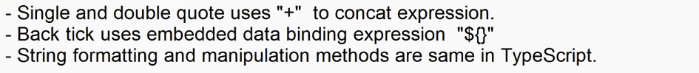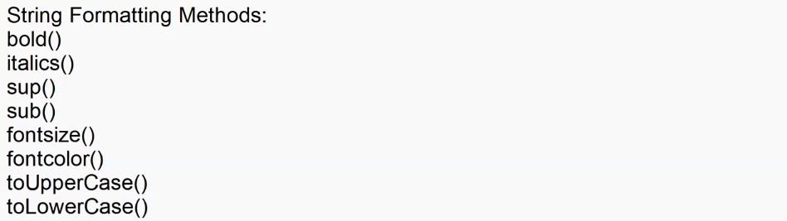

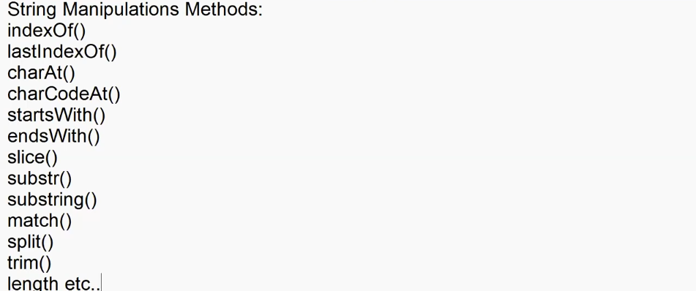

var mobile:string = "+919876543210";

if(mobile.match(/\+91\d{10}/)){

    console.log("Otp send");

}

else{

    console.log("Invalid Mobile");

}

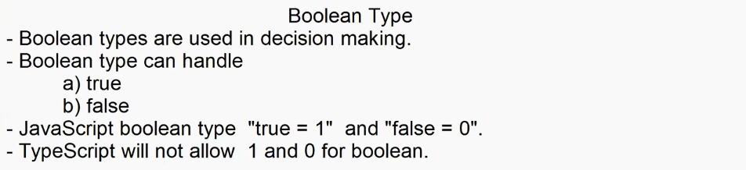

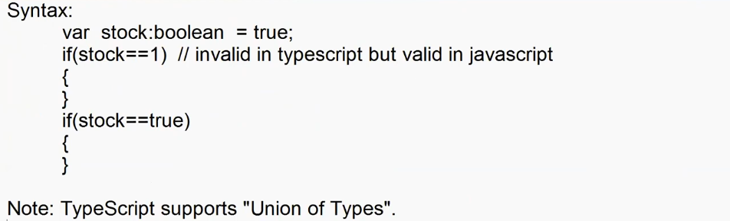

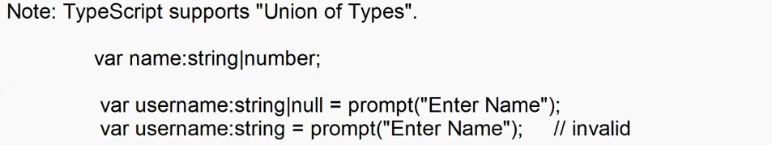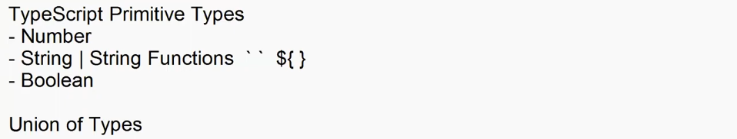

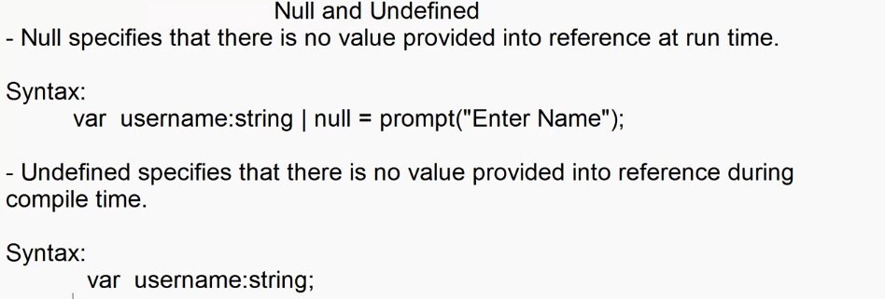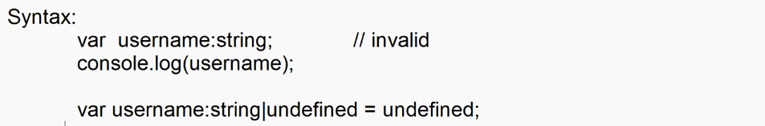

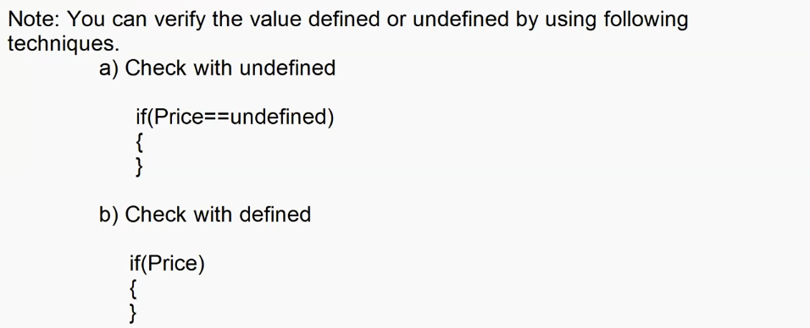

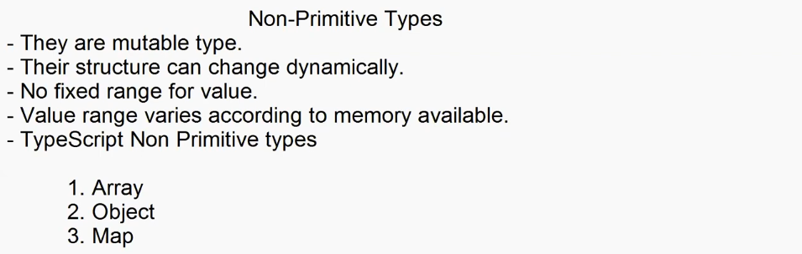

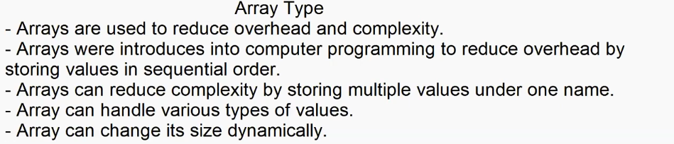

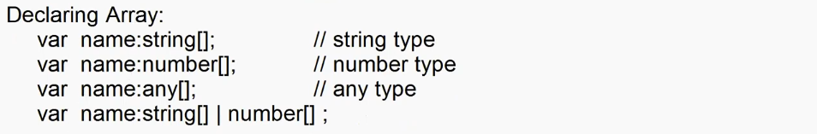

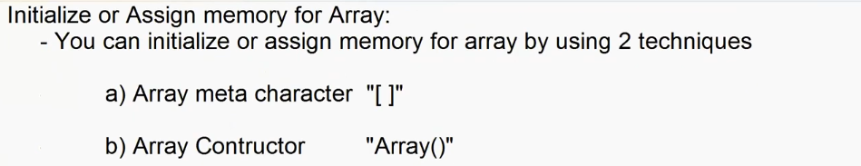

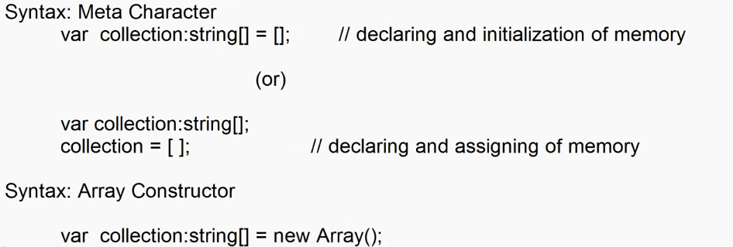

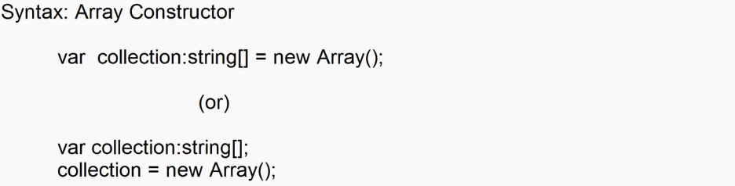

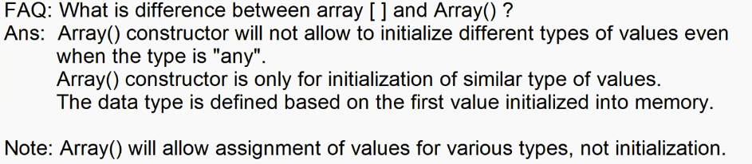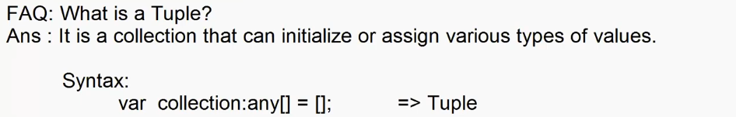

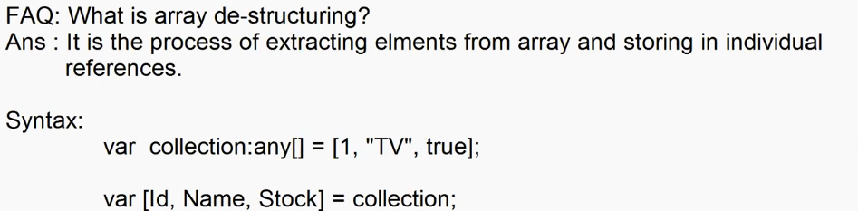

**Old**

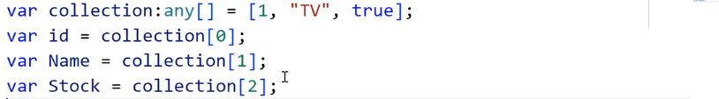

**New**

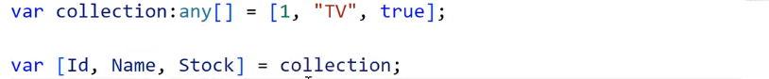

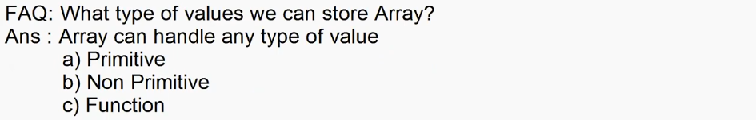

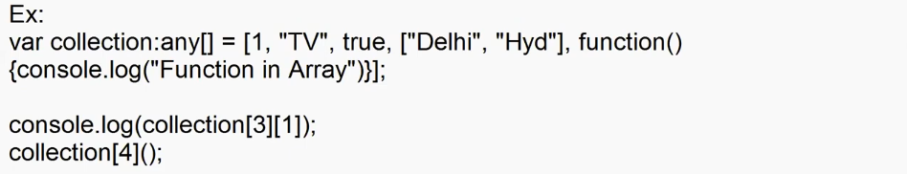

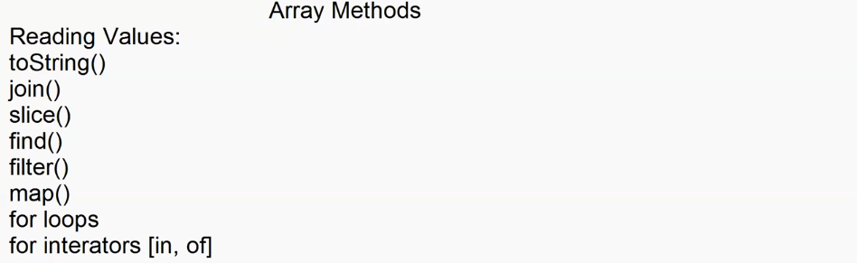

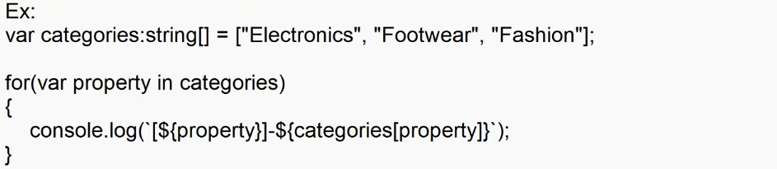

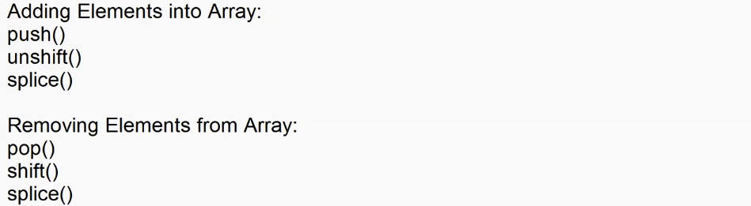



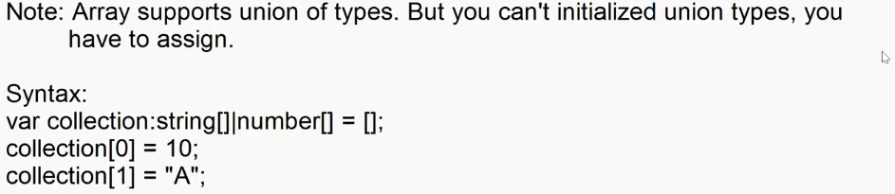

**Object**

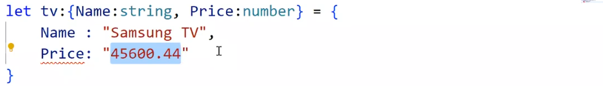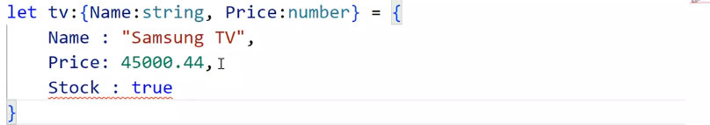

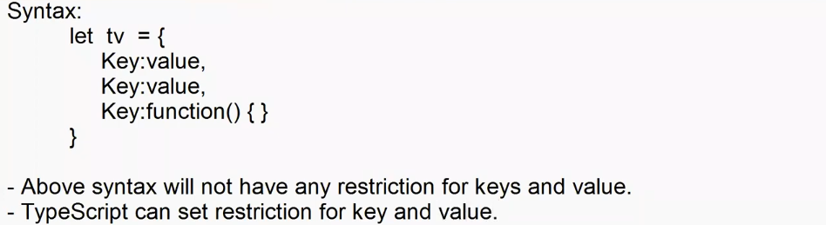

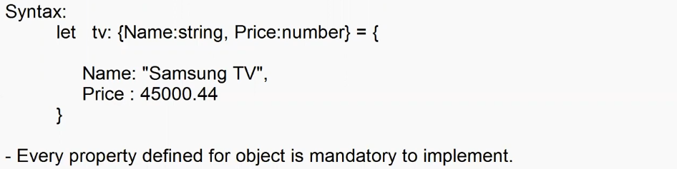

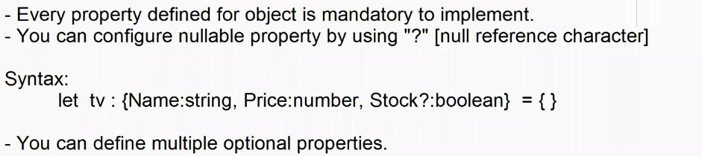

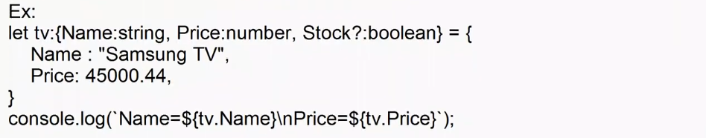

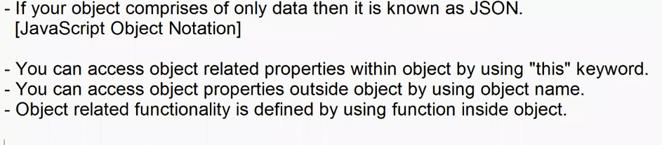

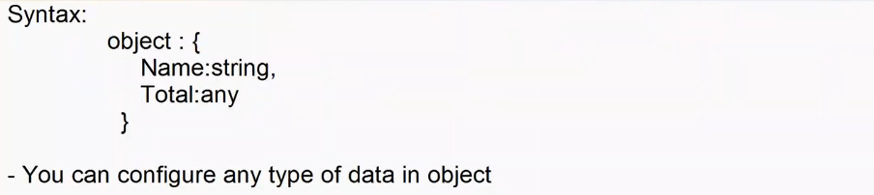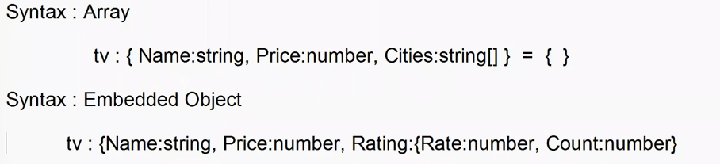

Ex:

let tv:{Name:String, Price:number, Qty:number, Cities:string[], Rating:any, Total:any, Print?:any } = {

    Name : "Samsung TV",

    Price:45000.44,

    Qty: 2,

    Total: function(){

        return this.Price*this.Qty;

    },

    Cities:["Pune","Hyd"],

    Rating: {Rate:4.3,Count:600},

    Print: function(){

        console.log(`

            Name=${this.Name}\n

            Price=${this.Price}\n

            Qty=${this.Qty}\n

            Rating=${this.Rating.t}\n

            Cities=${this.Cities.toString()}\n

            Rating=${this.Rating.Rate} [${this.Rating.Count}]\n

            Total=${this.Total()}\n`

        );

    }

}

tv.Print();



**\*\*\***

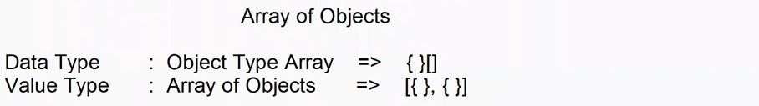**Wrong**

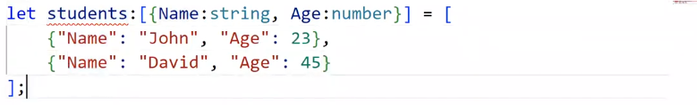

**Right**

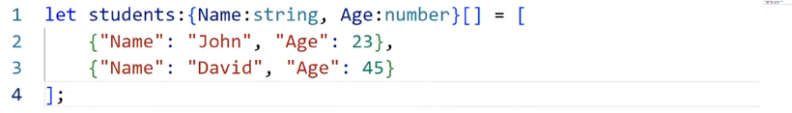

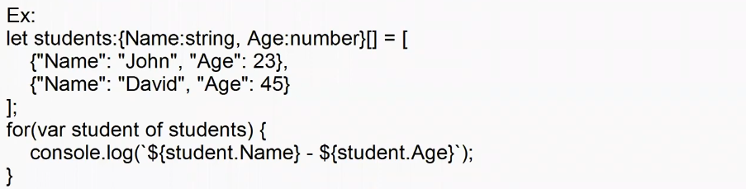

**Map Type**

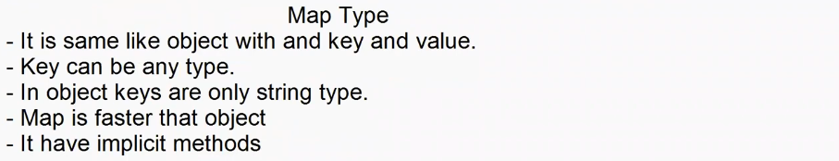

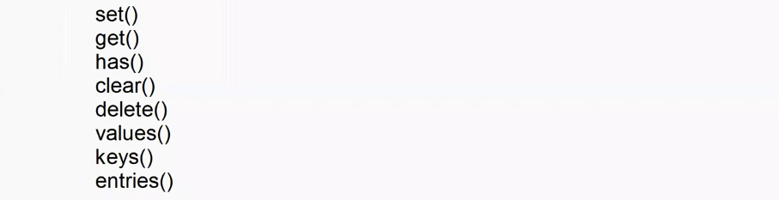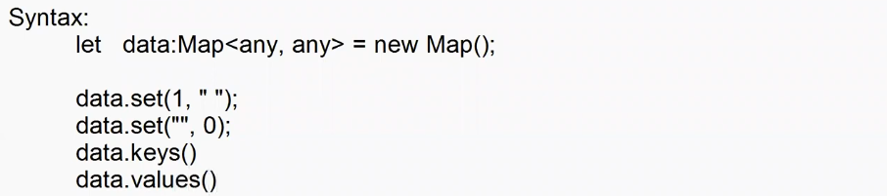

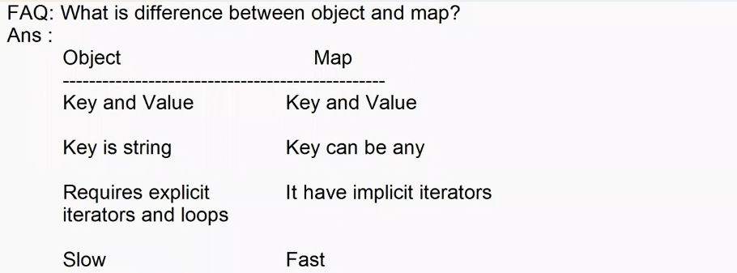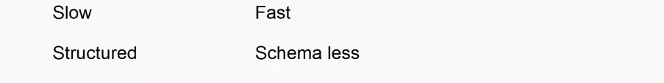

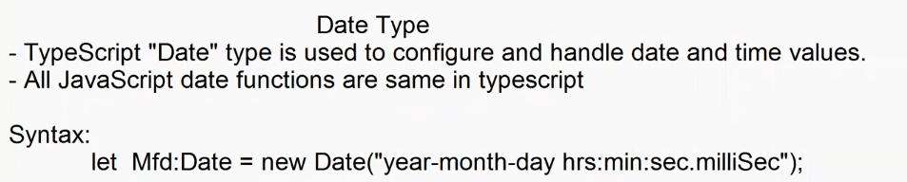

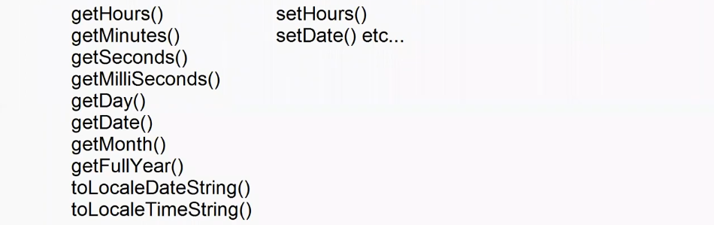 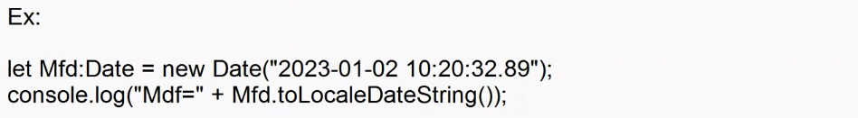

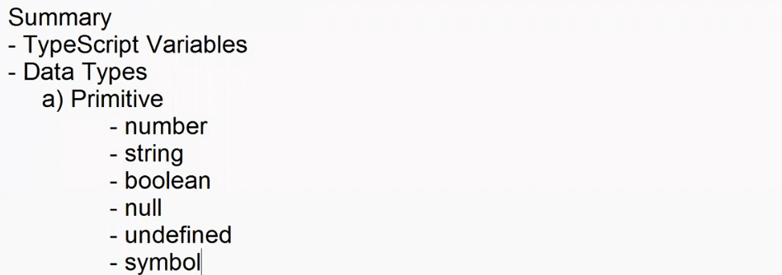

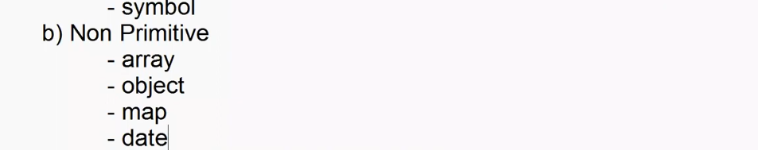

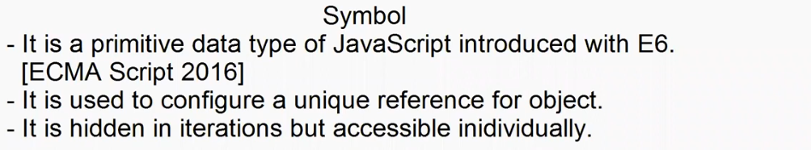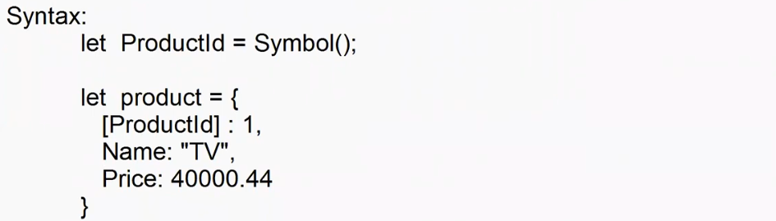

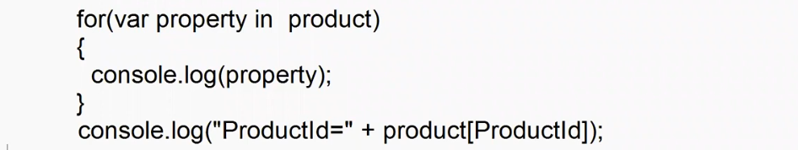

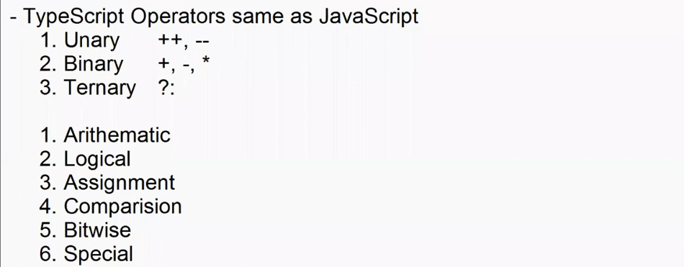

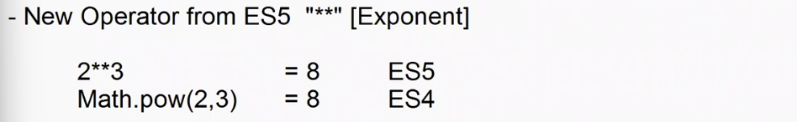

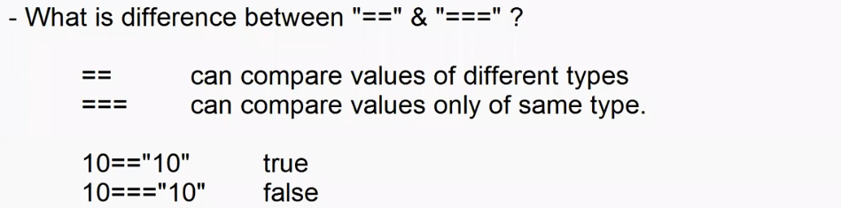

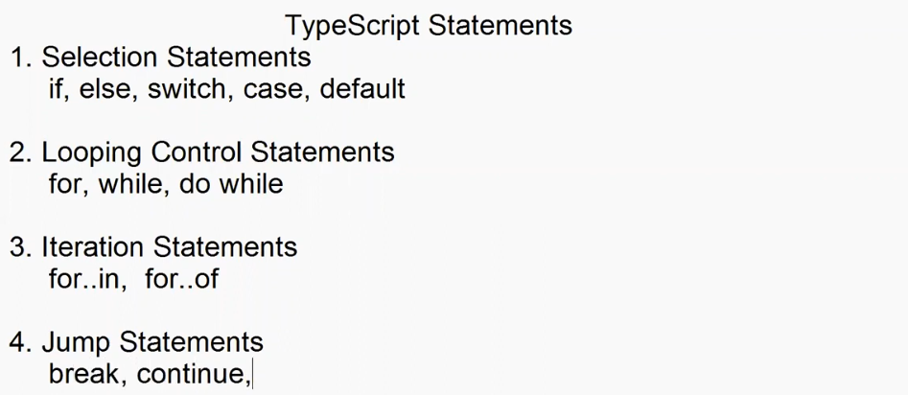



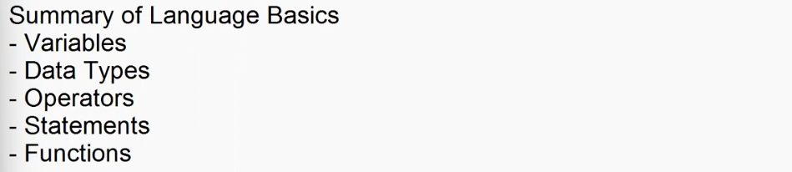

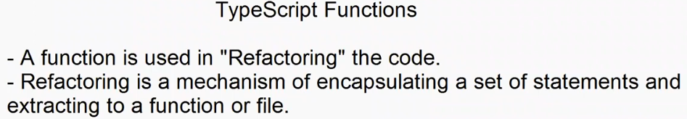

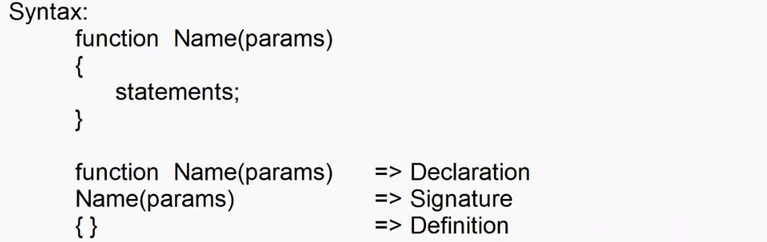

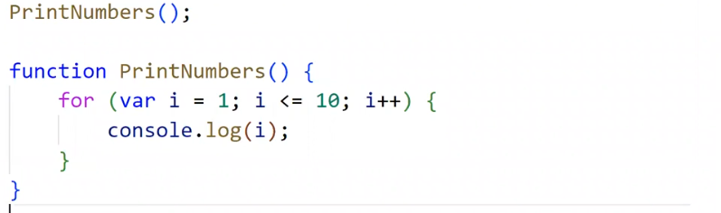

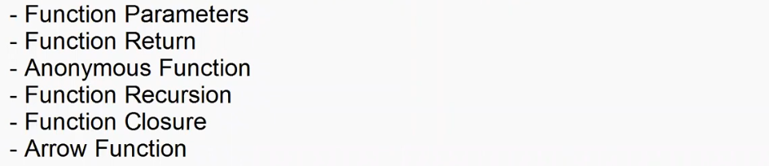

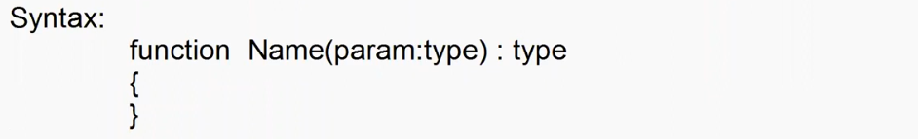

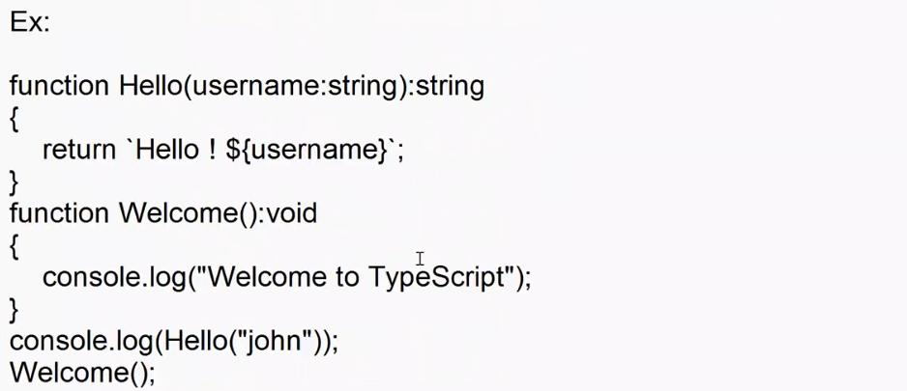

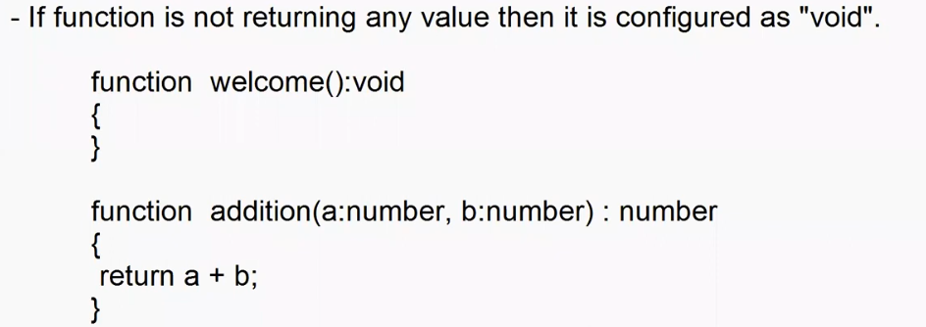

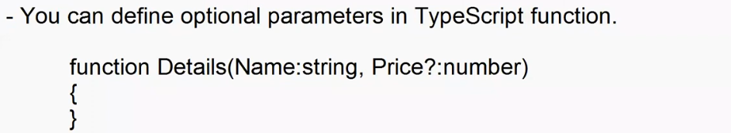



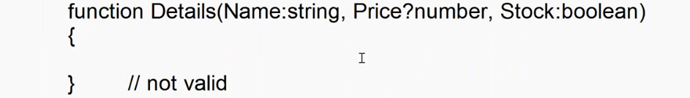

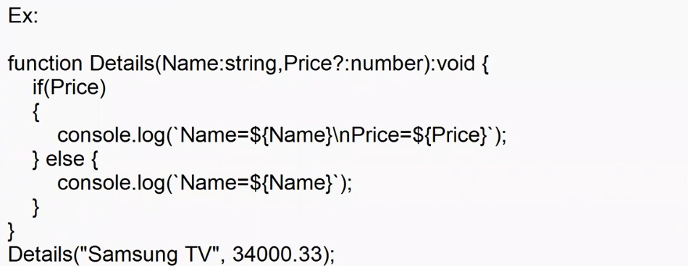

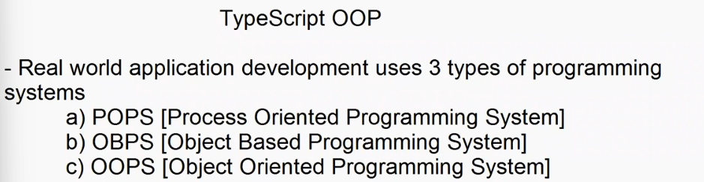

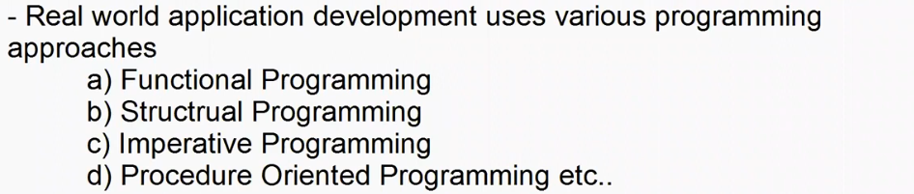

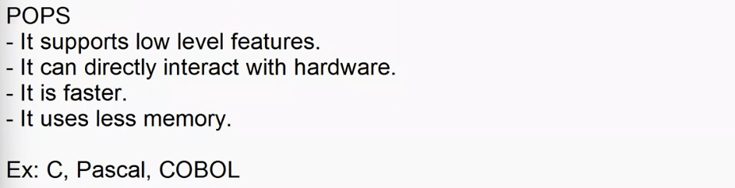

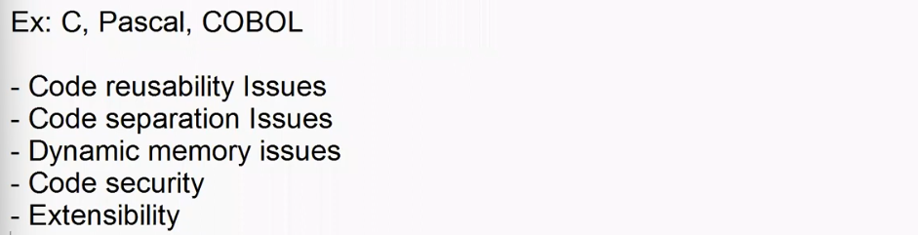

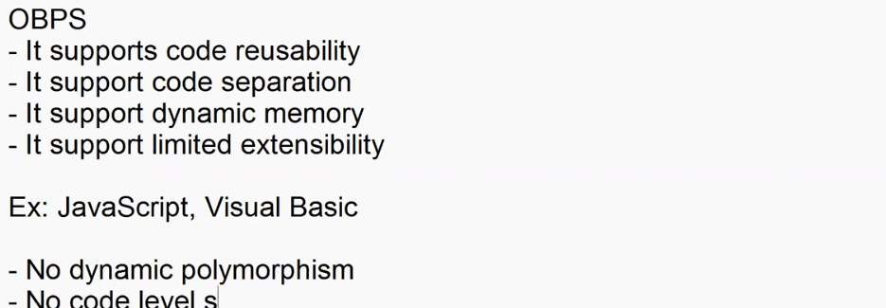



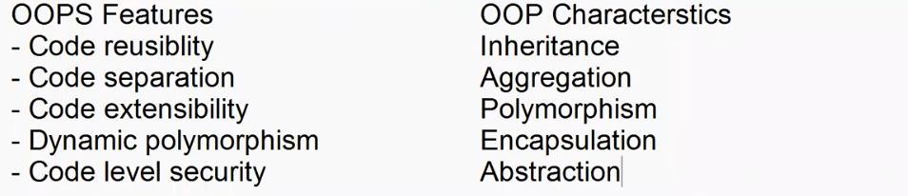

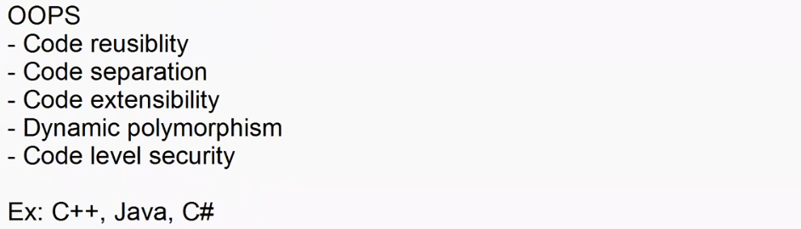

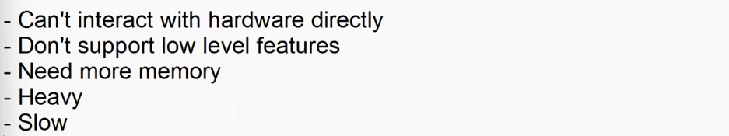

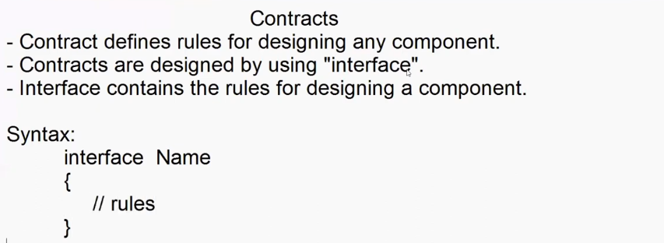

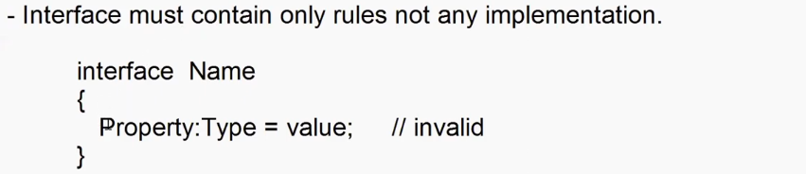

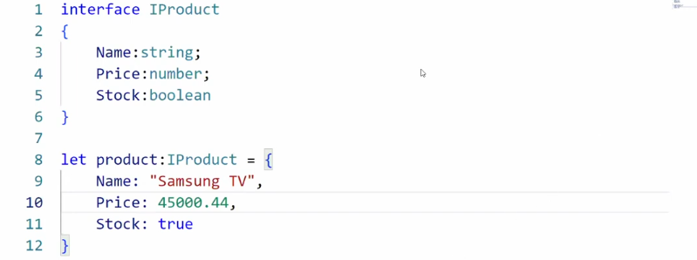

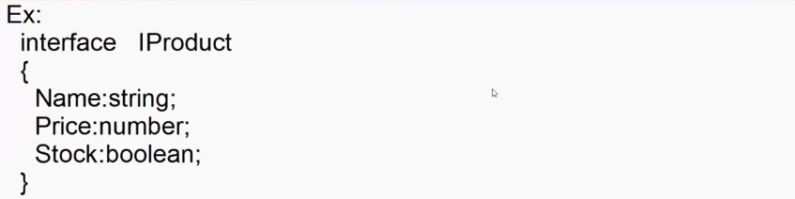

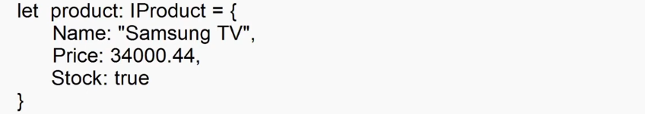

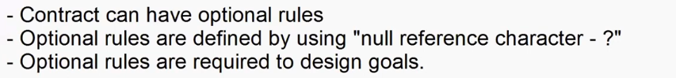

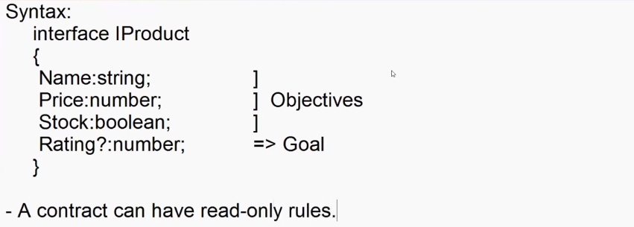

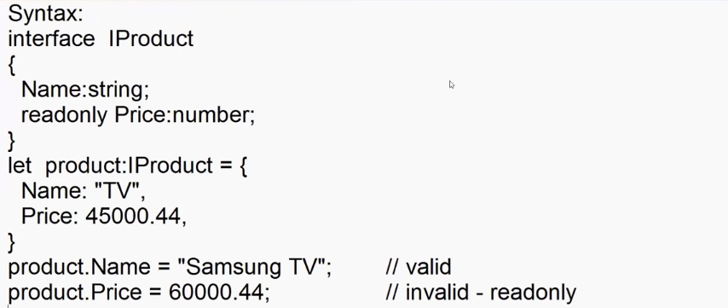

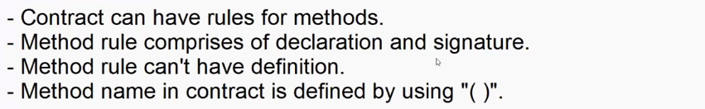

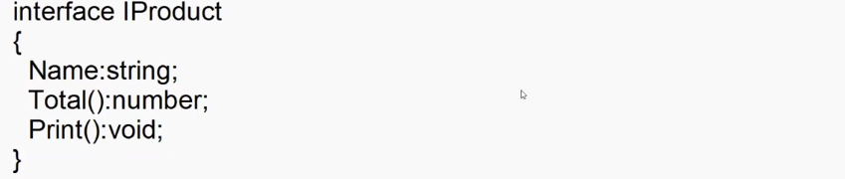

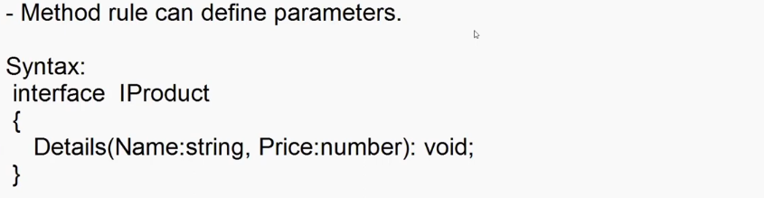

interface IProduct{

    Name:string;

    Price:number;

    Qty:number;

    Total():number;

    Print():void;

}

var product:IProduct = {

    Name:"Adesh",

    Price:45555.44,

    Qty:2,

    Total: function(){

        return this.Price*this.Qty;

    },

    Print:function(){

        console.log(`Name= ${this.Name}\nPrice= ${this.Price}\nQty=  ${this.Qty}\nTotal= ${this.Total()}`)

    }

}

product.Print();

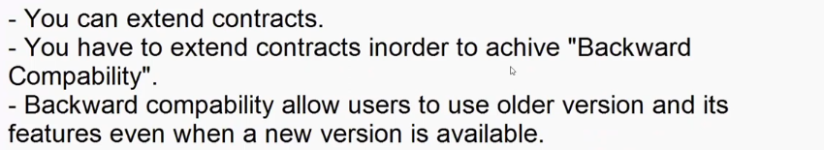

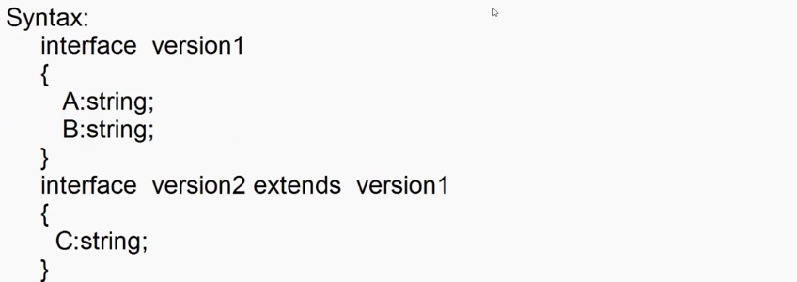

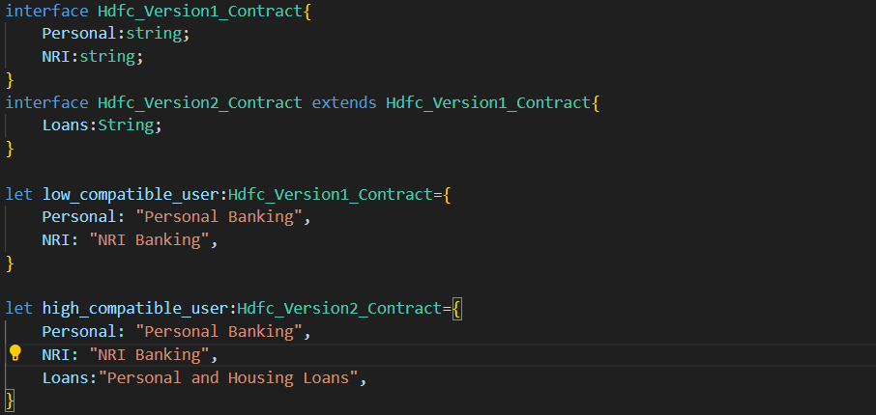

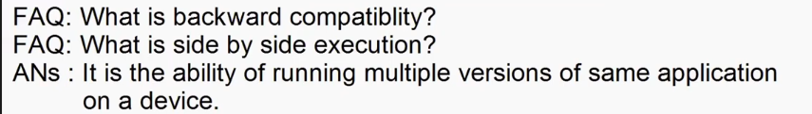

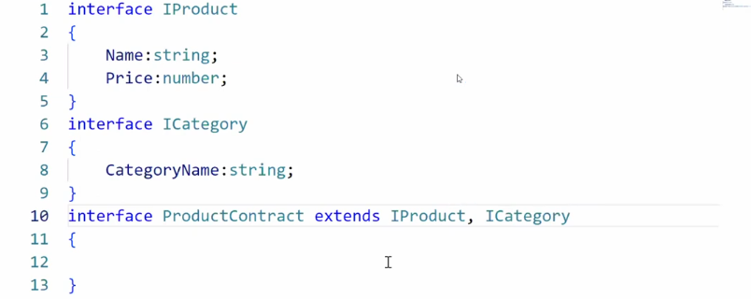

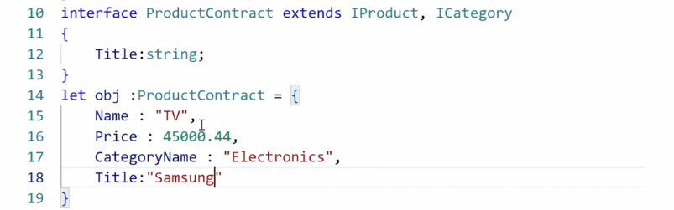

**-**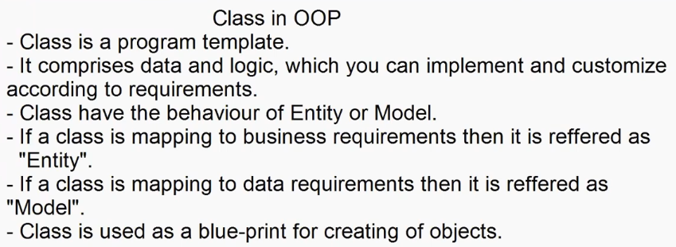

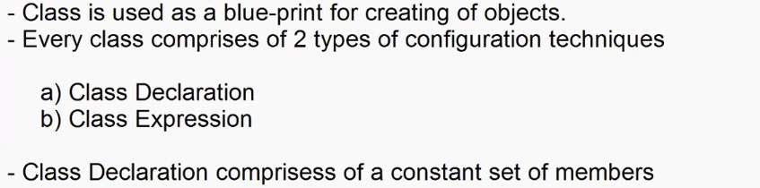

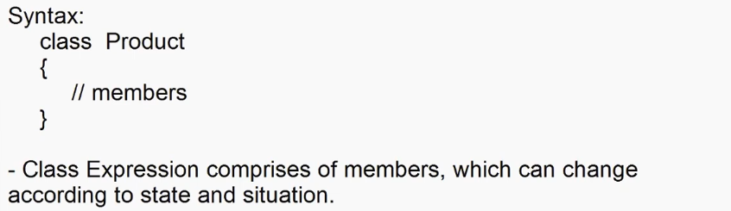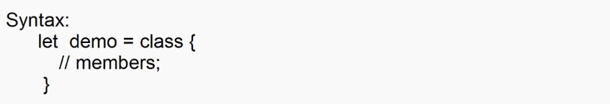

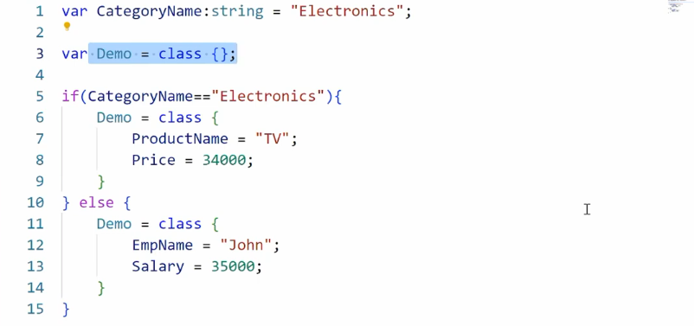

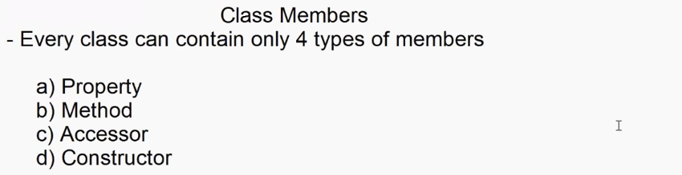

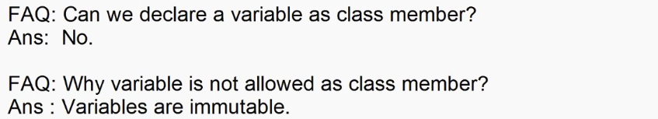

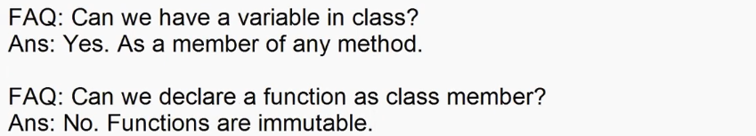



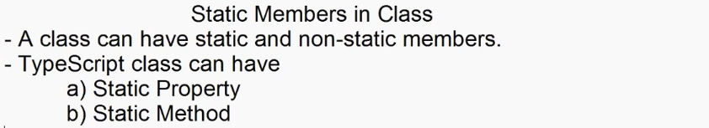

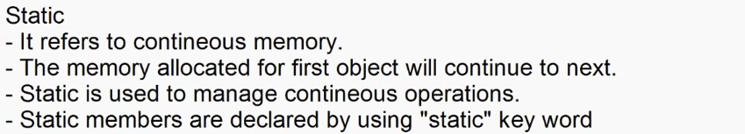

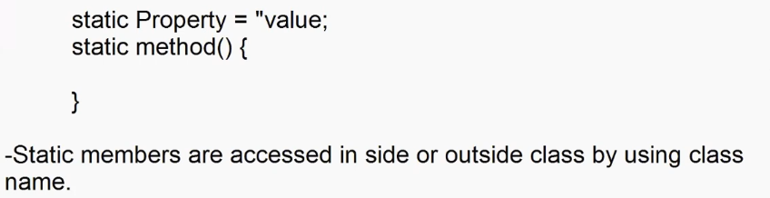

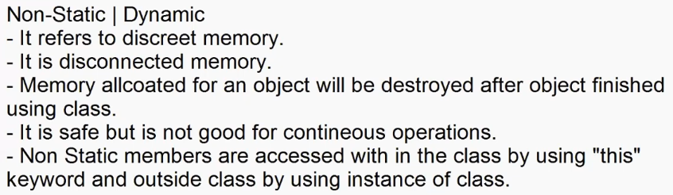

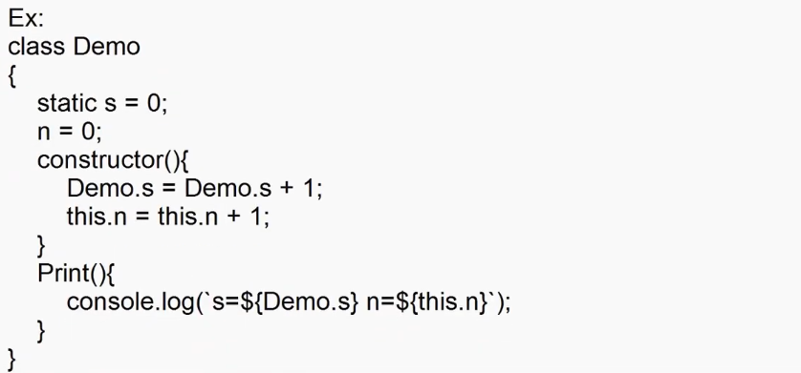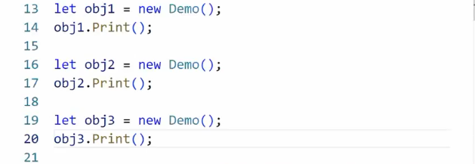

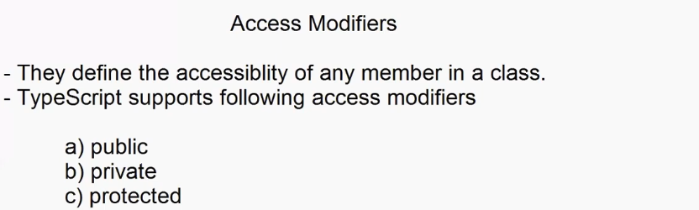

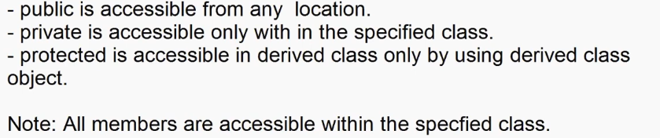

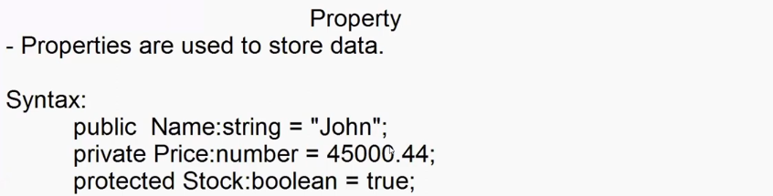

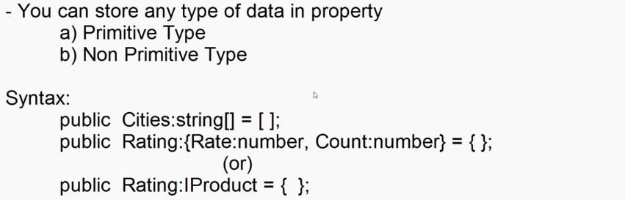



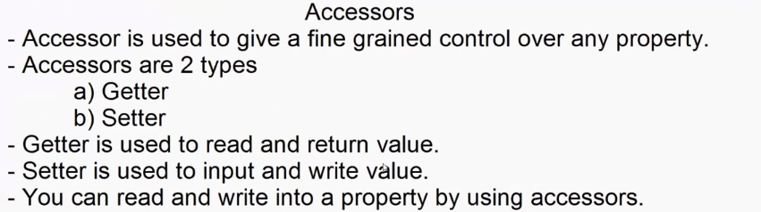

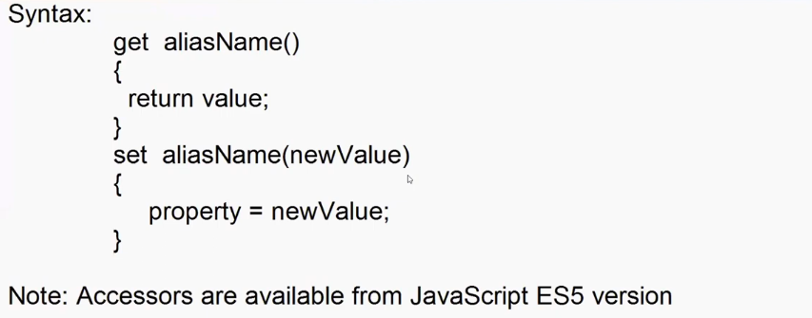

**Index.ts file > tsc index.ts**

var username:string|null = prompt("Enter Name :");

var role:string|null = prompt("Enter your role","admin|manager|customer");

var productname:string|null = prompt("Enter Product Name ");

class Product{

    public _productname:string|null = null;

    get productname(){

        return this._productname;

    }

    set productname(newName:string|null){

        if(role=="admin")

            {

                this._productname=newName;

            }

        else{

            document.write(`Hello ${username} your role ${role} is not authorized`);

        }

    }

}

let tv = new Product();

tv.productname = productname;

if(tv.productname){

    document.write("Product Name: " + tv.productname);

}



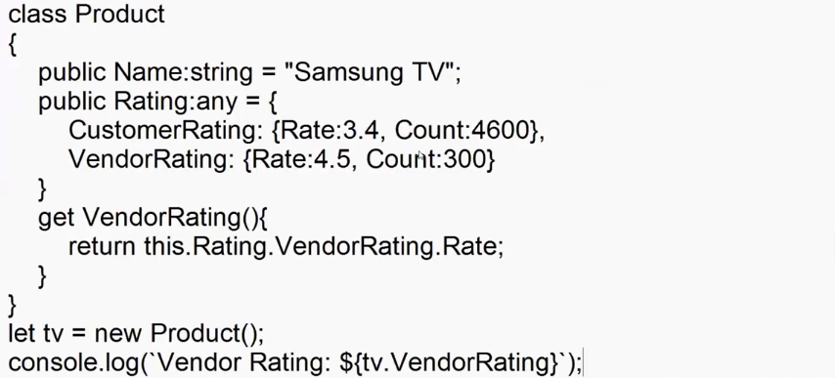

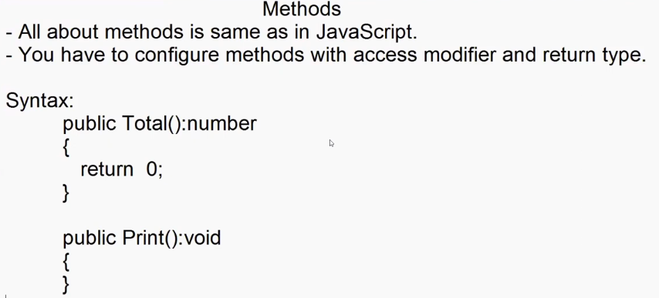 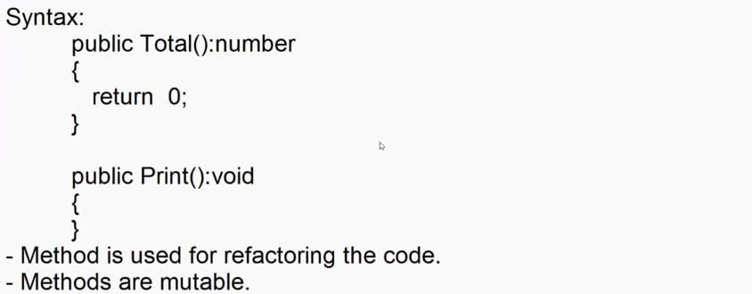

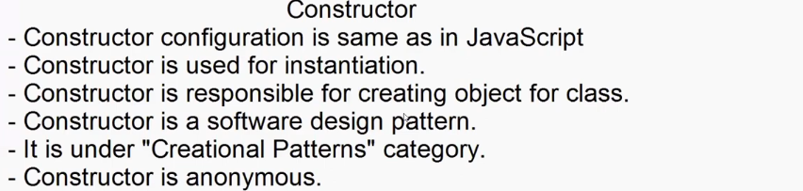

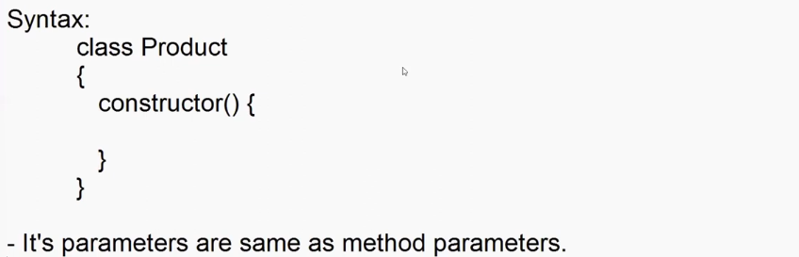

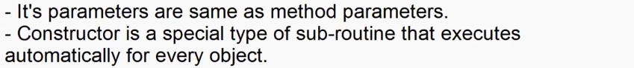

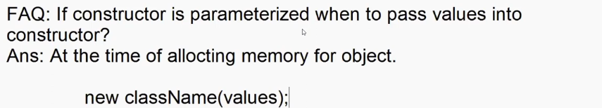

**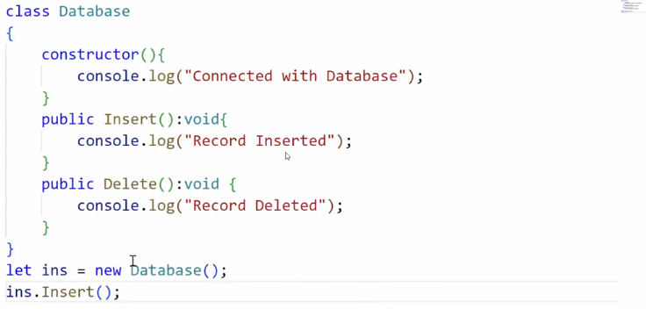  
Let ins = new Database(); -> parenthesis are not mandatory**



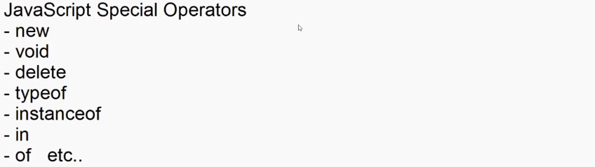

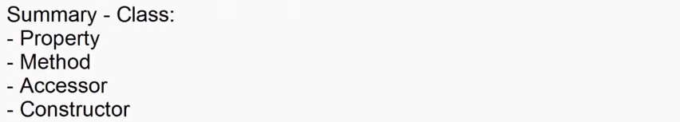

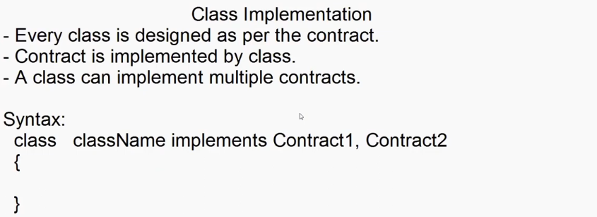

interface IProduct{

    Name:string;

    Price:number;

    Qty:number;

    Total():number;

    Print():void;

}

interface ICategory{

    CategoryName:string;

}

class Product implements IProduct, ICategory

{

    public Name: string = "";

    public Price: number = 0;

    public Qty: number = 0;

    public CategoryName: string = "";

    public Stock:boolean = true;

    public Total(): number {

        return this.Price * this.Qty;

    }

    public Print(): void {

        console.log(`Name= ${this.Name}\nPrice= ${this.Price}\nQty=  ${this.Qty}\nCategory=${this.CategoryName}\nTotal= ${this.Total()}\nStock=${this.Stock}`)

    }

}

let p1 = new Product();

p1.Name = "Samsung TV";

p1.Price = 45000.44;

p1.Qty=2;

p1.CategoryName="Electronics";

p1.Print();

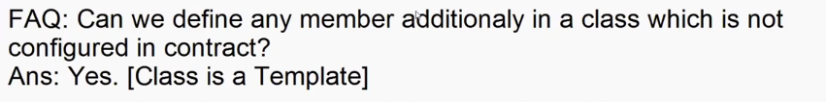

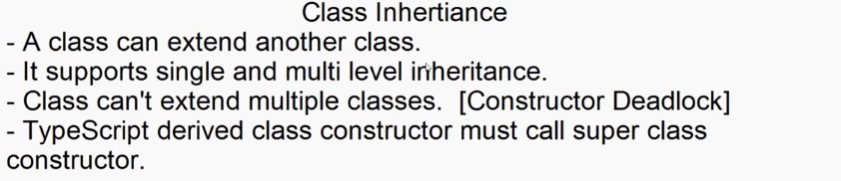 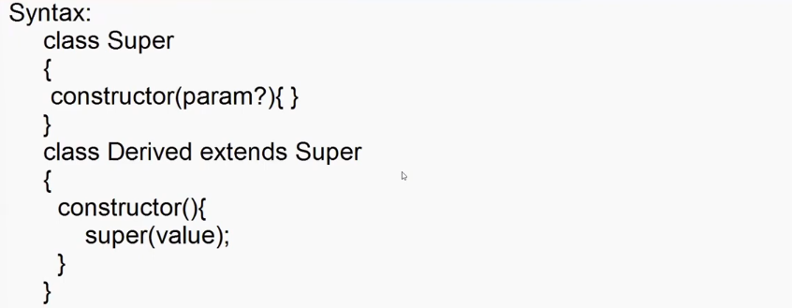

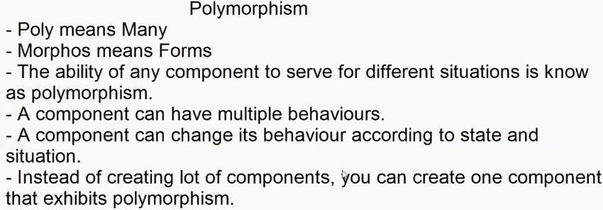 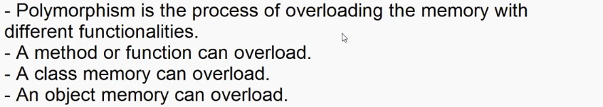 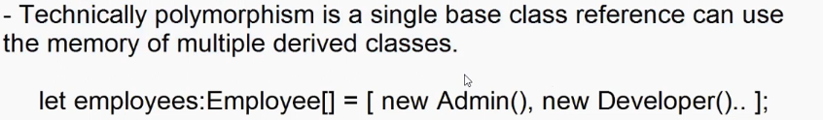

Ex:

1. **Index.ts**

class Employee{

    public FirstName:string = "";

    public LastName:string = "";

    public Designation:string = "";

    public Print():void

    {

        document.write(`${this.FirstName} ${this.LastName} - ${this.Designation}\n`)

    }

}

class Developer extends Employee{

    FirstName = "Raj";

    LastName = "Kumar";

    Designation = "Developer";

    Role = "Developer Role : Built, Debug, Test, Deploy";

    Print(){

        super.Print();

        document.write(this.Role);

    }

}

class Admin extends Employee{

    FirstName = "Kiran";

    LastName = "Kumar";

    Designation = "Admin";

    Role = "Admin Role : Authorization and Authentication";

    Print(){

        super.Print();

        document.write(this.Role);

    }

}

class Manager extends Employee{

    FirstName = "Tom";

    LastName = "Hanks";

    Designation = "Manager";

    Role = "Manager Role : Approvals";

    Print(){

        super.Print();

        document.write(this.Role);

    }

}

let employees: Employee[] = [new Developer(), new Admin(), new Manager()];

**>tsc index.ts**

**2) Index.html**

<!DOCTYPE html>

<html lang="en">

<head>

    <meta charset="UTF-8">

    <meta name="viewport"  content="width=device-width, initial-scale=1.0">

    <title>Document</title>

    <script src="src/index.js"></script>

    <script>

        var designation = prompt("Enter Designation : ");

        for(employee of employees)

        {

            if(employee.Designation == designation)

            {

                employee.Print();

            }

        }

    </script>

</head>

<body>

    <!-- <h1>Welcome Typescript</h1> -->

</body>

</html>

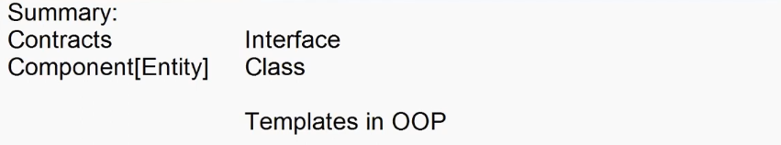

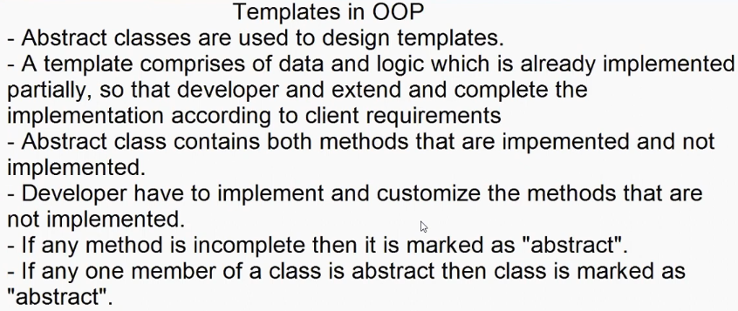 

interface ProductContracts {

    Name:string;

    Price:number;

    Qty:number;

    Total():number;

    Print():void;

}

abstract class ProductTemplete implements ProductContracts{

    public Name:string ="";

    public Price:number = 0;

    public Qty: number = 0;

    public abstract Total(): number;

    public abstract Print(): void;

}

class ProductComponent extends ProductTemplete{

    Name = "Samsung TV";

    Price = 45000.44;

    Qty = 2;

    public Total(): number {

        return this.Price*this.Qty;

    }

    public Print(): void {

        console.log(`Name= ${this.Name}\nPrice= ${this.Price}\nQty=  ${this.Qty}\nTotal= ${this.Total()}\n`)

    }

}

let tv = new ProductComponent();

tv.Print();

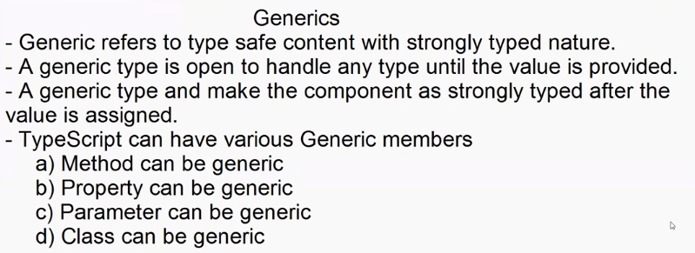

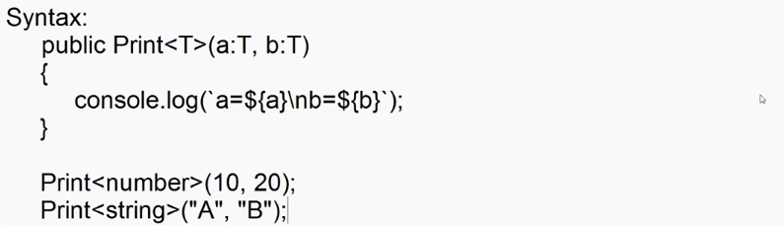

class Demo{

    public Print<T>(a:T,b:T){

        console.log(`A=${a}\nB=${b}`);

    }

}

let obj = new Demo();

obj.Print<number>(10,20);

obj.Print<string>("Adesh","Ritesh");

------------------------------------------------------------------------------

interface IProduct {

    Name : string;

    Price : number;

}

interface IEmployee{

    FirstName:string;

    Designation:string;

    Salary:number;

}

class Service{

    public GetData<T>(data:T){

        for(var property in data)

            {

                console.log(`${property} : ${data[property]}`);

            }

    }

}

let obj = new Service();

console.log("-------Employee Details--------")

obj.GetData<IEmployee>({FirstName:"Adesh",Designation:"Admin",Salary:50000});

console.log("-------Product Details---------")

obj.GetData<IProduct>({Name:"Samsung TV",Price:50000});

interface IOrcale{

    Username:string;

    Password:string;

    Database:string;

}

interface IMySql{

    Host:string;

    User:string;

    Pwd:string;

    Db:string;

}

interface IMongoDb{

    Url:string;

}

------------------------------------------------------------------------------

class Database<T>

{

    public ConnectionString:T|null=null;

    public Connect():void{

        for(var property in this.ConnectionString){

            console.log(`${property} : ${this.ConnectionString[property]}`);

        }

    }

}

console.log(`-------Orcal Connection--------`)

let oracal = new Database<IOrcale>();

oracal.ConnectionString={

    Username:"Adesh",

    Password:"Pass",

    Database:"Oracal"

}

oracal.Connect();

console.log(`-------MySql Connection--------`)

let mysql = new Database<IMySql>();

mysql.ConnectionString={

    Host:"localhost",

    User:"root",

    Pwd:"12345",

    Db:"EmpDb"

}

mysql.Connect();

console.log(`-------MongoDb Connection--------`)

let mongoDb = new Database<IMongoDb>();

mongoDb.ConnectionString={

    Url : "mongodb://127.0.0.1:27017"

}

mongoDb.Connect();

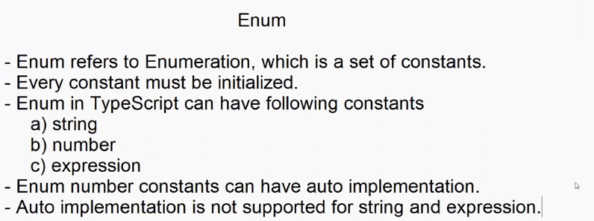

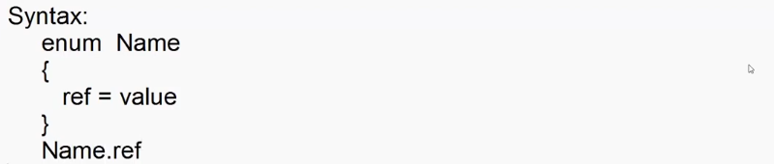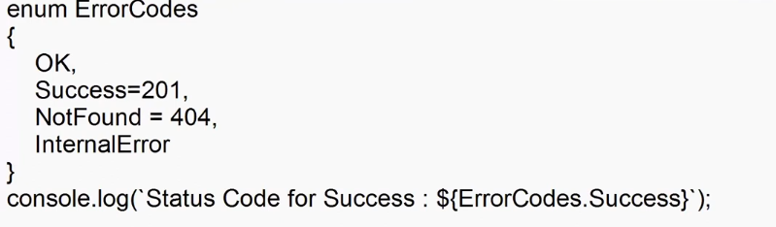

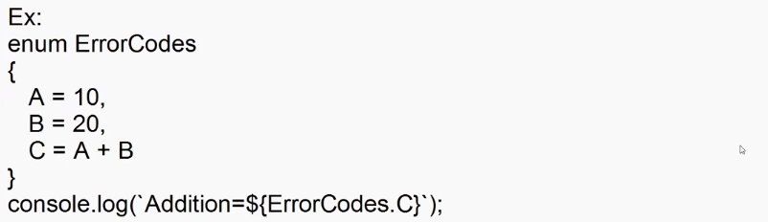



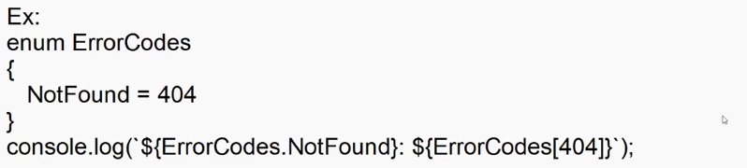

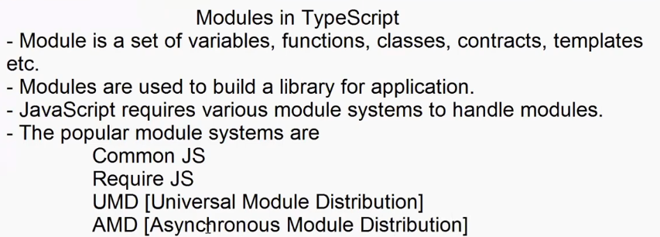

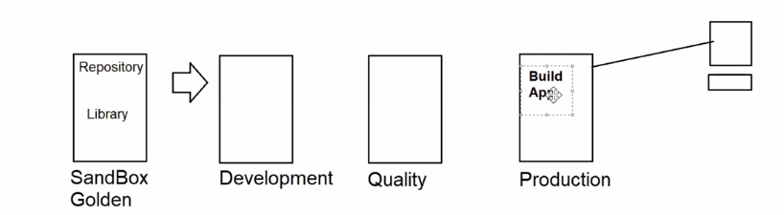



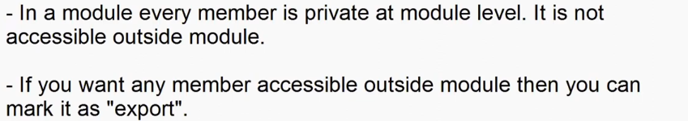

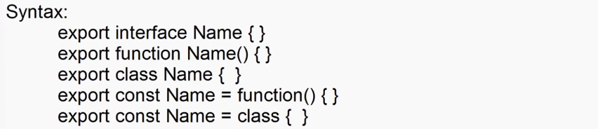

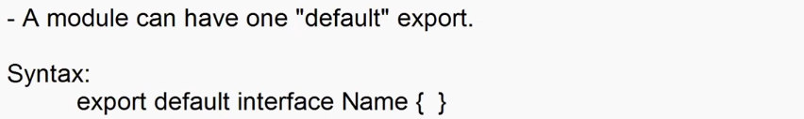



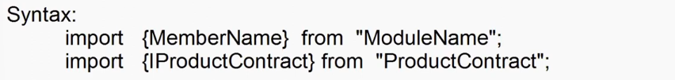

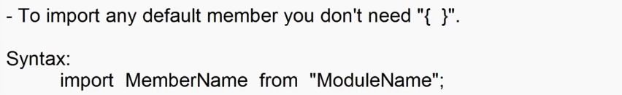





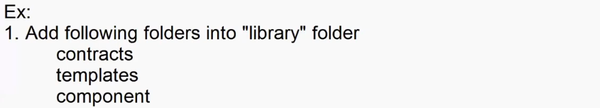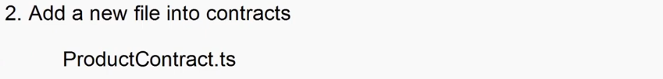

export interface IProductContract{

    Name:string;

    Price:number;

    Qty:number;

    Total():number;

    Print():void;

}

export default interface ICategory{

    CategoryName:String;

}

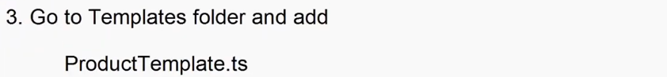

import ICategory,{ IProductContract }from "../contracts/ProductContract";

export abstract class ProductTempate implements ICategory,IProductContract{

    Name = "";

    Price = 0;

    Qty = 0;

    CategoryName="";

    public abstract Total(): number;

    public abstract Print(): void;

}

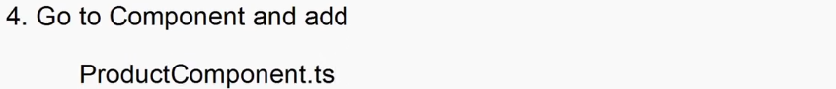

import { ProductTempate } from "../templates/ProductTemplate";

export class ProductComponent extends ProductTempate{

    Name = "Samsung TV";

    Price = 45000.44;

    Qty = 2;

    CategoryName = "Electronis";

    public Total(): number {

        return this.Price*this.Qty;

    }

    public Print(): void {

        console.log(`Name= ${this.Name}\nPrice= ${this.Price}\nQty=${this.Qty}\nTotal= ${this.Total()}\n`)

    }

}

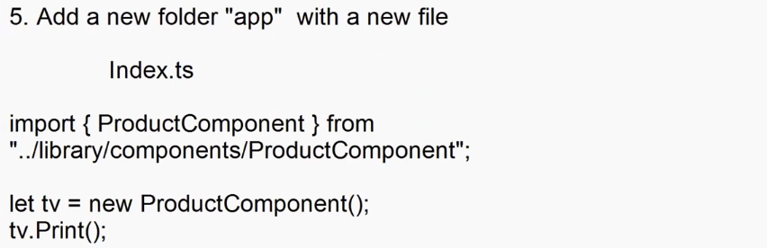

import { ProductComponent } from "../Library/components/ProductComponent";

let tv = new ProductComponent();

tv.Print();

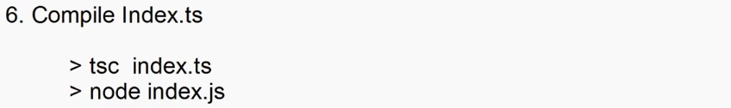

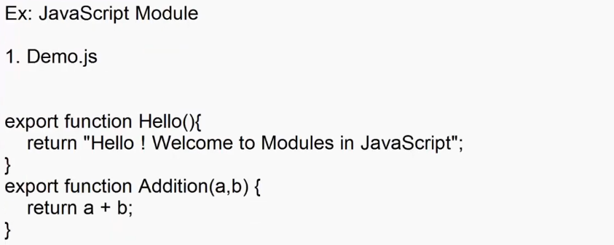



<!DOCTYPE html>

<html lang="en">

<head>

    <meta charset="UTF-8">

    <meta name="viewport" content="width=device-width, initial-scale=1.0">

    <title>Document</title>

    <script type="module">

        import { Hello,Addition } from "./Library/demo.js";

        document.querySelector("p").innerHTML = Hello() + "<br>" + "Addition = "+Addition(10,20);

    </script>

</head>

<body>

    <p></p>

</body>

</html>

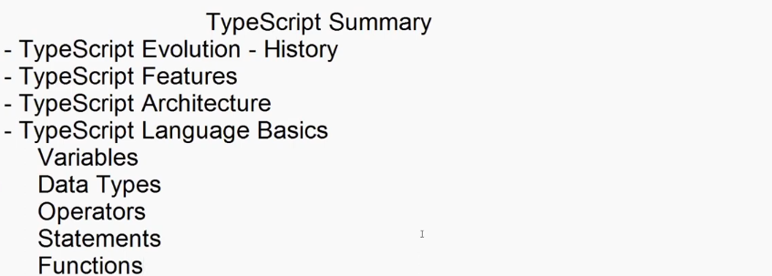

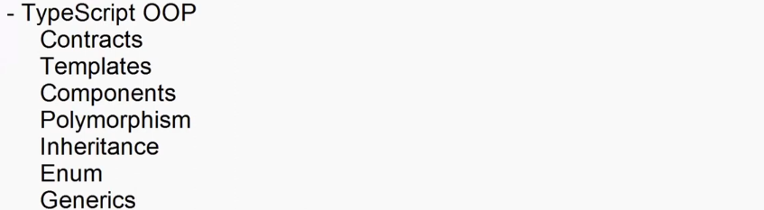

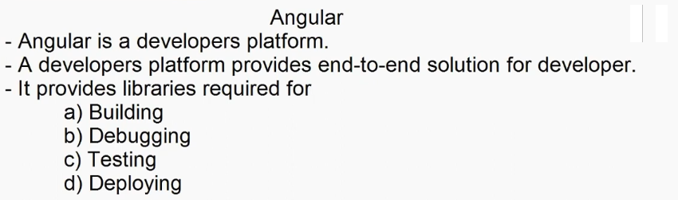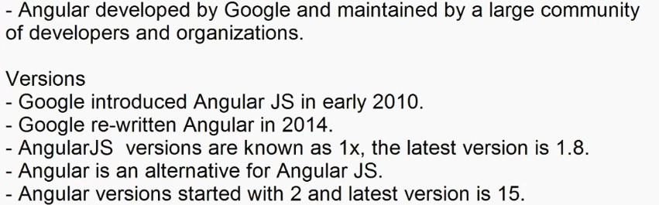

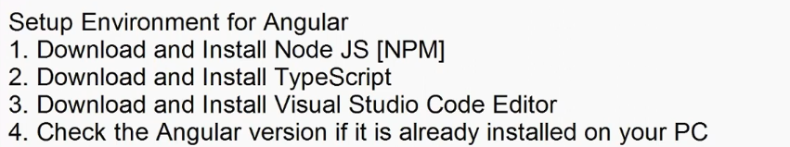

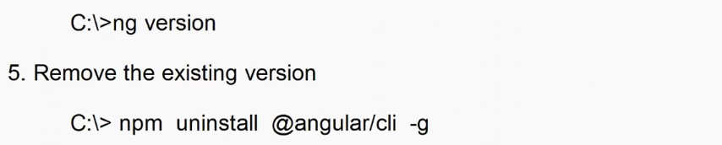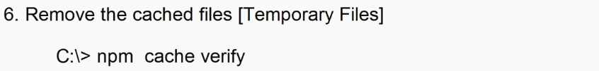

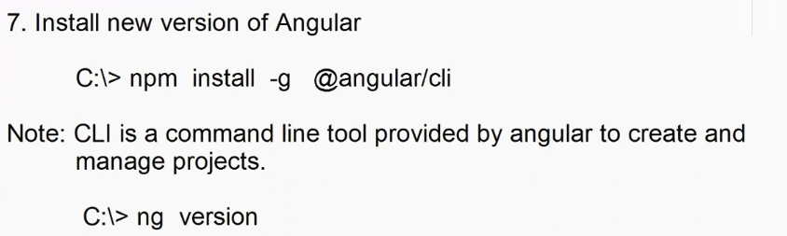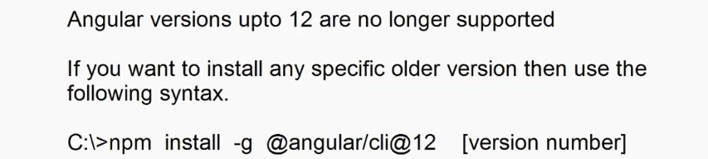

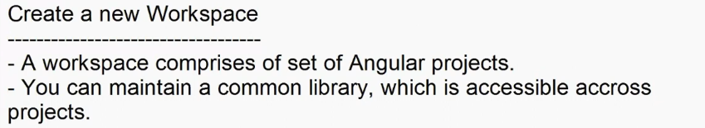

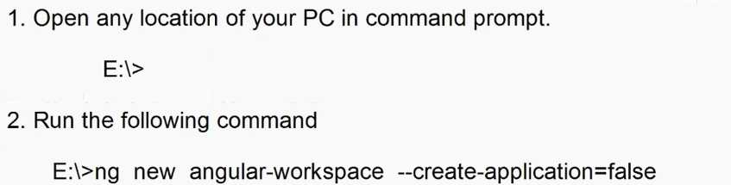

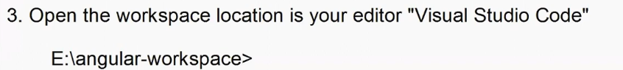



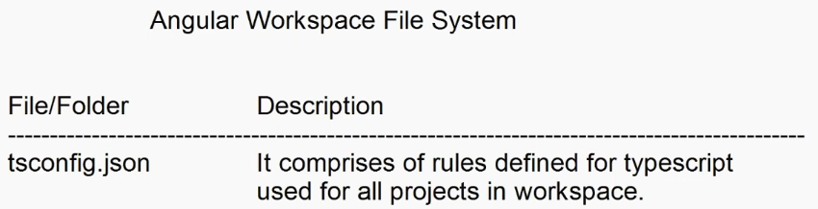

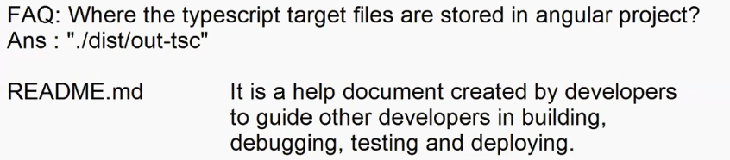

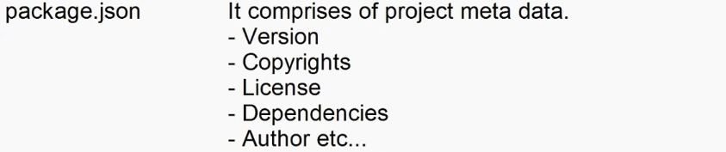







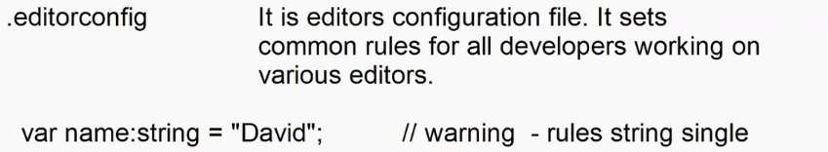





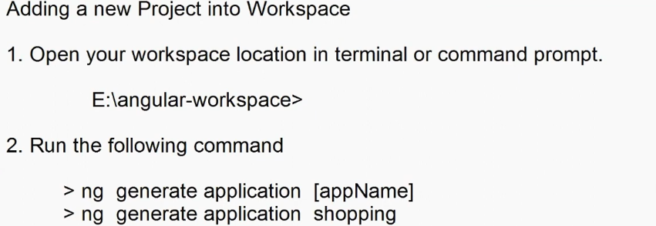

* **ng generate application shopping –standalone false**



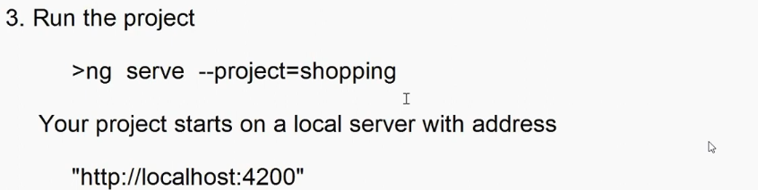

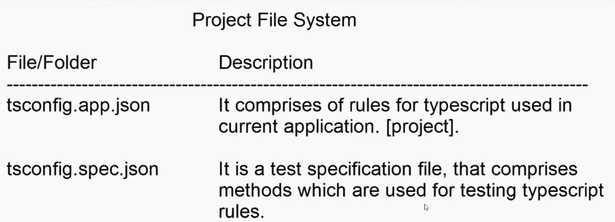

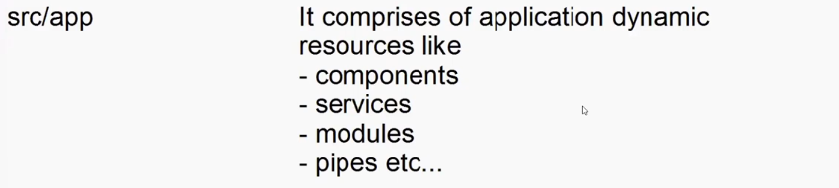

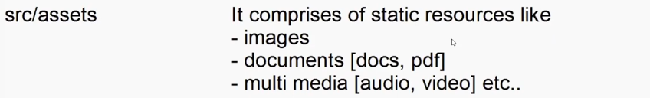









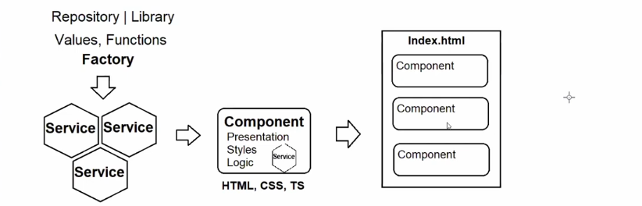

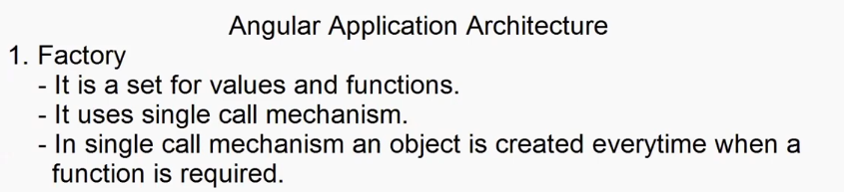

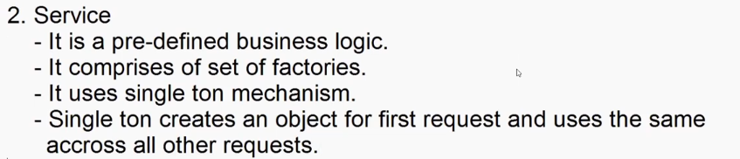

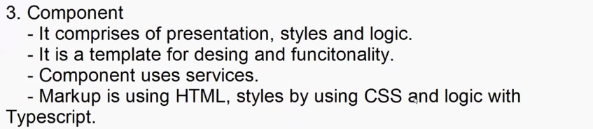

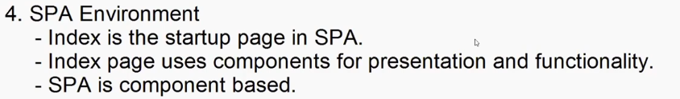

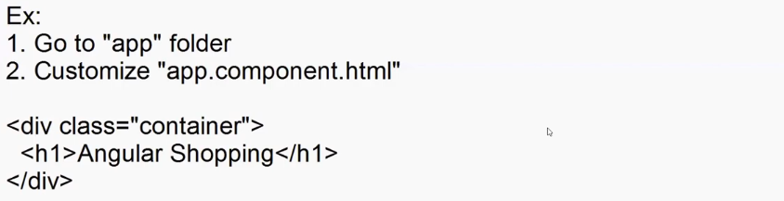

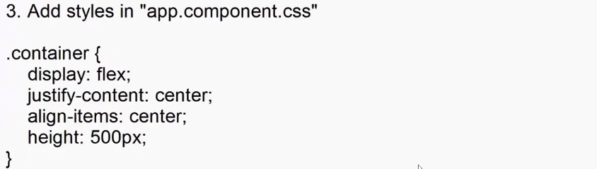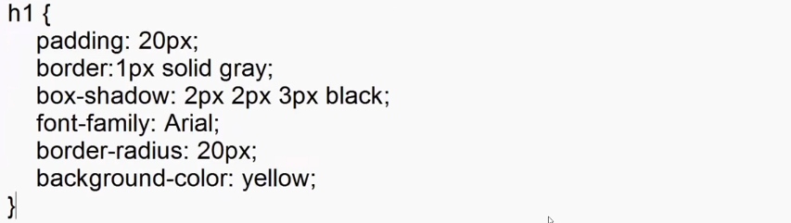

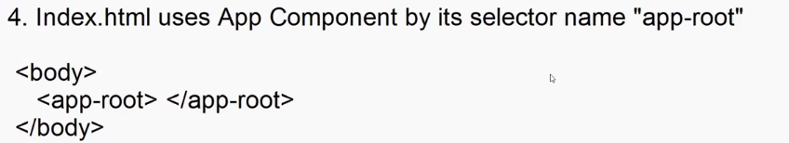

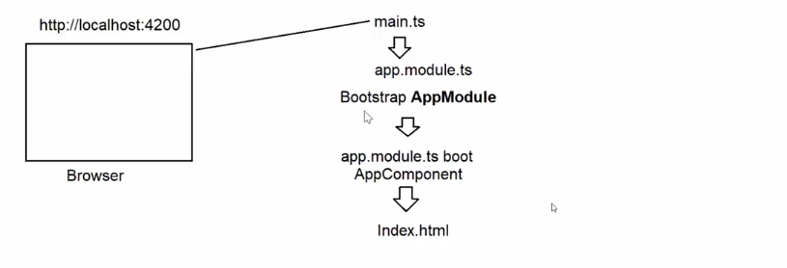

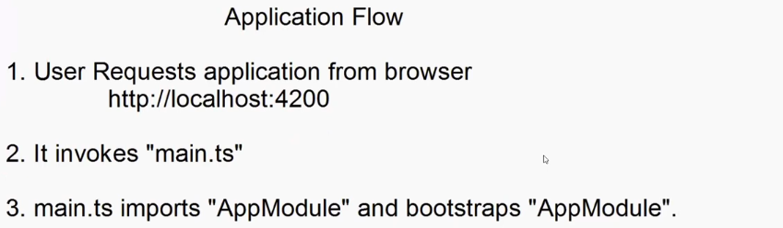

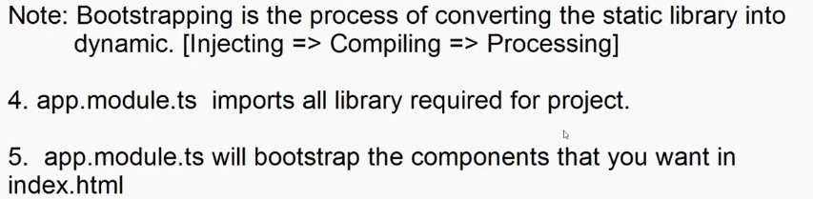

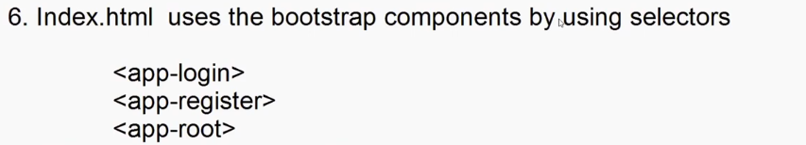

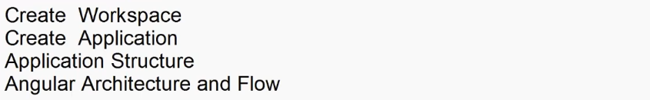

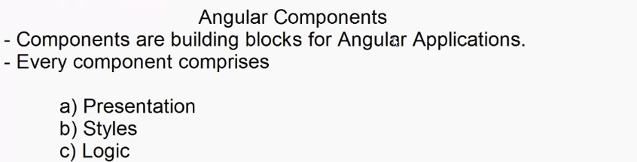

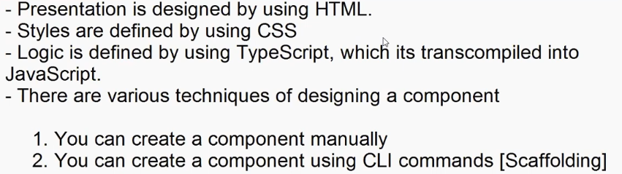

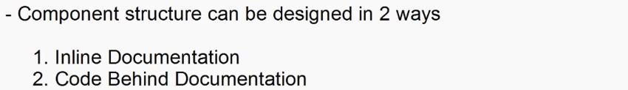

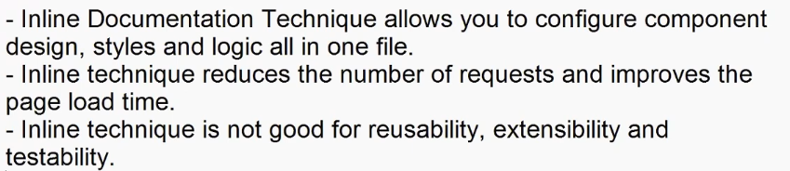

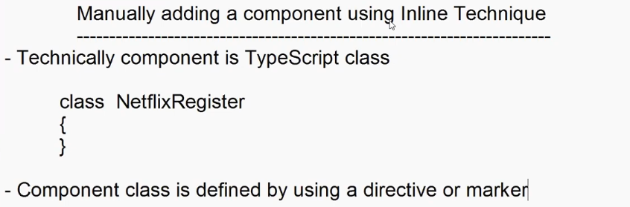



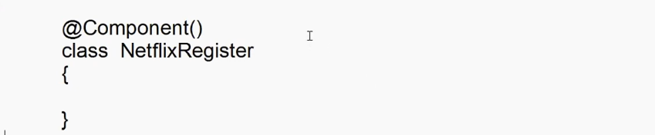

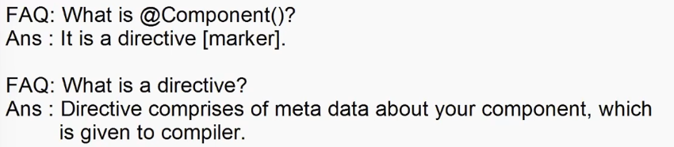

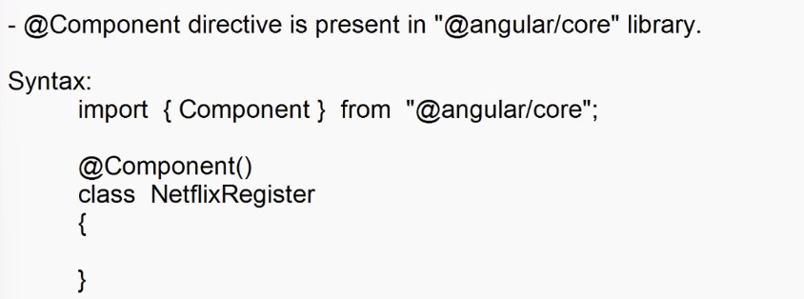

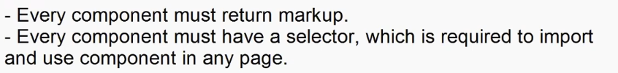

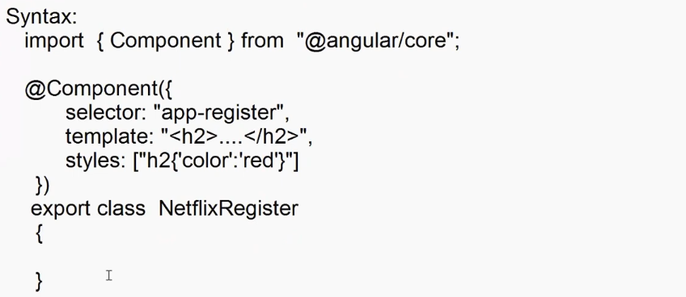



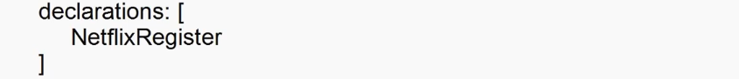

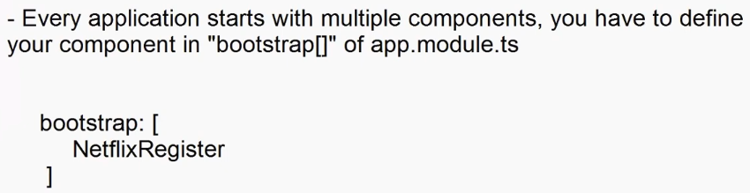

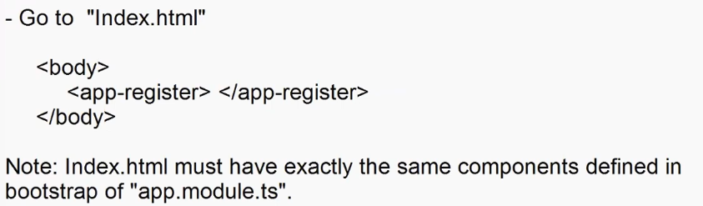

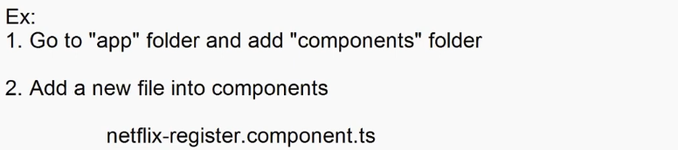

import { Component } from "@angular/core";

@Component({

    selector:'app-register',

    template:`

    <div class="register-container">

        <div>

            <p>Ready to watch? Enter your email to create or restart your membership</p>

            <input type="email" placeholder="Email Address">

            <button> Get Started></button>

        </div>

    </div> `,

    styles:[".register-container{display:flex;justify-content :center ; align-items:center;height:400px}"]

})

export class NetflixRegister{

}

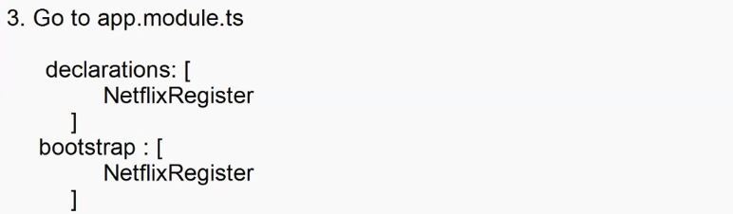

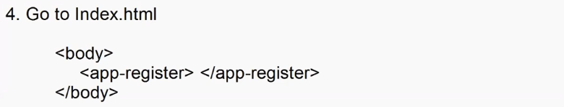

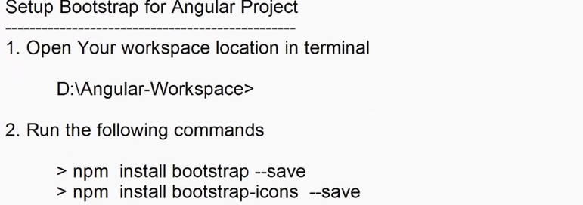

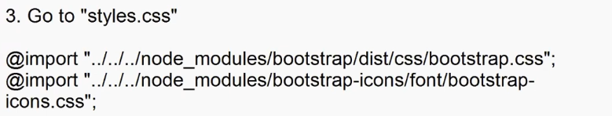

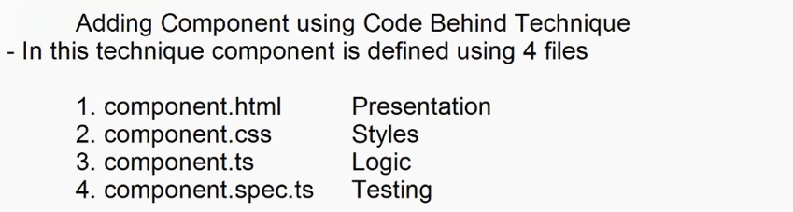

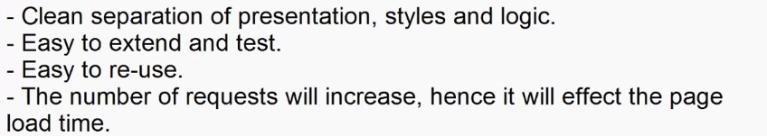

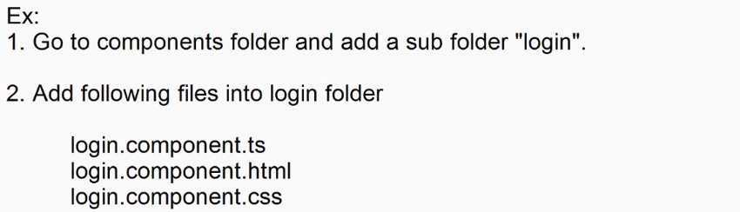

**login.component.ts**

import { Component } from "@angular/core";

@Component({

    selector:'app-login',

    templateUrl:'./login.component.html',

    styleUrls:['./login.component.css']

})

export class LoginComponent{

}

**login.component.html**

<div class="container-fluid">

  <div class="login-form">

    <form>

      <h2><span class="bi bi-person-fill"></span>User Login</h2>

      <dl>

        <dt>User Name</dt>

        <dd><input type="text" class="form-control" /></dd>

        <dt>Password</dt>

        <dd><input type="password" class="form-control" /></dd>

      </dl>

      <button class="btn btn-primary w-100">Login</button>

    </form>

  </div>

</div>

**login.component.css**

.login-form{

    display: flex;

    justify-content: center;

    align-items: center;

    height:600px;

}

form{

    border: 1px solid gray;

    box-shadow: 2px 2px 3px gray;

    padding: 20px;

    border-radius: 20px;

}

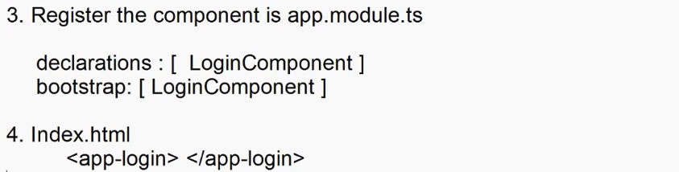

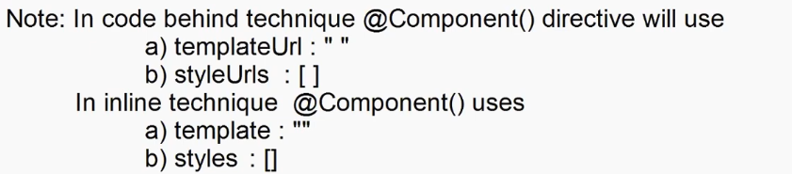

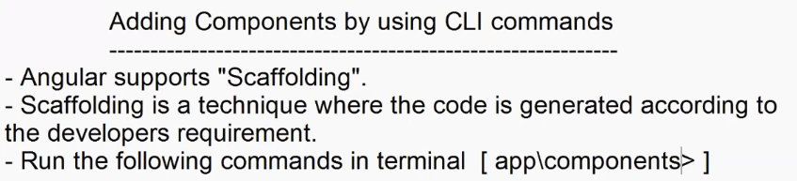

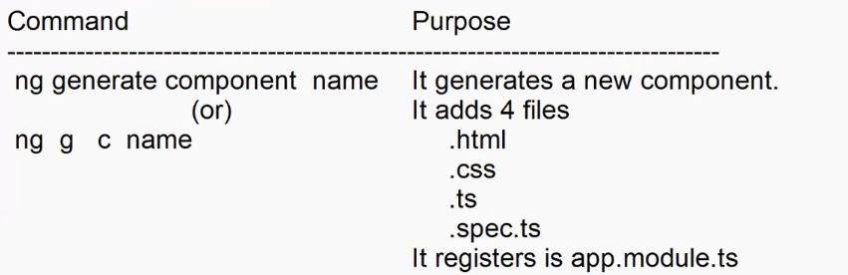

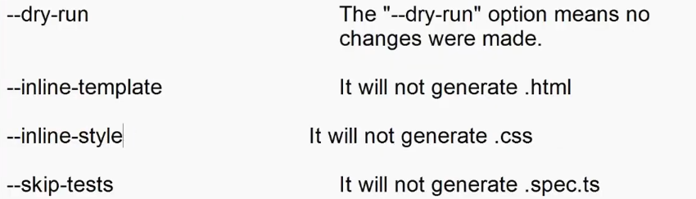

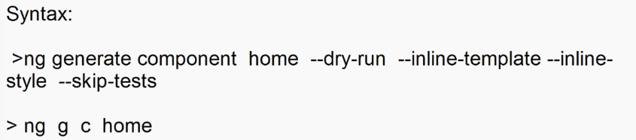

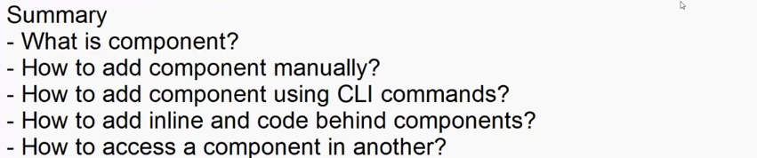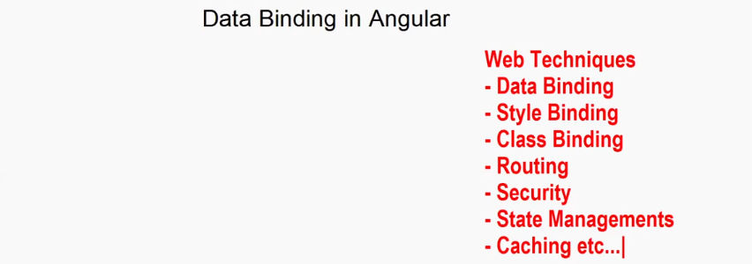

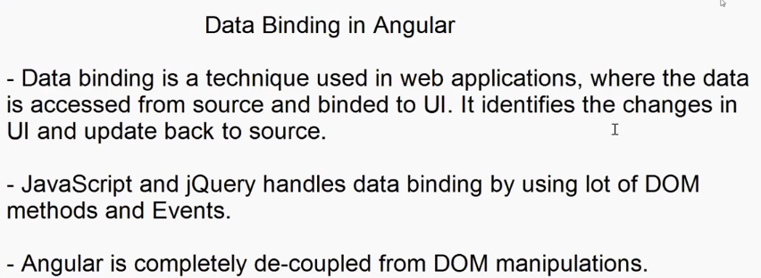

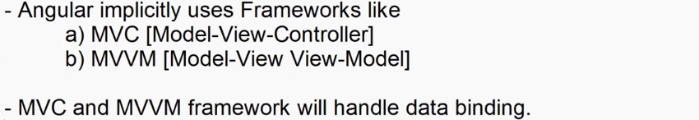

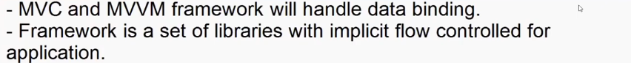

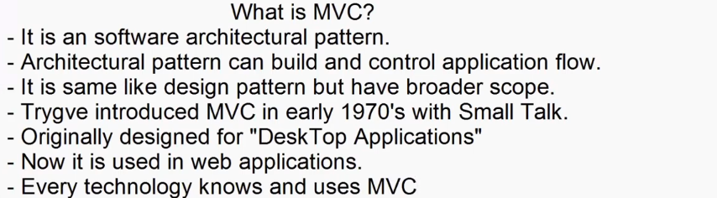

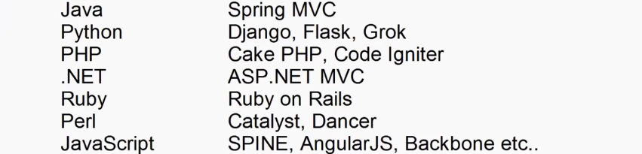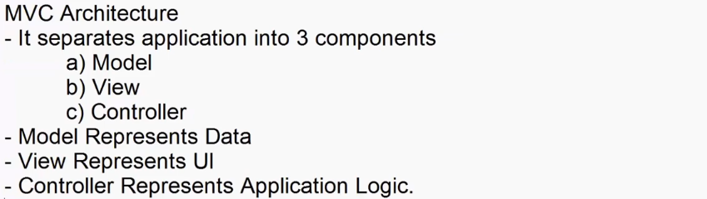

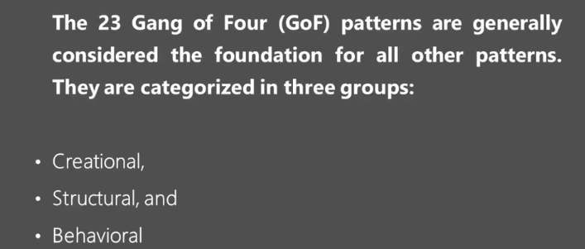



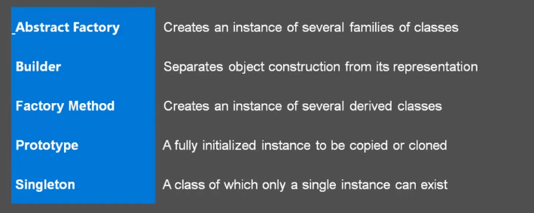



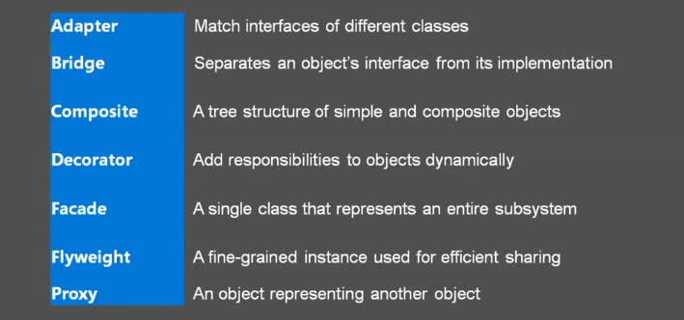



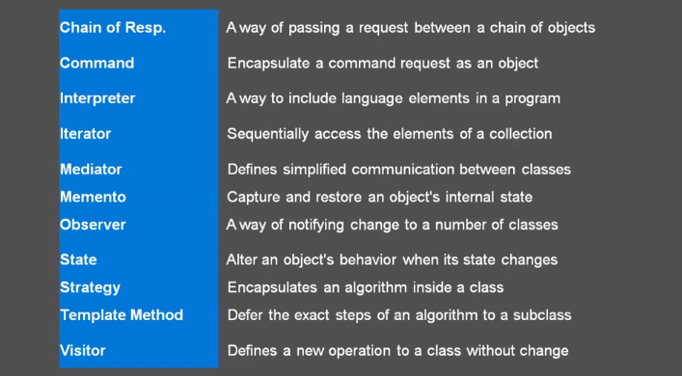



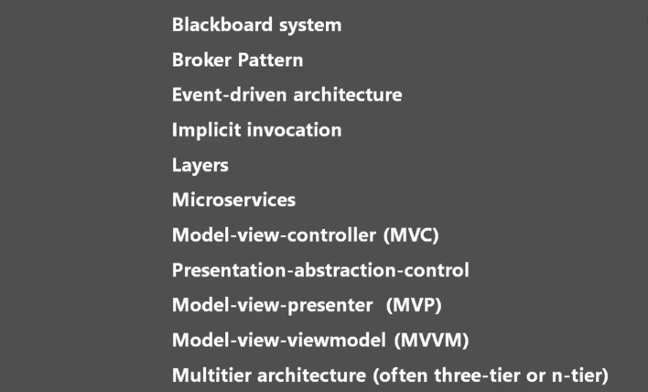

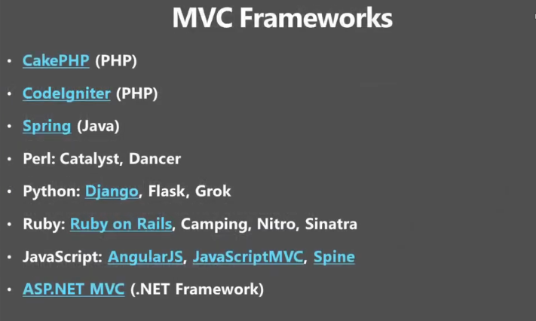

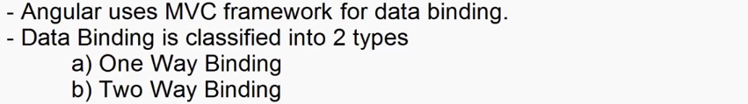

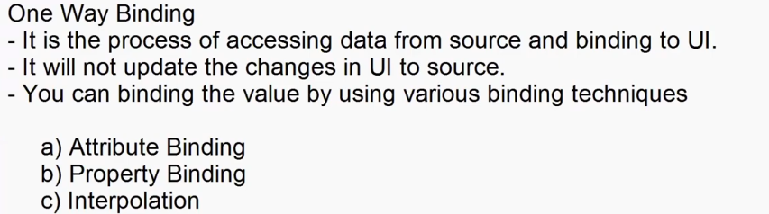

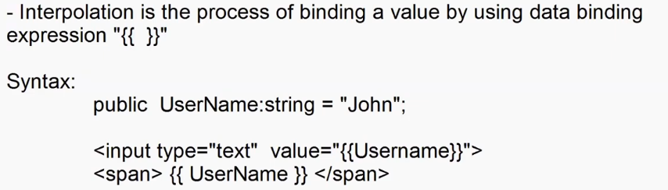



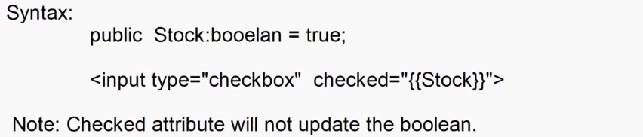

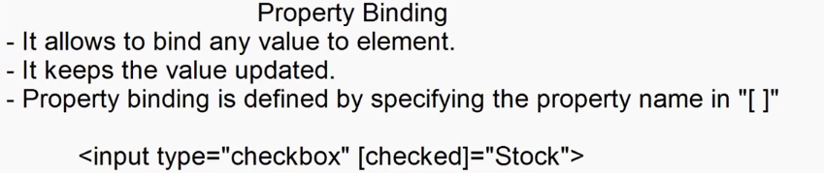



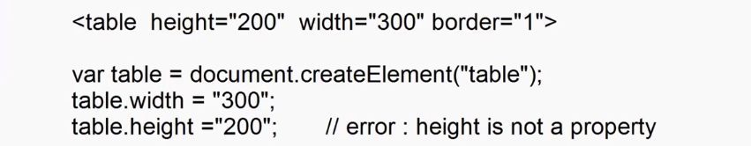

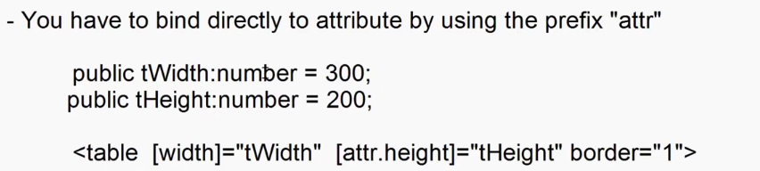

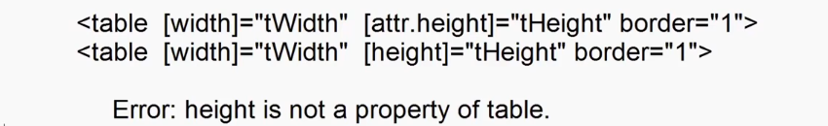



import { Component } from '@angular/core';

@Component({

  selector: 'app-data-binding',

  templateUrl: './data-binding.component.html',

  styleUrl: './data-binding.component.css'

})

export class DataBindingComponent {

  public Username:string = "Adesh";

  public Stock:boolean = false;

}



<div class="container-fluid">

    <h2>One way binding</h2>

    User Name: <input type="text" value="{{Username}}">

    <br><br>

    <h3>Hello ! <span>{{Username}}</span></h3>

</div>

<div class="container-fluid">

    <h2>Interpolation</h2>

    <dl>

        <dt>Stock</dt>

        <dd>

            <input type="checkbox" checked="{{Stock}}"> Available {{Stock}}

        </dd>

    </dl>

</div>

<div class="container-fluid">

    <h2>Property Binding</h2>

    <dl>

        <dt>Stock</dt>

        <dd>

            <input type="checkbox" [checked]="Stock"> Available {{Stock}}

        </dd>

    </dl>

</div>

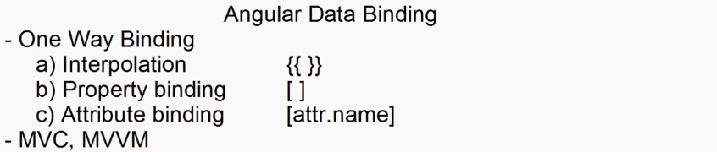

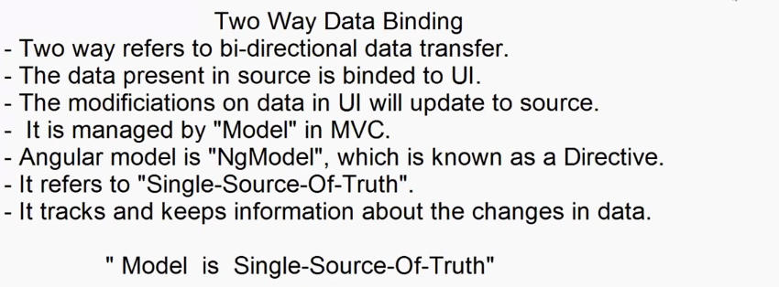

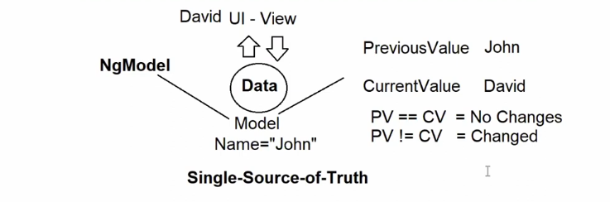



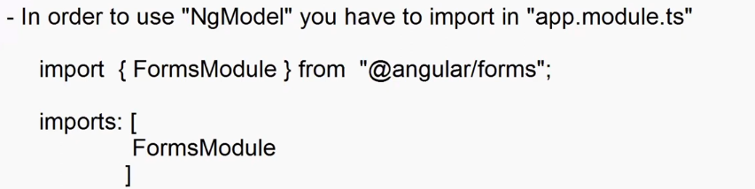

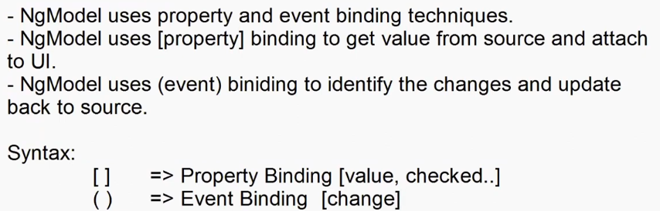



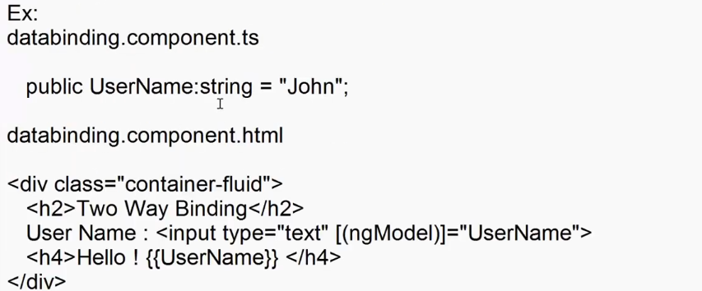

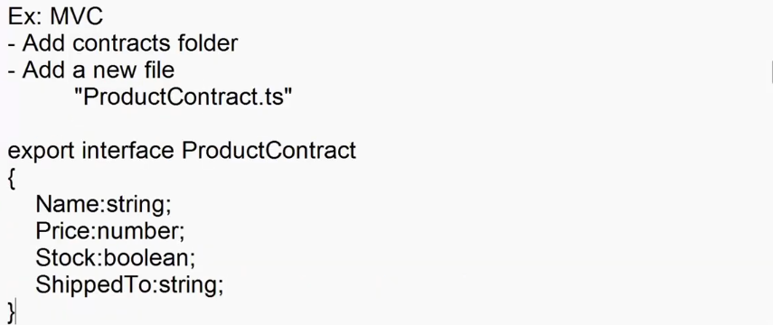

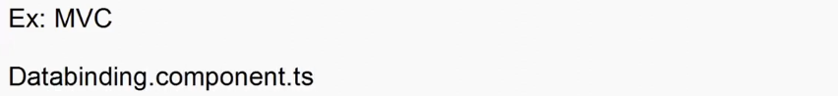

import { Component } from '@angular/core';

import { ProductContract } from '../../contracts/ProductContract';

@Component({

  selector: 'app-data-binding',

  templateUrl: './data-binding.component.html',

  styleUrl: './data-binding.component.css'

})

export class DataBindingComponent {

  public Product:ProductContract={

    Name: "",

    Price: 0,

    Stock: false,

    ShippedTO: ""

  }

  public UpdatedProduct:ProductContract={

    Name: "",

    Price: 0,

    Stock: false,

    ShippedTO: ""

  }

  public RegisterClick():void{

    this.UpdatedProduct=this.Product;

  }

}



<div class="container-fluid">

    <div class="row">

        <div class="col-3">

             <h2>Register Product</h2>

             <dl>

                <dt>Name</dt>

                <dd><input type="text" [(ngModel)]="Product.Name" class="from-control"></dd>

                <dt>Price</dt>

                <dd><input type="text" [(ngModel)]="Product.Price" class="from-control"></dd>

                <dt>Stock</dt>

                <dd class="form-switch"><input type="checkbox" [(ngModel)]="Product.Stock" class="form-check-input">Available</dd>

                <dt>Shipped to</dt>

                <dd >

                    <select [(ngModel)]="Product.ShippedTO" class="form-select">

                        <option>Delhi</option>

                        <option>Pune</option>

                        <option>Mumbai</option>

                    </select>

                </dd>

             </dl>

             <button (click)="RegisterClick()" class="btn btn-primary w-100">Register</button>

        </div>

        <div class="col-9 ">

            <h2>Details</h2>

            <dl>

                <dt>Name</dt>

                <dd [innerText]="UpdatedProduct.Name"></dd>

                <dt>Price</dt>

                <dd> {{UpdatedProduct.Price}}</dd>

                <dt>Stock</dt>

                <dd>{{(UpdatedProduct.Stock)==true?"Available":"Out of Stock"}}</dd>

                <dt>Shipped to</dt>

                <dd [innerText]="UpdatedProduct.ShippedTO"></dd>

             </dl>

        </div>

    </div>

</div>

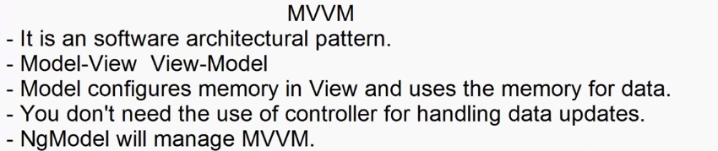

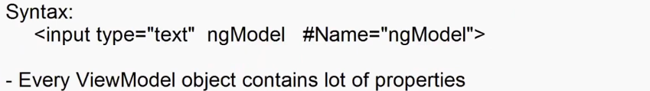

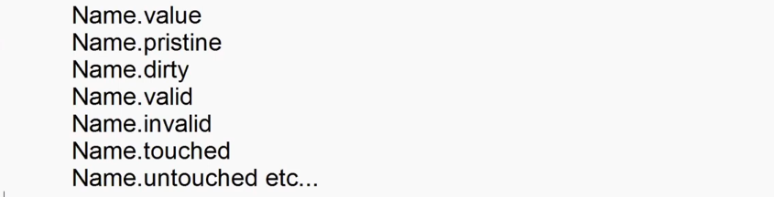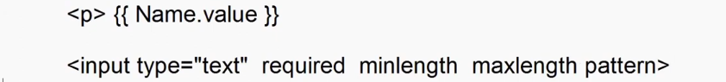

<div class="container-fluid">

    <div class="row">

        <div class="col-3">

             <h2>Register Product</h2>

             <dl>

                <dt>Name</dt>

                <dd><input type="text" ngModel #Name="ngModel" class="from-control"></dd>

                <dt>Price</dt>

                <dd><input type="text" ngModel #Price="ngModel" class="from-control"></dd>

                <dt>Stock</dt>

                <dd class="form-switch"><input ngModel #Stock="ngModel" type="checkbox"  class="form-check-input">Available</dd>

                <dt>Shipped to</dt>

                <dd >

                    <select ngModel #ShippedTO="ngModel" class="form-select">

                        <option>Delhi</option>

                        <option>Pune</option>

                        <option>Mumbai</option>

                    </select>

                </dd>

             </dl>

        </div>

        <div class="col-9 ">

            <h2>Details</h2>

            <dl>

                <dt>Name</dt>

                <dd>{{Name.value}}</dd>

                <dt>Price</dt>

                <dd>{{Price.value}}</dd>

                <dt>Stock</dt>

                <dd>{{(Stock.value==true)?"Available":"Out of Stock"}}</dd>

                <dt>Shipped to</dt>

                <dd>{{ShippedTO.value}}</dd>

             </dl>

        </div>

    </div>

</div>

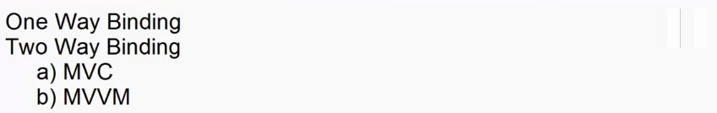

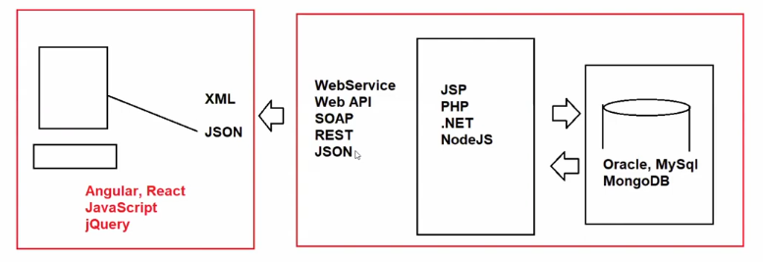

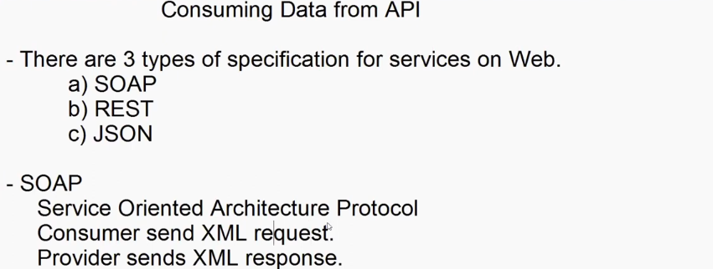

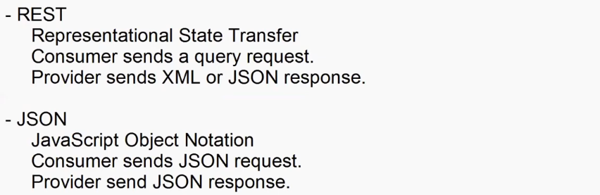

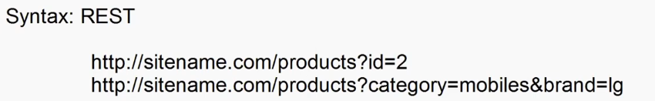



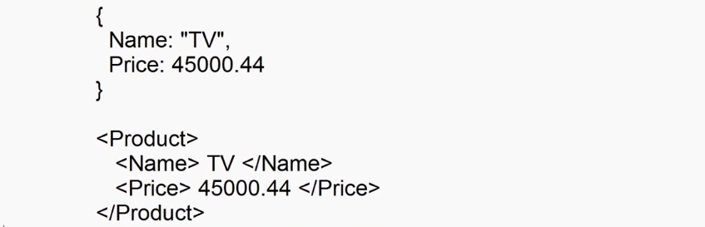

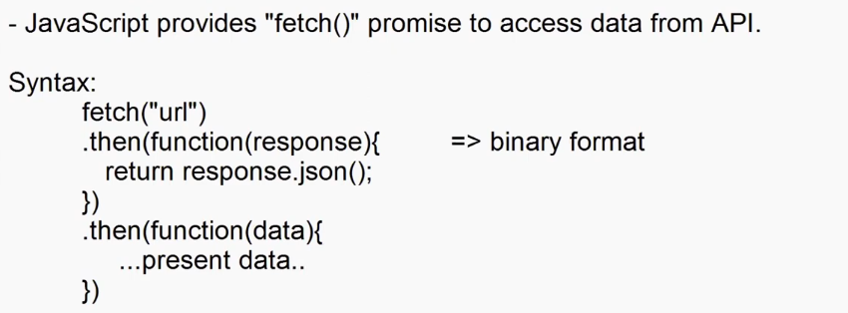

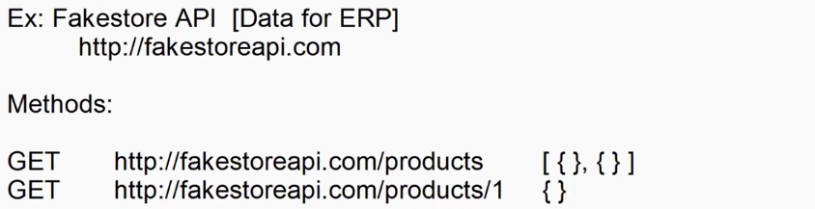

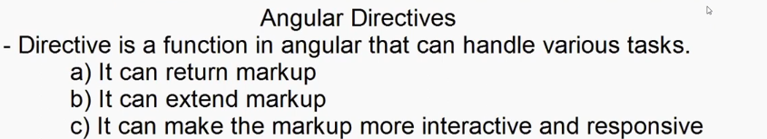

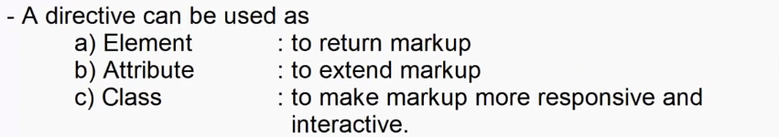

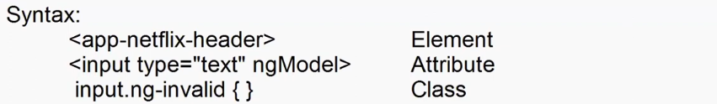

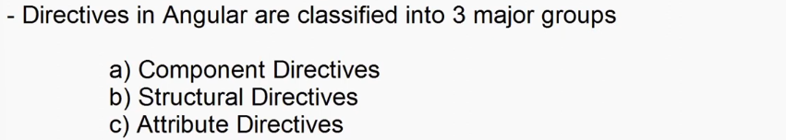

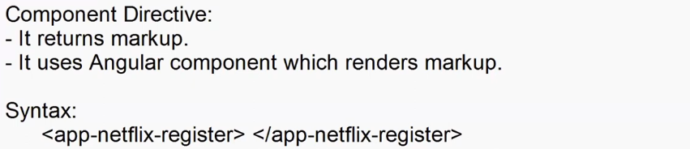

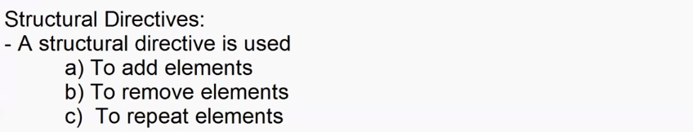

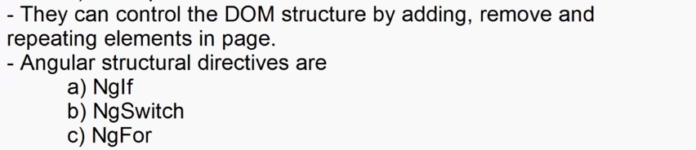

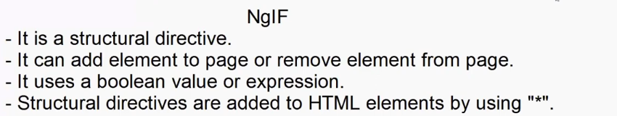

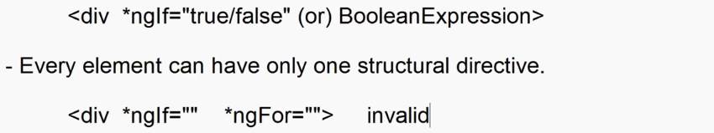

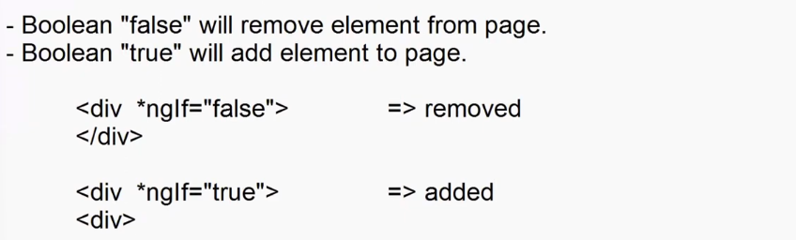



export interface FakeStoreProductContract{

    id:number;

    title:string;

    price:number;

    description:string;

    category:string;

    image:string;

    rating:{rate:number,count:number}

}

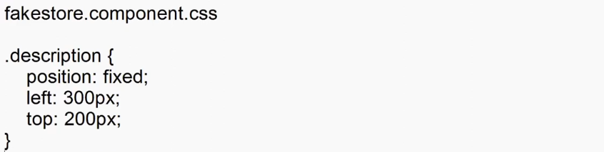

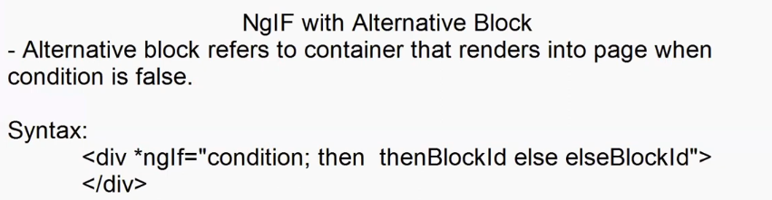

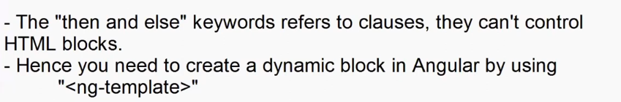

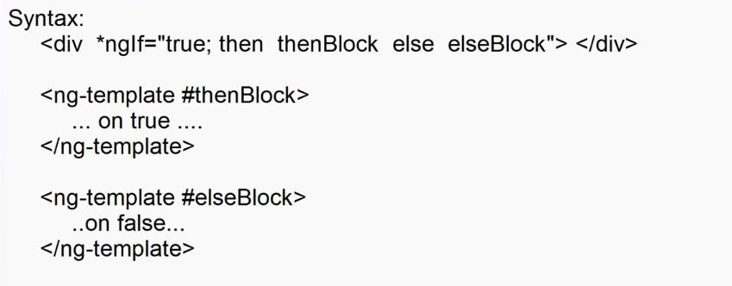



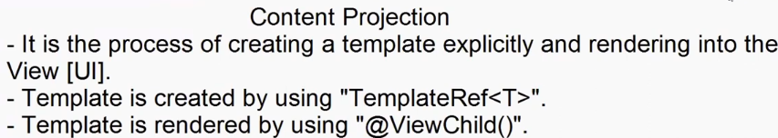

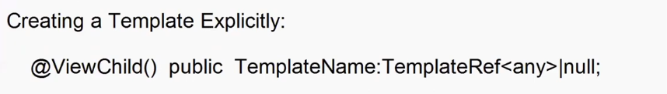



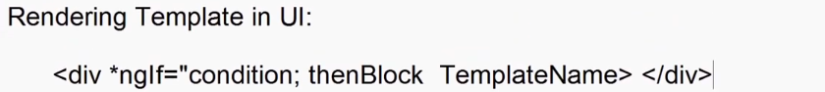

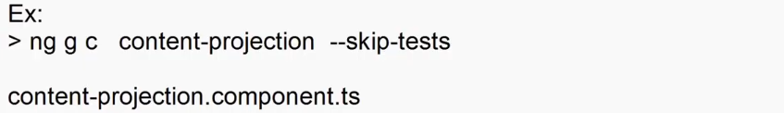

import { Component,OnInit,TemplateRef,ViewChild,viewChild } from '@angular/core';

@Component({

  selector: 'app-content-projection',

  templateUrl: './content-projection.component.html',

  styleUrl: './content-projection.component.css'

})

export class ContentProjectionComponent implements OnInit {

  constructor(){}

  public ThenBlock: TemplateRef<any> | null = null;

  public TemplateName : string = "choose Template";

  @ViewChild('Template1',{static:true}) public Template1:TemplateRef<any>|null =null;

  @ViewChild('Template2',{static:true}) public Template2:TemplateRef<any>|null =null;

  @ViewChild('Template3',{static:true}) public Template3:TemplateRef<any>|null =null;

  ngOnInit(): void {

    this.ThenBlock = this.Template1;

  }

  public TemplateChange():void{

    switch(this.TemplateName){

      case "Template1":

        this.ThenBlock = this.Template1;

        break;

      case "Template2":

        this.ThenBlock = this.Template2;

        break;

      case "Template3":

        this.ThenBlock = this.Template3;

        break;

    }

  }

}



<div class="container-fluid">

  <h2>Content Projection</h2>

  <div>

      <select (change)="TemplateChange()" [(ngModel)]="TemplateName">

        <option selected>Choose Option</option>

        <option value="Template1">Template1</option>

        <option value="Template2">Template2</option>

        <option value="Template3">Template3</option>

      </select>

  </div>

  <div *ngIf="true; then ThenBlock"></div>

  <ng-template #Template1> Template-1 </ng-template>

  <ng-template #Template2> Template-2 </ng-template>

  <ng-template #Template3> Template-3 </ng-template>

</div>

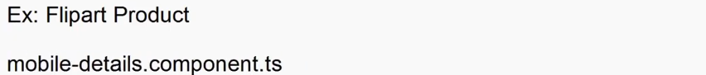

import { Component,OnInit,TemplateRef,ViewChild } from '@angular/core';

import { tick } from '@angular/core/testing';

@Component({

  selector: 'app-mobile-details',

  templateUrl: './mobile-details.component.html',

  styleUrl: './mobile-details.component.css'

})

export class MobileDetailsComponent implements OnInit {

  constructor(){}

  public ThenBlock : TemplateRef<any>|null = null;

  @ViewChild('View1',{static : true}) public View1 : TemplateRef<any>|null = null;

  @ViewChild('View2',{static : true}) public View2 : TemplateRef<any>|null = null;

  @ViewChild('View3',{static : true}) public View3 : TemplateRef<any>|null = null;

  @ViewChild('View4',{static : true}) public View4 : TemplateRef<any>|null = null;

  @ViewChild('View5',{static : true}) public View5 : TemplateRef<any>|null = null;

  @ViewChild('View6',{static : true}) public View6 : TemplateRef<any>|null = null;

  ngOnInit(): void {

    this.ThenBlock=this.View1;

  }

  public ChangeView(View:String)

  {

    switch(View){

      case "View1":

        this.ThenBlock = this.View1;

        break;

      case "View2":

        this.ThenBlock = this.View2;

        break;

      case "View3":

        this.ThenBlock = this.View3;

        break;

      case "View4":

        this.ThenBlock = this.View4;

        break;

      case "View5":

        this.ThenBlock = this.View5;

        break;

      case "View6":

        this.ThenBlock = this.View6;

        break;

    }

  }

}



nav div{

    border: 2px solid blue;

    margin-bottom: 20px;

    padding:5px;

    width: 65px;

    height: 65px;

}

nav{

    border: 1px solid black;

    width: 85px;

    padding: 10px;

}

nav div:hover{

    cursor: pointer;

}



<div class="container-fluid">

  <div class="row mt-3">

    <div class="col-2">

      <nav>

        <div (mouseover)="ChangeView('View1')">

          <img src="assets/View1.png" width="50" height="50" />

        </div>

        <div (mouseover)="ChangeView('View2')">

          <img src="assets/View2.png" width="50" height="50" />

        </div>

        <div (mouseover)="ChangeView('View3')">

          <img src="assets/View3.png" width="50" height="50" />

        </div>

        <div (mouseover)="ChangeView('View4')">

          <img src="assets/View4.png" width="50" height="50" />

        </div>

        <div (mouseover)="ChangeView('View5')">

          <img src="assets/View5.png" width="50" height="50" />

        </div>

        <div (mouseover)="ChangeView('View6')">

          <img src="assets/View6.png" width="50" height="50" />

        </div>

      </nav>

    </div>

    <div class="col-4">

      <div *ngIf="true; then ThenBlock"></div>

      <ng-template #View1>

        <img src="assets/View1.png" width="500" height="500" />

      </ng-template>

      <ng-template #View2>

        <img src="assets/View2.png" width="500" height="500" />

      </ng-template>

      <ng-template #View3>

        <img src="assets/View3.png" width="500" height="500" />

      </ng-template>

      <ng-template #View4>

        <img src="assets/View4.png" width="500" height="500" />

      </ng-template>

      <ng-template #View5>

        <img src="assets/View5.png" width="500" height="500" />

      </ng-template>

      <ng-template #View6>

        <img src="assets/View6.png" width="500" height="500" />

      </ng-template>

    </div>

    <div class="col-6">

      <div>

        <div>

          <h3>Apple iPhone 15 (Black, 128 GB)</h3>

        </div>

        <div class="mt-3">

          <span class="bg-success p-2 rounded rounded-2"

            ><span class="bi bi-star-fill text-success text-white">4.633</span>

          </span>

          <span class="ms-3">826 Ratings & 1,987 Reviews</span>

        </div>

        <div>

          <div class="mt-3">

            <span

              ><h3>₹70,999</h3>

              <del>₹79900 </del>11% off

            </span>

          </div>

          <div>

            <ul class="list-unstyled">

              <li>

                <span class="bi bi-tag-fill text-success"> </span> Bank OfferGet

                ₹50 instant discount on first Flipkart UPI txn on order of ₹200

                and above

              </li>

              <li>

                <span class="bi bi-tag-fill text-success"></span>

                Bank Offer5% Cashback on Flipkart Axis Bank CardT&C

              </li>

              <li>

                <span class="bi bi-tag-fill text-success"></span>

                Bank Offer₹4000 Off On ICICI Bank Credit Non EMI, Credit and

                Debit Card EMI TransactionsT&C

              </li>

              <li>

                <span class="bi bi-tag-fill text-success"> </span>Special

                PriceGet extra ₹6901 off (price inclusive of cashback/coupon)T&C

              </li>

            </ul>

          </div>

        </div>

      </div>

    </div>

  </div>

</div>

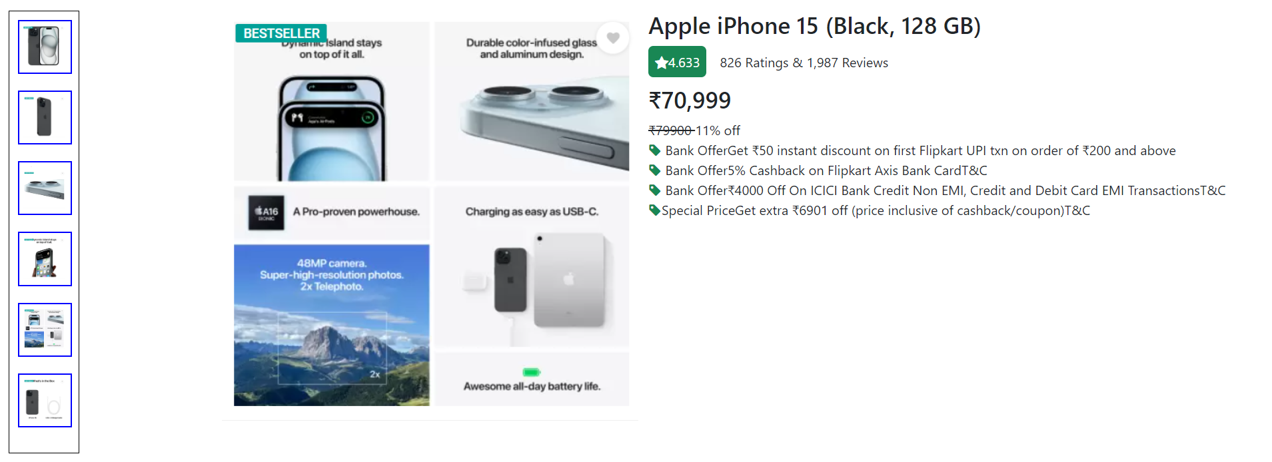

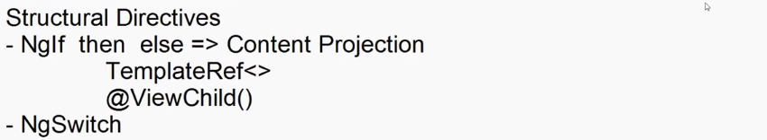

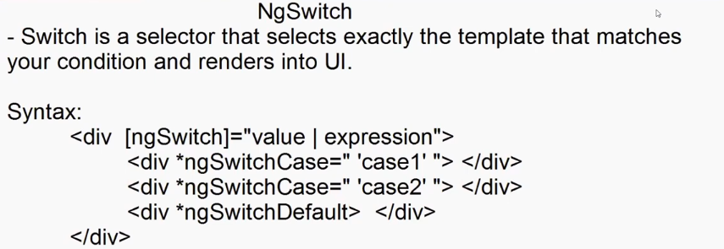



import { Component } from '@angular/core';

@Component({

  selector: 'app-product-details',

  templateUrl: './product-details.component.html',

  styleUrl: './product-details.component.css'

})

export class ProductDetailsComponent {

  public ViewName : string = 'View1';

  ViewClick(Viewname: string) {

    this.ViewName = Viewname;

    }

}



<div class="container-fluid">

  <div class="row mt-4">

    <div class="col-2">

      <div class="btn-group-vertical">

        <button (click)="ViewClick('View1')" class="btn btn-primary w-100 mb-2">

          Basic Details

        </button>

        <button (click)="ViewClick('View2')" class="btn btn-primary w-100 mb-2">

          Preview

        </button>

        <button (click)="ViewClick('View3')" class="btn btn-primary w-100">

          Description

        </button>

      </div>

      <div class="mt-4">

        <select [(ngModel)]="ViewName" class="form-select">

          <option value="Info">Select Info</option>

          <option value="View1">Basic Details</option>

          <option value="View2">Preview</option>

          <option value="View3">Description</option>

        </select>

      </div>

    </div>

    <div class="col-10">

      <div [ngSwitch]="ViewName">

        <div *ngSwitchCase="'View1'">

          <div>

            <h3>Apple iPhone 15 (Black, 128 GB)</h3>

          </div>

          <div class="mt-3">

            <span class="bg-success p-2 rounded rounded-2"

              ><span class="bi bi-star-fill text-success text-white"

                >4.633</span

              >

            </span>

            <span class="ms-3">826 Ratings & 1,987 Reviews</span>

          </div>

          <div>

            <div class="mt-3">

              <span

                ><h3>₹70,999</h3>

                <del>₹79900 </del>11% off

              </span>

            </div>

            <div>

              <ul class="list-unstyled">

                <li>

                  <span class="bi bi-tag-fill text-success"> </span> Bank

                  OfferGet ₹50 instant discount on first Flipkart UPI txn on

                  order of ₹200 and above

                </li>

                <li>

                  <span class="bi bi-tag-fill text-success"></span>

                  Bank Offer5% Cashback on Flipkart Axis Bank CardT&C

                </li>

                <li>

                  <span class="bi bi-tag-fill text-success"></span>

                  Bank Offer₹4000 Off On ICICI Bank Credit Non EMI, Credit and

                  Debit Card EMI TransactionsT&C

                </li>

                <li>

                  <span class="bi bi-tag-fill text-success"> </span>Special

                  PriceGet extra ₹6901 off (price inclusive of

                  cashback/coupon)T&C

                </li>

              </ul>

            </div>

          </div>

        </div>

        <div *ngSwitchCase="'View2'">

          <img src="assets/View1.png" width="500" height="500" />

        </div>

        <div *ngSwitchCase="'View3'">

          <div>

            <h3>Key Features</h3>

            <ul>

              <li>Display: 6.1 inches (15.54 cm), Super Retina XDR Display</li>

              <li>Memory: 128GB ROM</li>

              <li>Processor: Apple A16 Bionic Chip, Hexa Core</li>

              <li>Camera: 48 MP + 12 MP Dual Rear & 12 MP Front Camera</li>

              <li>Battery: 15W MagSafe Wireless Charging</li>

              <li>USP: Dynamic Island, IP68 Water Resistant</li>

            </ul>

          </div>

        </div>

        <div *ngSwitchDefault>

          <h4>Please Select View</h4>

        </div>

      </div>

    </div>

  </div>

</div>

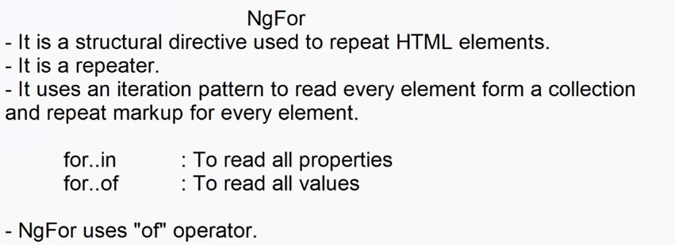





import { Component } from '@angular/core';

@Component({

  selector: 'app-for-demo',

  templateUrl: './for-demo.component.html',

  styleUrl: './for-demo.component.css'

})

export class ForDemoComponent {

  public Categories:string[] = ["All","Electronics","Footwear","Fashion"]

}



<div class="container-fluid">

  <div class="mt-4 row">

    <div class="col">

      <ol>

        <li *ngFor="let item of Categories">{{ item }}</li>

      </ol>

    </div>

    <div class="col">

      <select>

        <option *ngFor="let item of Categories">{{ item }}</option>

      </select>

    </div>

    <div class="col">

      <ul class="list-unstyled">

        <li *ngFor="let item of Categories"><input type="checkbox">{{item}}</li>

      </ul>

    </div>

    <div class="col">

      <div class="btn-group-vertical">

        <button class="btn btn-primary mt-2" *ngFor="let item of Categories">

            {{item}}

        </button>

      </div>

    </div>

    <div class="col">

        <div *ngFor="let item of Categories" >

            <a href="#">{{item}}</a>

        </div>

    </div>

    <div class="col">

        <table class="table table-hover table-dark">

            <thead>

                <tr>

                    <th>Categories</th>

                </tr>

            </thead>

            <tbody>

                <tr *ngFor="let item of Categories">

                    <td>{{item}}</td>

                </tr>

            </tbody>

        </table>

    </div>

  </div>

</div>



import { Component } from '@angular/core';

@Component({

  selector: 'app-for-demo',

  templateUrl: './for-demo.component.html',

  styleUrl: './for-demo.component.css'

})

export class ForDemoComponent {

  // public Categories:string[] = ["All","Electronics","Footwear","Fashion"]

  public Menu: { Category: string, Product: String[] }[] = [

    {

      Category: "Electronis",

      Product: ["Television", "Mobile"]

    },

    {

      Category: "Footwear",

      Product: ["Sneakers", "Boots", "Casulas"]

    }

  ]

  public Products:{Name:string, Price:number}[]=[

    {Name:"Samsung TV",Price: 45000.00},

    {Name:"Mobile",Price: 20000.00},

    {Name:"Nike Casuals",Price: 5300.00},

]

}



<div class="container-fluid">

    <div class="mt-4">

        <table class="table table-hover">

            <thead>

                <tr>

                    <th>Name</th>

                    <th>Price</th>

                </tr>

            </thead>

            <tbody>

                <tr *ngFor="let item of Products">

                    <th>{{item.Name}}</th>

                    <th>{{item.Price}}</th>

                </tr>

            </tbody>

        </table>

    </div>

  <div class="mt-4 row">

    <div class="col">

      <ol>

        <li *ngFor="let item of Menu">

          {{ item.Category }}

          <ul>

            <li *ngFor="let Product of item.Product">

              {{ Product }}

            </li>

          </ul>

        </li>

      </ol>

    </div>

    <div class="col">

      <select>

        <optgroup *ngFor="let item of Menu" [label]="item.Category">

          <option *ngFor="let product of item.Product">

            {{ product }}

          </option>

        </optgroup>

      </select>

    </div>

    <div class="col">

      <details *ngFor="let item of Menu">

            <summary>{{item.Category}}</summary>

            <ul>

                <li *ngFor="let product of item.Product">

                {{product}}</li>

            </ul>

      </details>

    </div>

  </div>

</div>

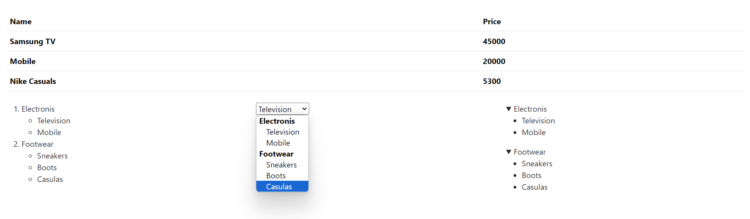



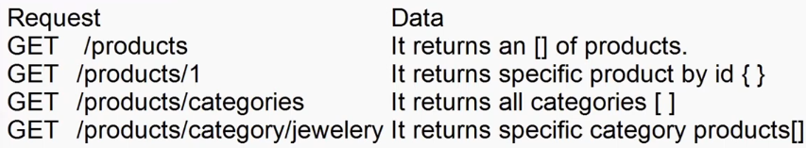

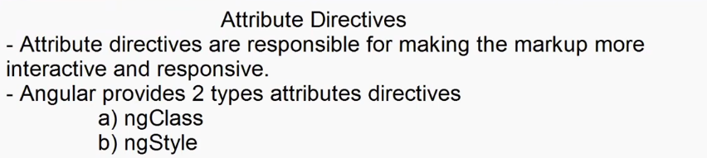

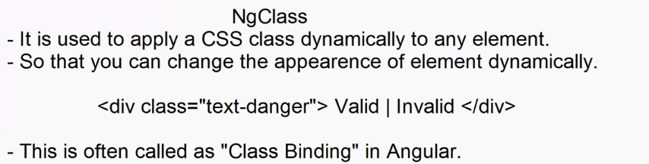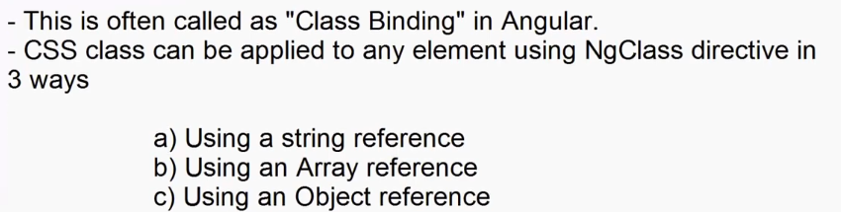

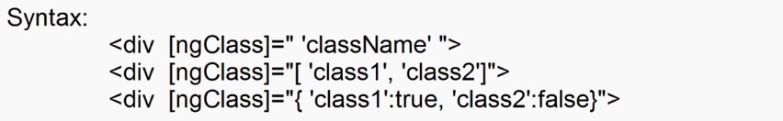

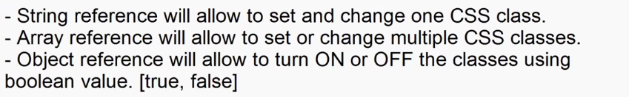



.bg-style{

    background-color: yellow;

}

.text-style{

    color: red;

    text-align: center;

    padding: 10px;

}

.border-style{

    border:2px solid red;

}



<div class="container-fluid">

    <h2>Class Binding</h2>

    <ul class="list-unstyled">

        <li><input ngModel #border="ngModel" type="checkbox">Border</li>

        <li><input ngModel #background="ngModel" type="checkbox">Background</li>

        <li><input ngModel #textEffect="ngModel" type="checkbox">Text Effect</li>

    </ul>

    <h1 [ngClass]="'bg-style'">Sample Text</h1>

    <h1 [ngClass]="['bg-style','text-style','border-style']">Sample Text</h1>

    <h1 [ngClass]="{'bg-style':background.value ,'text-style':textEffect.value, 'border-style':border.value}">Sample Text</h1>

</div>

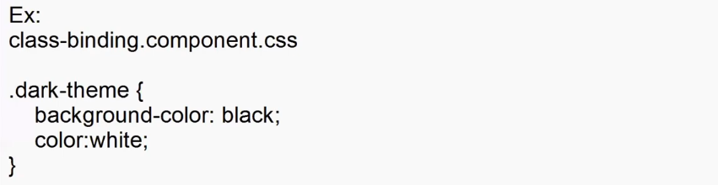

<div  class="container-fluid d-flex justify-content-center align-items-center" style="height: 500px" >

  <div>

    <div class="form-switch">

      <input type="checkbox" ngModel #darkTheme="ngModel" class="form-check-input"/>

    </div>

    <form class="border border-2 p-2" [ngClass]="{ 'dark-theme': darkTheme.value }">

      <h2><span class="bi bi-person-fill"></span>User Login</h2>

      <dl>

        <dt>User Name</dt>

        <dd><input type="text" class="form-control" /></dd>

        <dt>Password</dt>

        <dd><input type="password" class="form-control" /></dd>

      </dl>

      <button type="button" class="btn btn-dark w-100 e" [ngClass]="{ 'bg-white': darkTheme.value, 'text-dark': darkTheme.value}">Login</button>

    </form>

  </div>

</div>

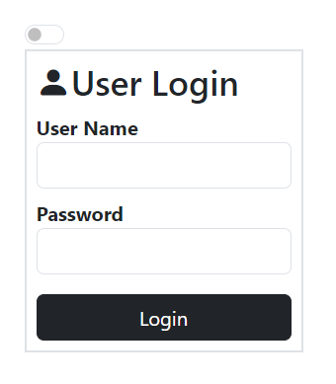

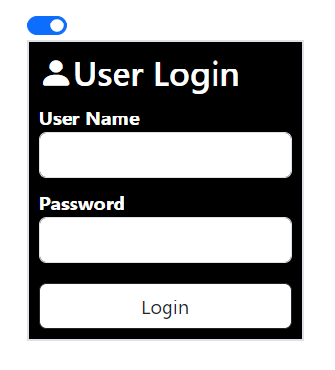

      <dl>

        <dt>User Name</dt>

        <dd><input [ngClass]="{'bg-danger':Username.invalid}" ngModel #Username="ngModel" name="Username" type="text" class="form-control"  required minlength="4"/></dd>

        <dt>Password</dt>

        <dd><input type="password" ngModel #Password="ngModel" class="form-control" /></dd>

      </dl>

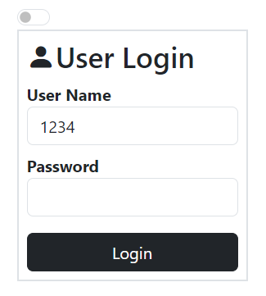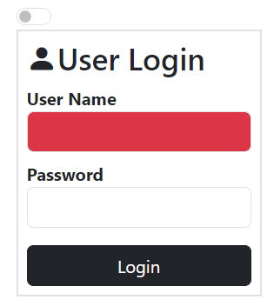

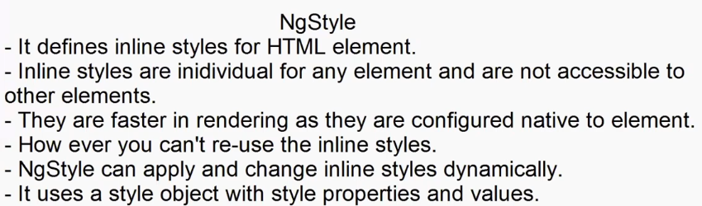

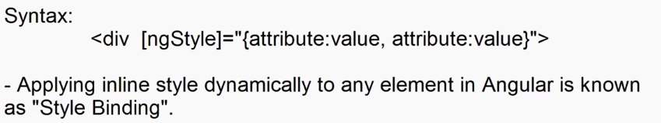



import { Component } from '@angular/core';

@Component({

  selector: 'app-class-binding',

  templateUrl: './class-binding.component.html',

  styleUrl: './class-binding.component.css'

})

export class ClassBindingComponent {

  public bgStyle:string = 'red';

  public textStyle:string = 'white';

  public padding:string="0px";

  public fontSize:string="0px";

  public ApplyClick(){

    this.styleObject = {

      "background-color":this.bgStyle,

      "color":this.textStyle,

      "padding":this.padding+ "px",

      "fontSize":this.fontSize+"px"

    }

  }

  public FontChange(){

    this.styleObject = {

      "background-color":this.bgStyle,

      "color":this.textStyle,

      "padding":this.padding+ "px",

      "fontSize":this.fontSize+"px"

    }

  }

  public styleObject:{'background-color':string , 'color': string, 'padding':string, 'fontSize':string }={

    "background-color":"red",

    "color":"white",

    "padding":"10px",

    "fontSize":"11px"

  }

}



<div class="container">

    <h1>Select Styles</h1>

    <dl>

        <dt>Background</dt>

        <dd>

            <select [(ngModel)]="bgStyle" >

                <option value="red">Red</option>

                <option value="black">black</option>

                <option value="white">white</option>

                <option value="yellow">Yellow</option>

            </select>

        </dd>

    </dl>

    <dl>

        <dt>Text Color</dt>

        <dd>

            <select [(ngModel)]="textStyle">

                <option value="red">Red</option>

                <option value="green">Green</option>

                <option value="blue">Blue</option>

                <option value="yellow">Yellow</option>

            </select>

        </dd>

        <dt>Padding</dt>

        <dd>

           1px <input [(ngModel)]="padding" type="range" value="1" min="1" max="50"> 50px

        </dd>

        <dd>

           10px <input (change)="FontChange()" [(ngModel)]="fontSize" type="range" value="10" min="10" max="50"> 50px

        </dd>

    </dl>

    <dd><button (click)="ApplyClick()" class="btn btn-primary">Apply</button></dd>

    <div  class="container-fluid d-flex justify-content-center align-items-center" style="height: 500px" >

        <h1 [ngStyle]="styleObject">Welcome to Angular</h1>

    </div>

</div>

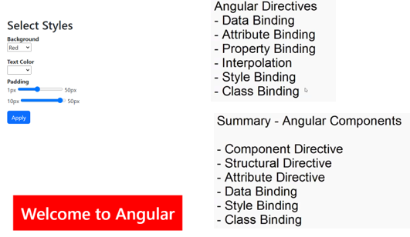

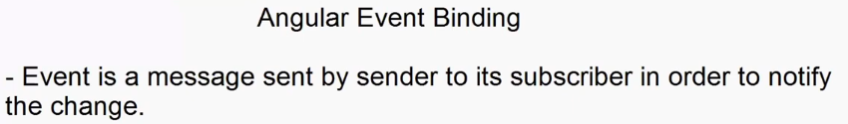

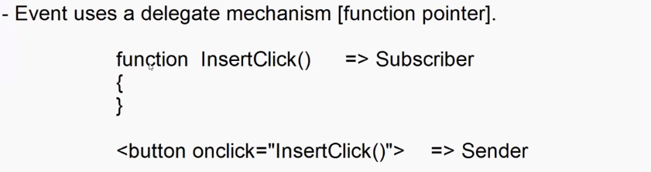

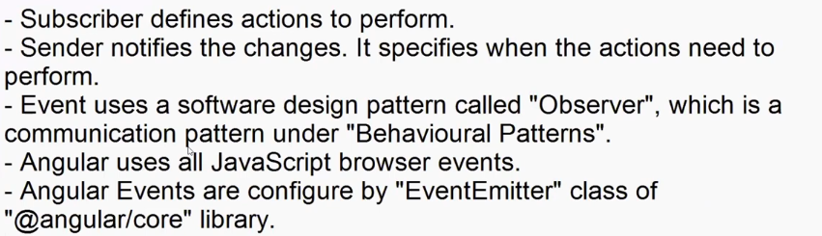

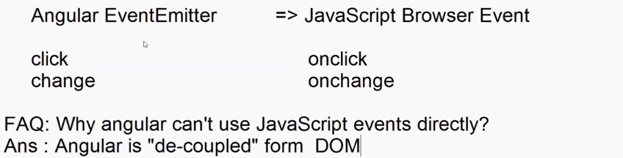

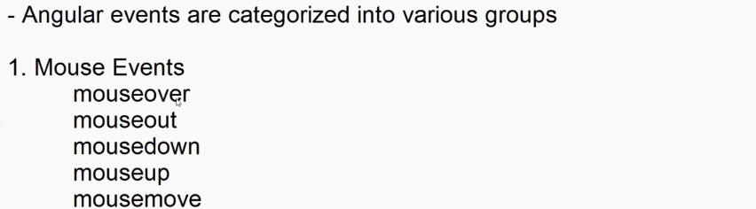

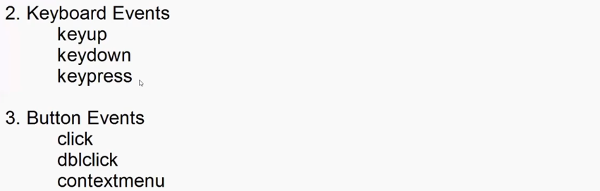

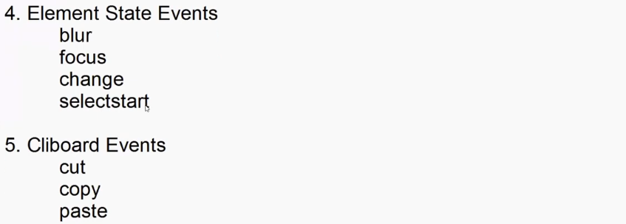

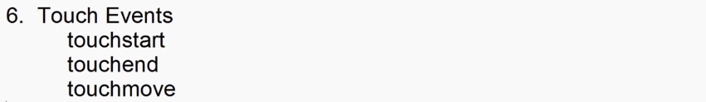

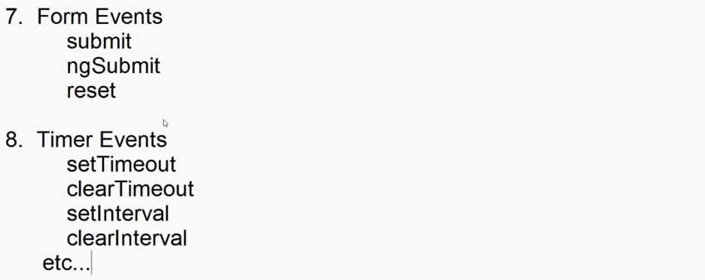

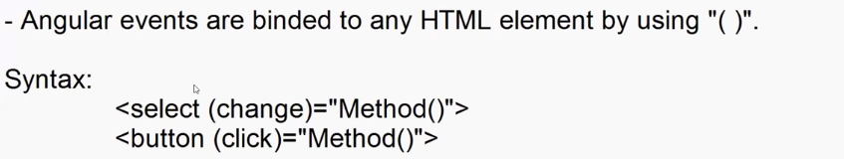

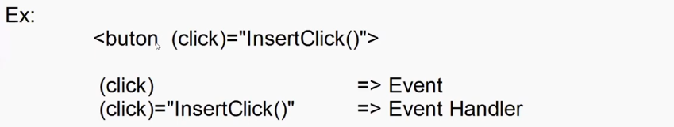

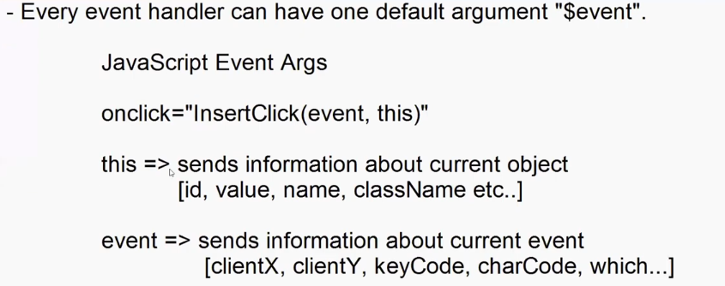



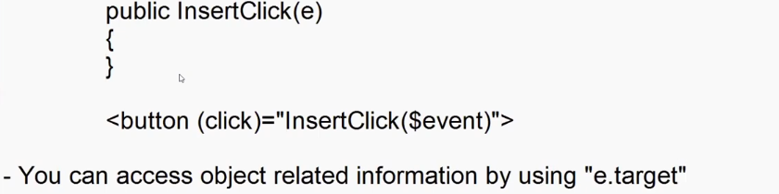



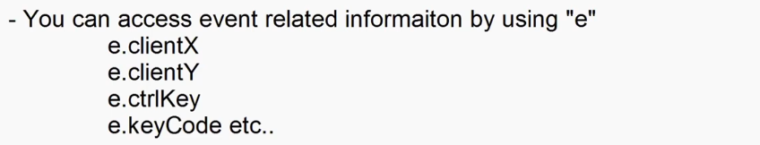



import { Component } from '@angular/core';

@Component({

  selector: 'app-event-binding',

  templateUrl: './event-binding.component.html',

  styleUrl: './event-binding.component.css'

})

export class EventBindingComponent {

 public InsertClick(e: any):void {

    document.write(`

      Button Id    : ${e.target.id} <br>

      Button Name  : ${e.target.name} <br>

      Button Class : ${e.target.className} <br>

      X Position   : ${e.clientX} <br>

      Ctrl Key     : ${e.ctrlKey}

    `);

    }

}



 <div class="container-fluid">

    <h2>Event Binding</h2>

    <button (click)="InsertClick($event)" id="btnInsert" name="InsertButton" class="btn btn-primary">Insert</button>

 </div>

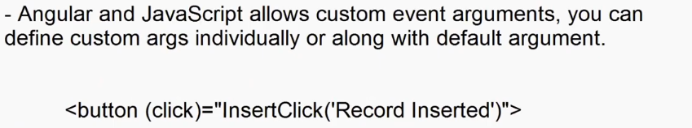

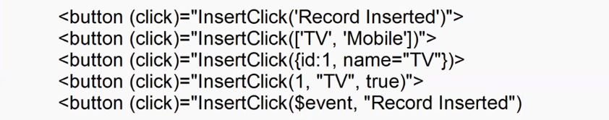

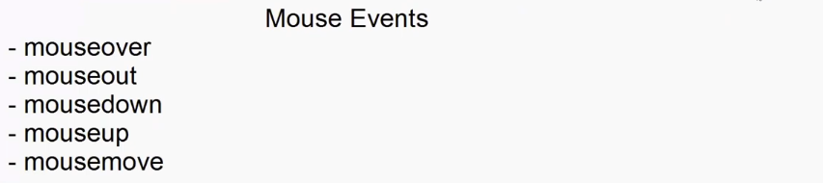



import { Component } from '@angular/core';

@Component({

  selector: 'app-event-binding',

  templateUrl: './event-binding.component.html',

  styleUrl: './event-binding.component.css'

})

export class EventBindingComponent {

    public img_src = "assets/shoe.png";

    public styleObject:{position:string,left:string,top:string}={

      position:'',

      left:'',

      top:''

    }

    public changeColor(e:any){

      this.img_src = `assets/shoe${e.target.name}.png`

    }

    public MouseMove(e:any)

    {

      this.styleObject={

        position:'fixed',

        left:e.clientX+'px',

        top:e.clientY+'px'

      }

    }

}



 <div class="container-fluid" (mousemove)="MouseMove($event)">

   <h2>Shoe</h2>

   <img width="200" [src]="img_src" height="100">

      <div class="mt-2">

         <div class="btn-group">

         <button (mouseover)="changeColor($event)" name="" class="text-dark" style="background-color: white;">White</button>

         <button (mouseover)="changeColor($event)" name="Red" class="text-white" style="background-color: red;">Red</button>

         <button (mouseover)="changeColor($event)" name="Green" class="text-white" style="background-color: green;">Green</button>

         <button (mouseover)="changeColor($event)" name="Blue" class="text-white" style="background-color: blue;">Blue</button>

      </div>

   </div>

   <div style="height: 1000px;"></div>

      <img src="assets/flag.gif" [ngStyle]="styleObject" width="50" height="50">

 </div>

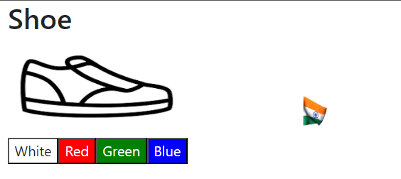

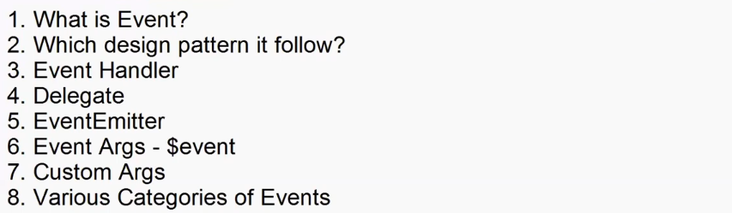

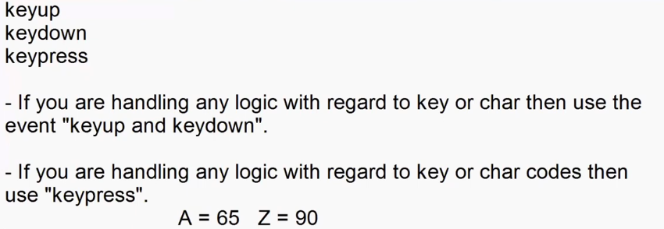





public user:any[]=[

    {Username:'adesh'},

    {Username:'adesh12'},

    {Username:'ad_mh'},

    {Username:'david'}

  ];

  public UserError:string = '';

  public isInValid:boolean = false;

  public capsOn:boolean = false;

  public VerifyUser(e:any){

    for(var user of this.user)

      {

        if(user.Username==e.target.value)

          {

            this.UserError = 'User Name Taken';

            this.isInValid=true;

            break;

          }

          else{

            this.UserError="Username available";

            this.isInValid=false;

          }

      }

  }

  public CapsOn(e:any) {

    if(e.keyCode>=65 && e.keyCode<=95)

      {

        this.capsOn=true;

      }

      else{

        this.capsOn=false;

      }

  }



    <div class="container-fluid">

      <h2>Register User</h2>

      <dl>

         <dt>User Name</dt>

         <dd><input type="text" [ngClass]="{ 'text-danger':isInValid,'text-success':true,}"  (keyup)="VerifyUser($event)"></dd>

         <dd [ngClass]="{ 'text-danger':isInValid,'text-success':true,}" >{{UserError}}</dd>

         <dt>Password</dt>

         <dd><input (keypress)="CapsOn($event)"  type="password"></dd>

         <dd *ngIf="capsOn" class="text-warning">

            <span class="bi bi-exclamation-triangle-fill"></span>Caps ON

         </dd>

      </dl>

    </div>

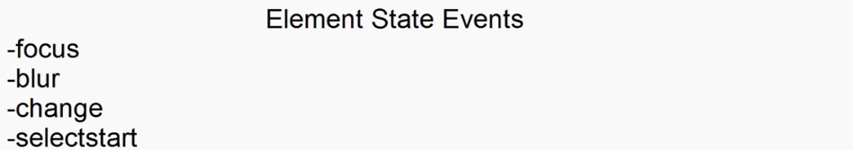



  verifyRequired(e:any) {

    if(e.target.value==""){

      this.UserError="Username Required";

      this.isInValid=true;

    }

    else{

      if(this.isInValid==false)

        {

          this.UserError="";

        }

    }

  }



<dd><input type="text" (blur)="verifyRequired($event)" [ngClass]="{ 'text-danger':isInValid,'text-success':true,}"  (keyup)="VerifyUser($event)"></dd>

**Emi-component.html**

<div class="container-fluid">

    <h2 class="text-center">Personal Loan EMI Calculator</h2>

    <div class="border border-2 border-dark p-3">

        <div class="row">

            <div class="col">

                Amount you need &#8377; <input type="text" [value]="p" >

            </div>

            <div class="col">

                For <input type="text" size="4" [value]="n" > years

            </div>

            <div class="col">

                Interest rate <input type="text" size="4" [value]="r" > %

            </div>

        </div>

        <div class="row mt-4">

            <div class="col">

                &#8377; 10,000 <input (change)="AmountChange($event)" type="range" value="10000" min="10000" max="1000000" > &#8377; 10,00,000

            </div>

            <div class="col">

                1 <input (change)="YearChange($event)" type="range" value="1" min="1" max="5"> 5

            </div>

            <div class="col">

                10.25% <input (change)="RateChange($event)" type="range" value="10.25" step="0.1" min="10.25" max="18.45"> 18.45 %

            </div>

        </div>

        <div class="row mt-4">

            <div class="col text-center">

                <button (click)="CalculateClick()" class="btn btn-primary">Calculate</button>

            </div>

        </div>

        <h1 class="text-center mt-4">

            Your monthly installment is <span class="text-primary">{{emi | currency:'INR'}}</span> for {{n}} years.

        </h1>

    </div>

</div>

Emi-component.ts

import { Component } from '@angular/core';

@Component({

  selector: 'app-emi',

  templateUrl: './emi.component.html',

  styleUrl: './emi.component.css'

})

export class EmiComponent {

  public p:number = 10000;

  public r:number = 10.25;

  public n:number = 1;

  public emi:number = 0;

  public AmountChange(e:any) {

    this.p = e.target.value;

  }

 public YearChange(e:any) {

    this.n = e.target.value;

  }

  public RateChange(e:any) {

    this.r = e.target.value;

  }

  public CalculateClick(){

    var n = this.n*12;

    var r = this.r/12/100;

    this.emi = this.p * r * Math.pow(1+r,n)/Math.pow(1+r,n)-1;

    // this.emi = Math.round(this.emi);

  }  
}

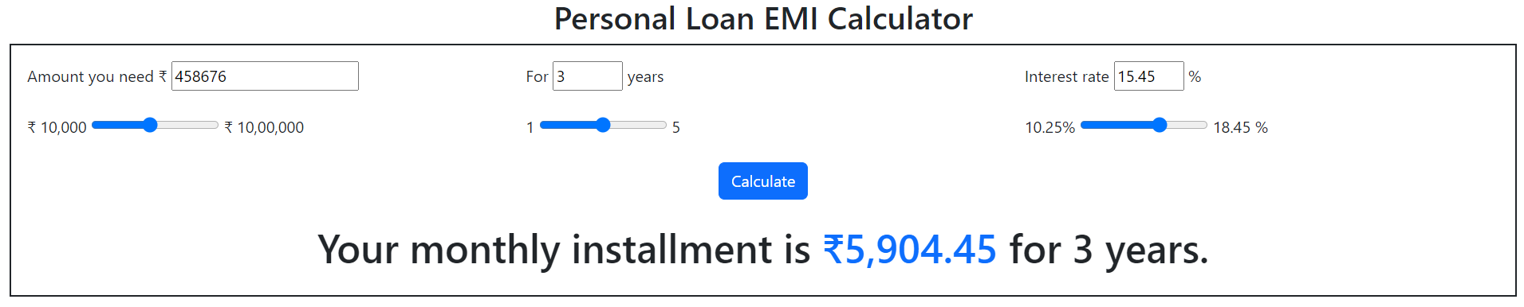

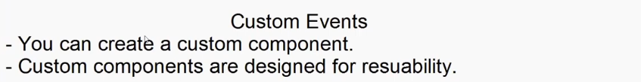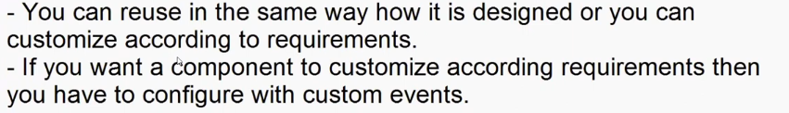

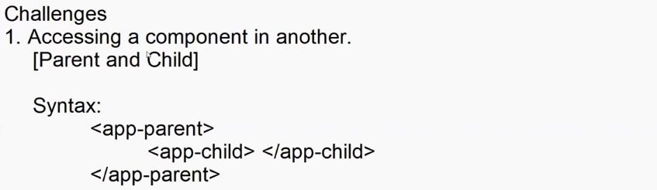



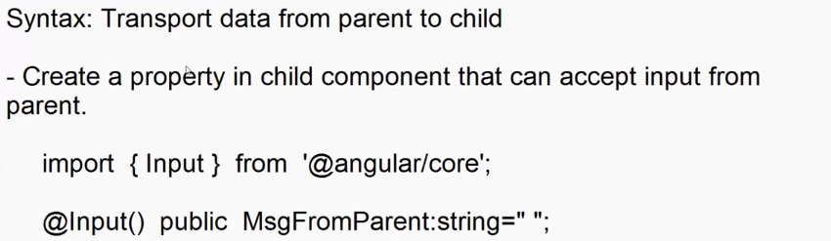









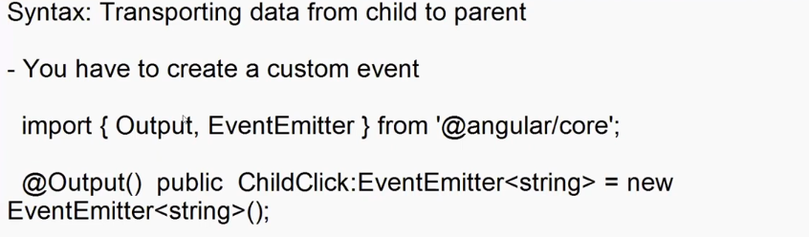

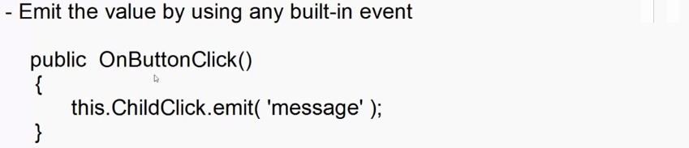

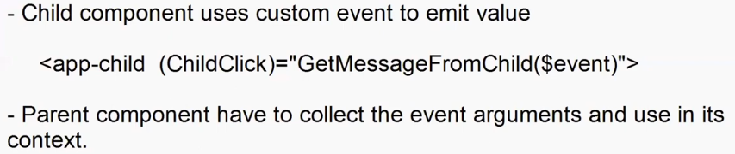

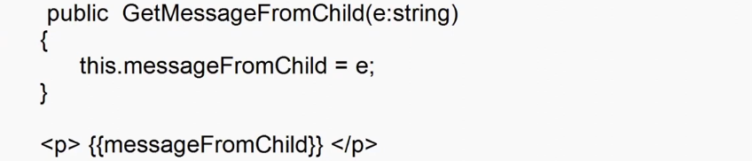

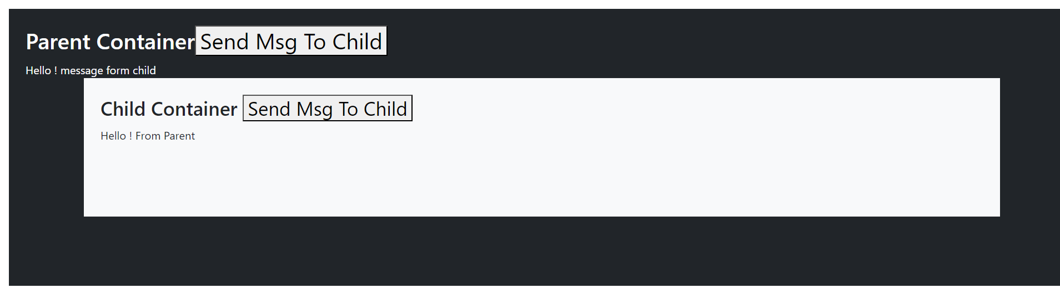



import { Component, Input, EventEmitter, Output  } from '@angular/core';

@Component({

  selector: 'app-child',

  templateUrl: './child.component.html',

  styleUrl: './child.component.css'

})

export class ChildComponent {

  @Input() public MSGFromParent:string = '';

  @Output() public ChildClick:EventEmitter<string> = new EventEmitter<string>();

  public ChildButtomClick(){

    this.ChildClick.emit('Hello ! message form child');

  }

}



<div class="container p-4 bg-light text-dark" style="height: 200px;">

    <h3>Child Container <button (click)="ChildButtomClick()">Send Msg To Child</button></h3>

    {{MSGFromParent}}

</div>



<div class="container-fluid m-3 p-4 bg-dark text-white" style="height: 400px;">

    <h2>Parent Container<button (click)="SendClick()">Send Msg To Child</button></h2>

    {{msgFromChild}}

    <app-child [MSGFromParent]="msg" (ChildClick)="GetMessageFromChild($event)"></app-child>

</div>



import { Component } from '@angular/core';

@Component({

  selector: 'app-parent',

  templateUrl: './parent.component.html',

  styleUrl: './parent.component.css'

})

export class ParentComponent {

  public msg = '';

  public msgFromChild:string = '';

  public SendClick(){

    this.msg = "Hello ! From Parent";

  }

  public GetMessageFromChild(e:string){

    this.msgFromChild=e;

  }

}

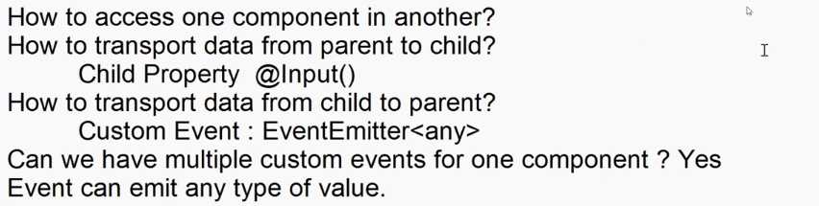

**filter.component.ts**

import { Component, EventEmitter, Input, Output } from '@angular/core';

@Component({

  selector: 'app-filter',

  templateUrl: './filter.component.html',

  styleUrl: './filter.component.css'

})

export class FilterComponent {

  @Input() public AllCount:number = 0;

  @Input() public ElectronicCount:number = 0;

  @Input() public JewelleryCount:number = 0;

  @Input() public MensCount:number = 0;

  @Input() public WomensCount:number = 0;

  public CategoryName:string = 'all';

  @Output() public CategoryChanged:EventEmitter<string> = new EventEmitter<string>();

  @Output() public SendClick:EventEmitter<any> = new EventEmitter<any>();

  public SendCategoryName(e:any) {

    this.CategoryChanged.emit(e.target.value);

  }

  public SendClickButton(e:any) {

    this.SendClick.emit({name:'samsung tv', price:'10000'});

  }

}

**Filter.component.html**<h3>Filter Products</h3>

<ul class="list-unstyled">

    <li class="d-flex justify-content-between mb-2"> <span><input type="radio" value="all" (change)="SendCategoryName($event)" class="form-check-input" name="category">All</span> <span class="badge bg-primary">{{AllCount}}</span></li>

    <li class="d-flex justify-content-between mb-2"> <span><input type="radio"  value="electronics" (change)="SendCategoryName($event)"  class="form-check-input" name="category">Electronics</span> <span class="badge bg-primary">{{ElectronicCount}}</span></li>

    <li class="d-flex justify-content-between mb-2"> <span><input type="radio"  value="jewelery" (change)="SendCategoryName($event)" class="form-check-input" name="category">Jewellery</span> <span class="badge bg-primary">{{JewelleryCount}}</span></li>

    <li class="d-flex justify-content-between mb-2"> <span><input type="radio"  value="men's clothing" (change)="SendCategoryName($event)" class="form-check-input" name="category">Men's Clothing</span> <span class="badge bg-primary">{{MensCount}}</span></li>

    <li class="d-flex justify-content-between"> <span><input type="radio"  value="women's clothing" (change)="SendCategoryName($event)" class="form-check-input" name="category">Women's Clothing</span> <span class="badge bg-primary">{{WomensCount}}</span></li>

</ul>

<button (click)="SendClickButton($event)">Send</button>

**Products-data.component.html**

<div class="container-fluid">

    <header class="bg-dark text-white p-1 text-center">

        <h2> <span class="bi bi-cart3"></span> Shopping - Online</h2>

    </header>

    <section class="row">

        <nav class="col-3">

            <app-filter [AllCount]="AllCount" [ElectronicCount]="ElectronicCount" [JewelleryCount]="JewelleryCount" [MensCount]="MensCount" [WomensCount]="WomensCount" (CategoryChanged)="GetCategoryName($event)" (SendClick)="GetProductData($event)"></app-filter>

        </nav>

        <main class="col-9 d-flex flex-wrap overflow-auto" style="height: 600px;">

            <div *ngFor="let item of Products" class="card m-2 p-2" style="width: 200px;">

                <img [src]="item.image" class="card-img-top" height="150">

                <div class="card-header" style="height: 150px;">

                    <p>{{item.title}}</p>

                </div>

            </div>

        </main>

    </section>

</div>

**Products-data.component.html**

import { Component, OnInit } from '@angular/core';

import { FakeStoreProductContract } from '../../contracts/FakeStore';

@Component({

  selector: 'app-products-data',

  templateUrl: './products-data.component.html',

  styleUrl: './products-data.component.css'

})

export class ProductsDataComponent implements OnInit{

  public Products:FakeStoreProductContract[] = [];

  public AllCount:number = 0;

  public ElectronicCount:number = 0;

  public JewelleryCount:number = 0;

  public MensCount:number = 0;

  public WomensCount:number = 0;

  ngOnInit(): void {

    fetch('http://fakestoreapi.com/products')

    .then(responce=>responce.json())

    .then(data=>{

      this.Products=data;

      this.AllCount=data.length;

      this.ElectronicCount = data.filter((product:any) => product.category=='electronics').length;

      this.JewelleryCount = data.filter((product:any) => product.category=='jewelery').length;

      this.MensCount = data.filter((product:any) => product.category=="men's clothing").length;

      this.WomensCount = data.filter((product:any) => product.category=="women's clothing").length;

    });

  }

  public GetCategoryName(e:any) {

    if(e=='all'){

      fetch(`http://fakestoreapi.com/products`)

      .then(responce=>responce.json())

      .then(data=>{

        this.Products=data;

      });

    }

    else{

      fetch(`http://fakestoreapi.com/products/category/${e}`)

      .then(responce=>responce.json())

      .then(data=>{

        this.Products=data;

      });

    }

  }

  public GetProductData(e:any)

  {

    alert(JSON.stringify(e))

  }

}

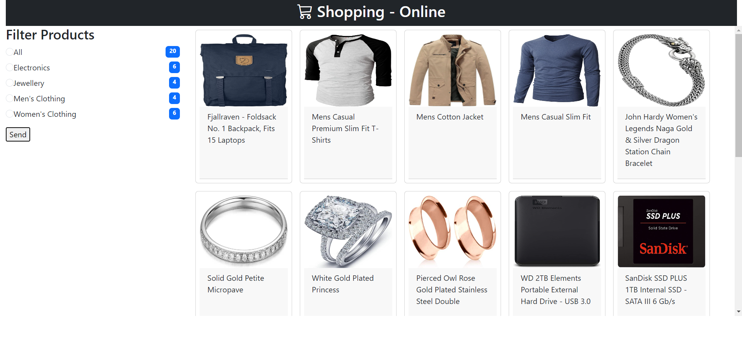

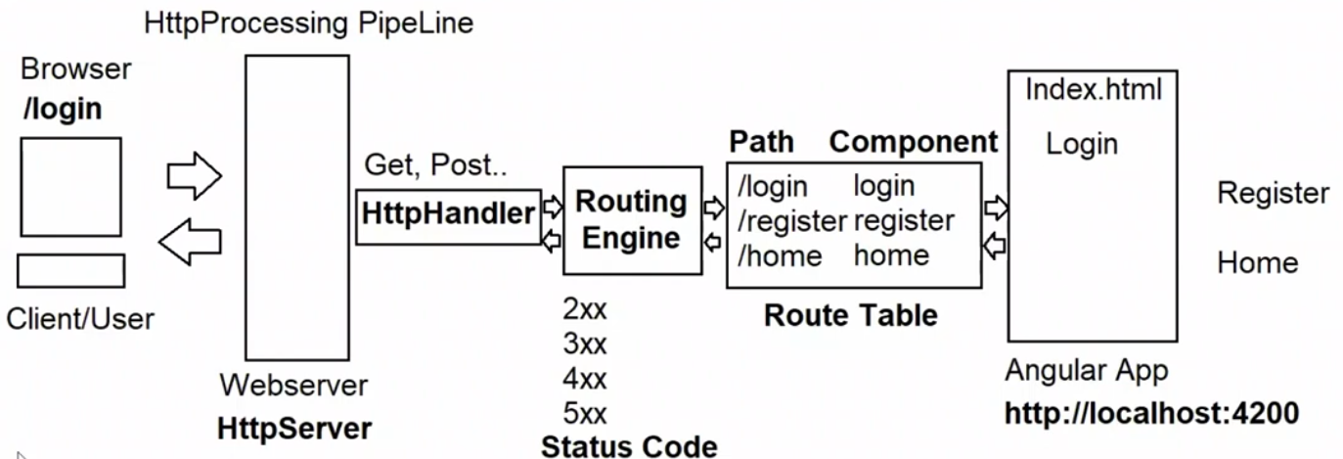

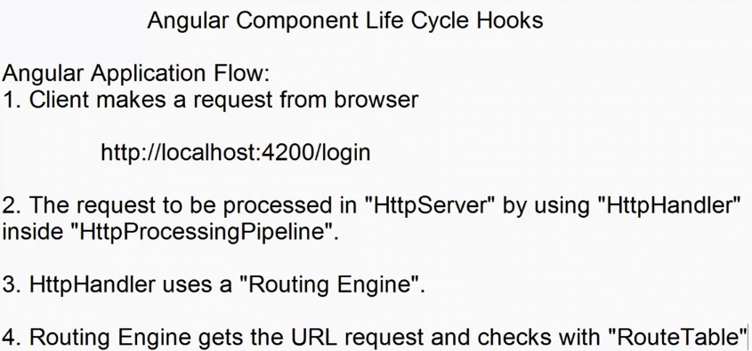

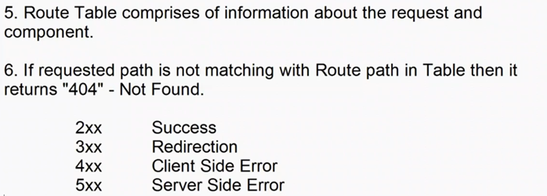

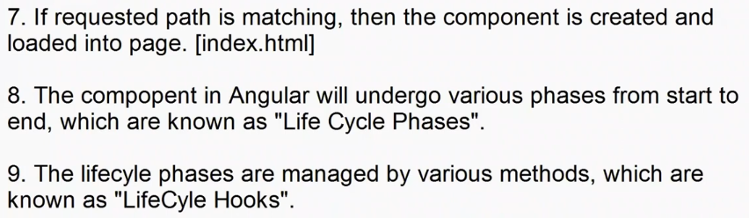



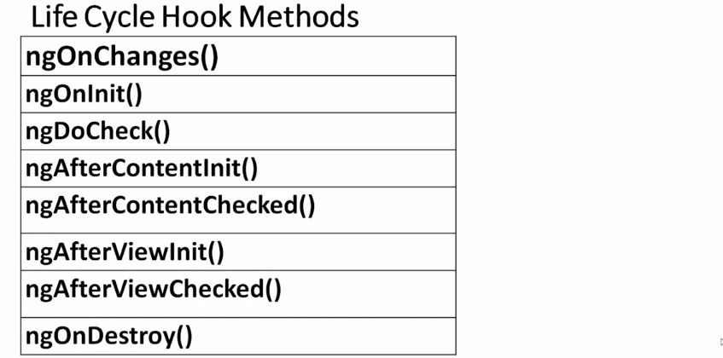

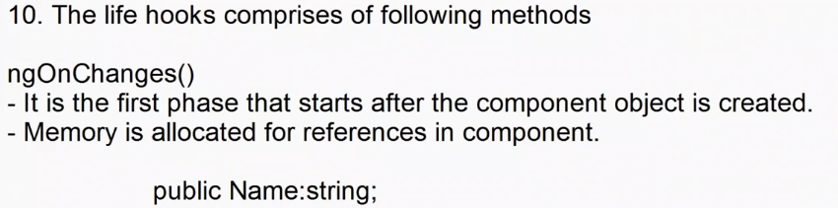

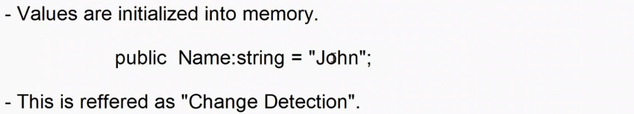

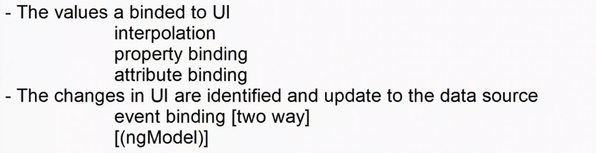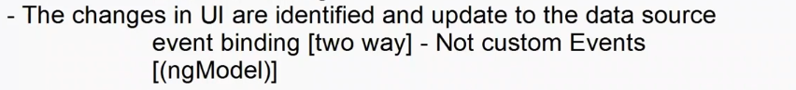

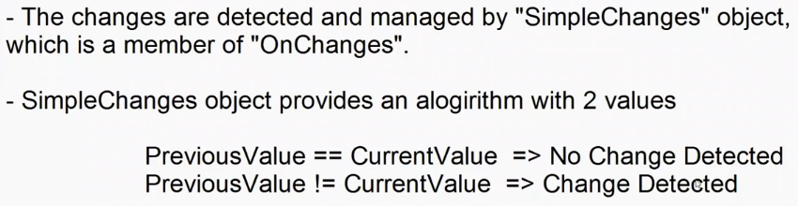

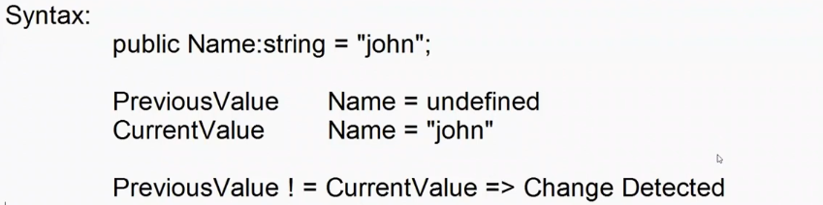

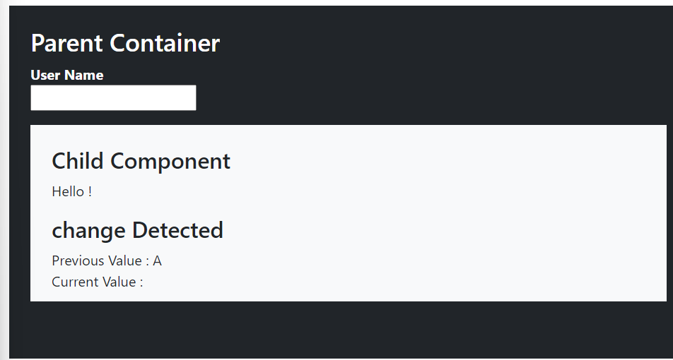

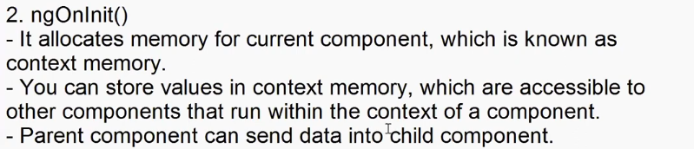

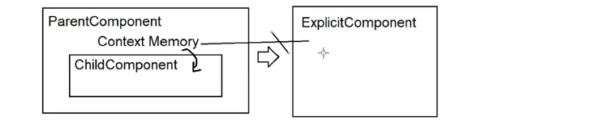

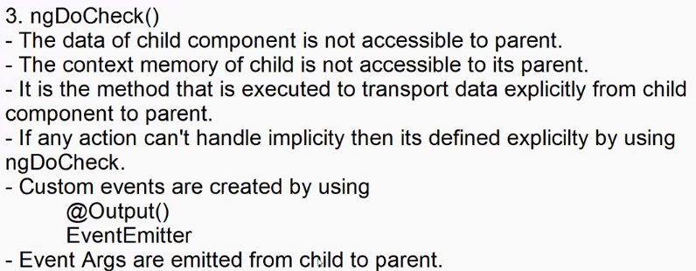

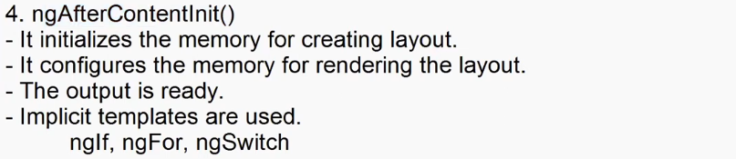

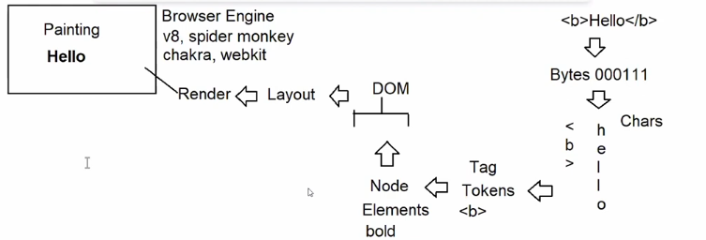

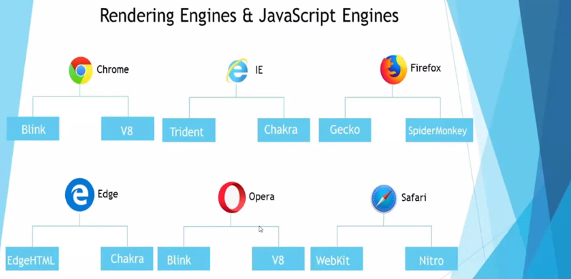

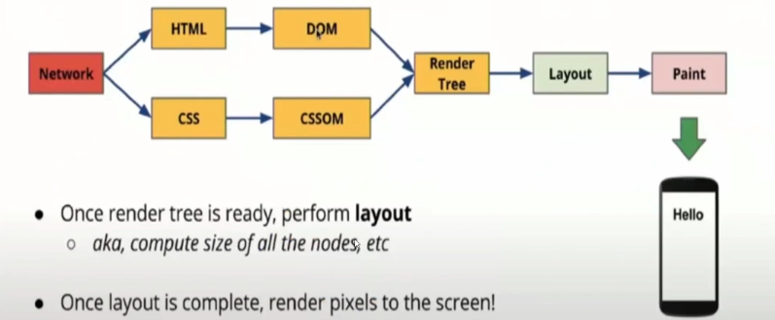

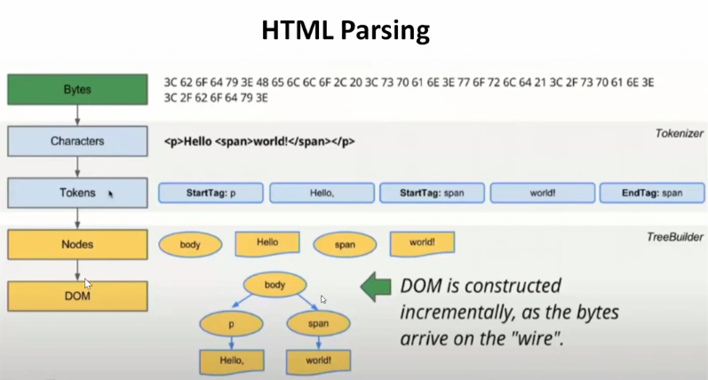

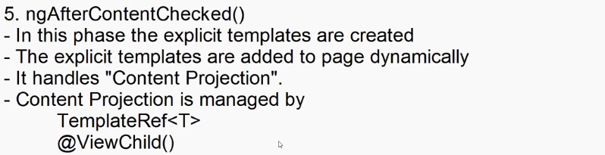

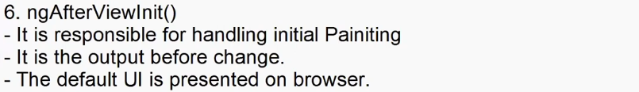

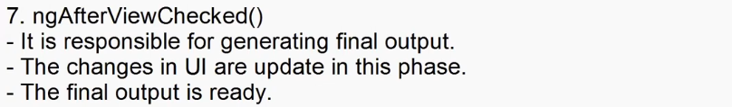

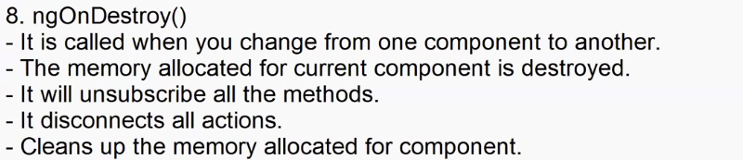

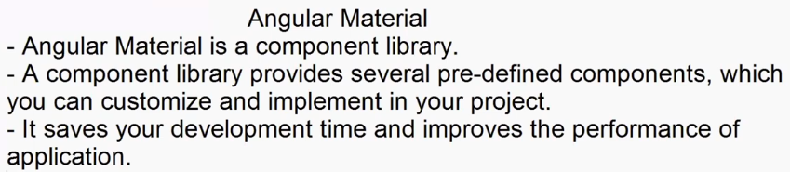

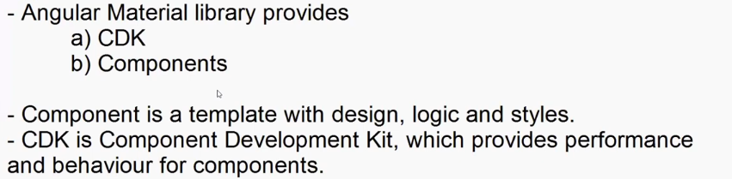

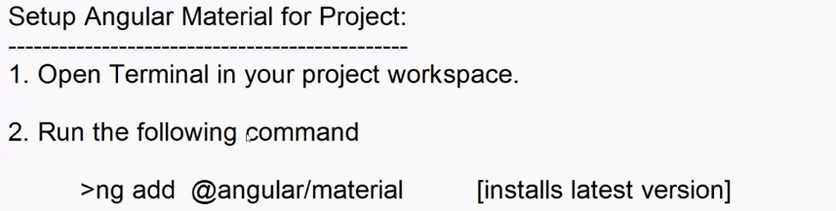

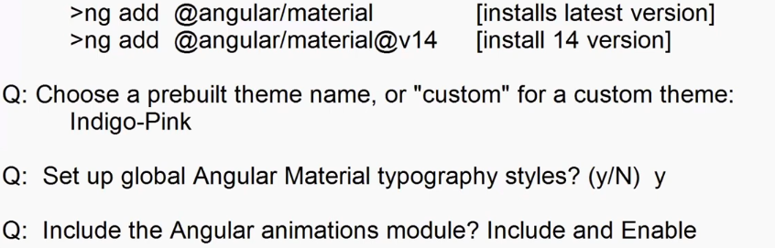

The package @angular/material@17.3.10 will be installed and executed.

Would you like to proceed? Yes

✔ Packages successfully installed.

? Choose a prebuilt theme name, or "custom" for a custom

theme: Indigo/Pink[ Preview: https://material.angular.io?theme=indigo-pink ]

? Set up global Angular Material typography styles? Yes

? Include the Angular animations module? Include and enable

animations

UPDATE package.json (1177 bytes)

✔ Packages installed successfully.

UPDATE projects/shopping/src/app/app.module.ts (3022 bytes)

UPDATE angular.json (3311 bytes)

UPDATE projects/shopping/src/index.html (540 bytes)

UPDATE projects/shopping/src/styles.css (324 bytes)

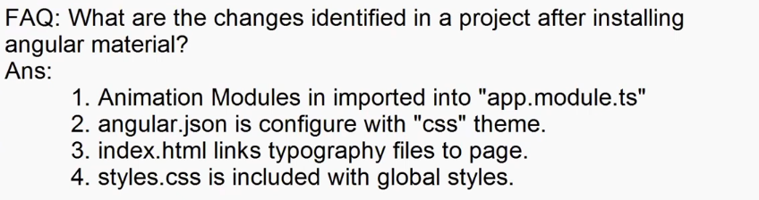

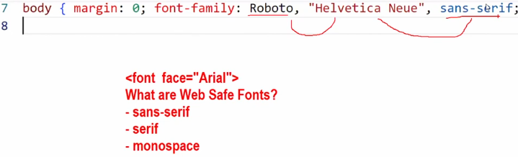

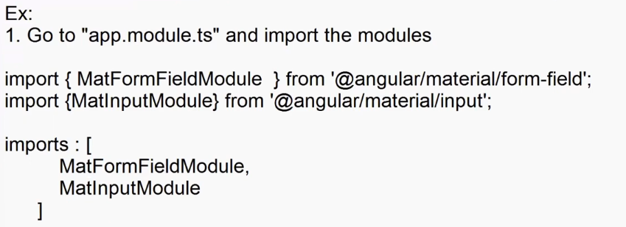

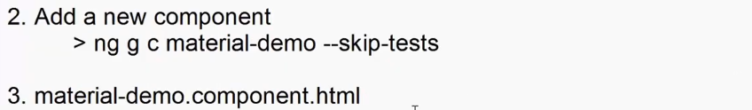

<div class="container-fluid">

    <h2>BootStrap Input</h2>

    <div class="w-25">

        <label class="form-label">User Name</label>

        <div>

            <input type="text" placeholder="Enter Name" class="form-control">

        </div>

    </div>

    <hr>

    <h2>Material Input</h2>

    <mat-form-field appearance="outline">

        <mat-label>User Name</mat-label>

        <input type="text" matInput placeholder="Enter Name">

    </mat-form-field>

</div>

**Ex. Date Pickers**

**material-demo.component.html**

<div class="container-fluid">

    <h2>Date Picker</h2>

    <mat-form-field appearance="outline">

        <mat-label >Choose a date</mat-label>

        <mat-datepicker-toggle matSuffix [for]="deprarture"></mat-datepicker-toggle>

        <input [matDatepicker]="deprarture" type="text" matInput>

        <mat-datepicker #deprarture></mat-datepicker>

    </mat-form-field>

</div>

**App.module.ts**

import { MatFormFieldModule } from '@angular/material/form-field';

import { MatInputModule } from '@angular/material/input';

import { MatDatepickerModule } from '@angular/material/datepicker';

import { MatNativeDateModule } from '@angular/material/core';

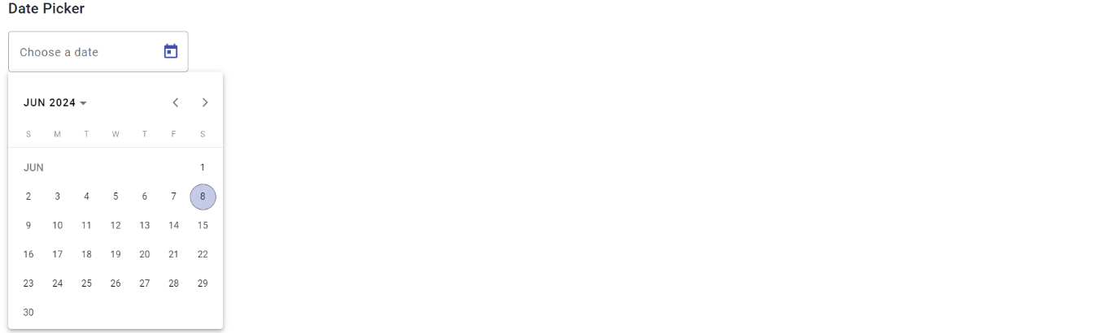  imports: [

    BrowserModule,

    AppRoutingModule,

    FormsModule,

    MatFormFieldModule,

    MatInputModule,

    MatDatepickerModule,

    MatNativeDateModule

  ],

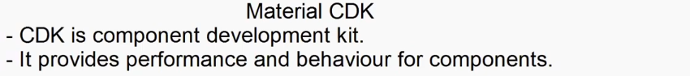

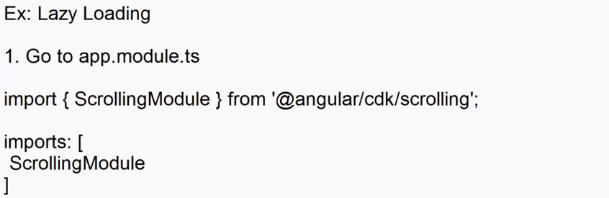

 import { Component, OnInit } from '@angular/core';

import { provideNativeDateAdapter } from '@angular/material/core';

import { FakeStoreProductContract } from '../../contracts/FakeStore';

@Component({

  selector: 'app-material-demo',

  templateUrl: './material-demo.component.html',

  styleUrl: './material-demo.component.css',

})

export class MaterialDemoComponent implements OnInit{

  // component development kit

  public Products:FakeStoreProductContract[]=[];

  ngOnInit(){

      fetch('http://fakestoreapi.com/products')

      .then(res => res.json())

      .then(data=>{

        this.Products=data;

      })

  }

}



<!----- component development kit ----->

<div class="container-fluid">

    <h2>Without Lazy Loading</h2>

    <div class="overflow-auto" style="height: 300px; width: 250px; border: 1px solid black; padding: 5px;">

        <div *ngFor="let item of Products">

            <img [src]="item.image" width="150" height="150">

        </div>

    </div>

    <h2>With Lazy Loading</h2>

    <cdk-virtual-scroll-viewport itemSize="100" style="height: 300px; width: 250px; border: 1px solid black; padding: 5px;">

        <div *cdkVirtualFor="let item of Products">

            <img [src]="item.image" height="150" width="15 0">

        </div>

    </cdk-virtual-scroll-viewport>

</div>

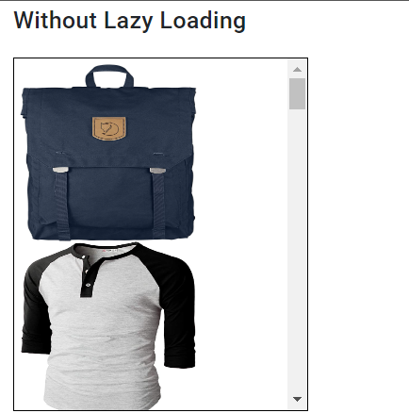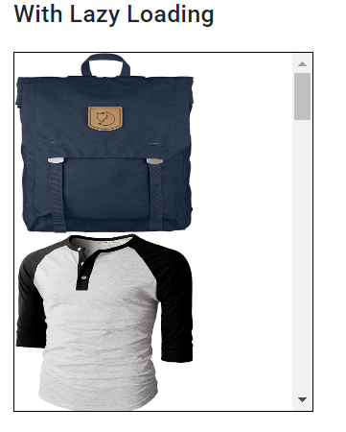

**Angular Pipes**

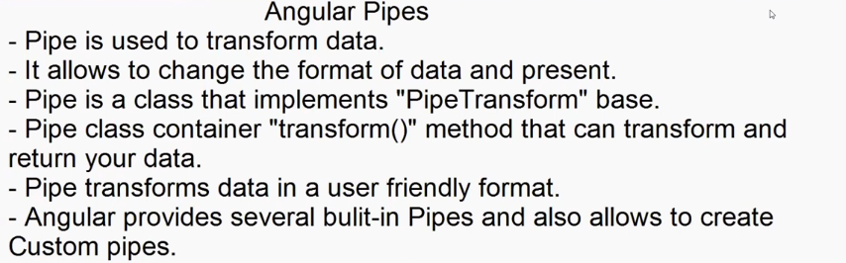

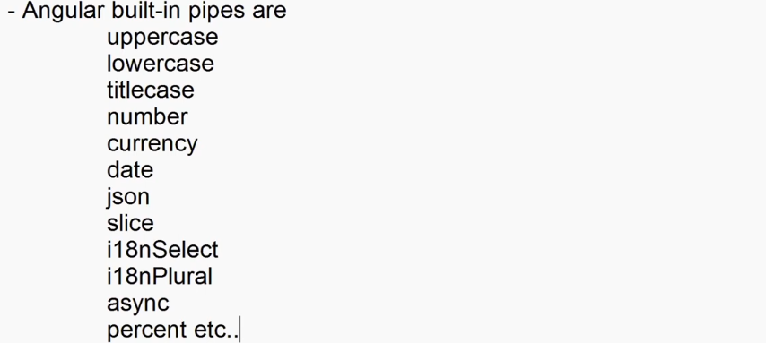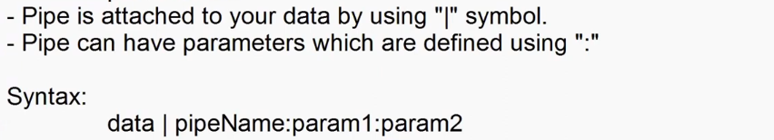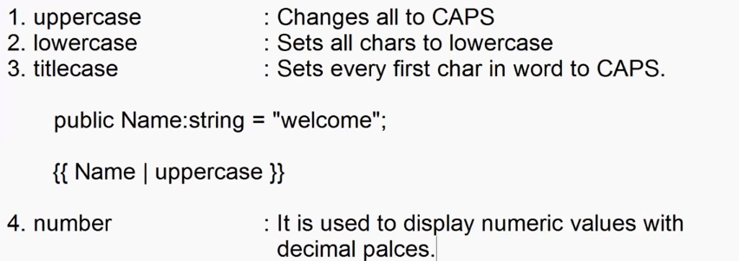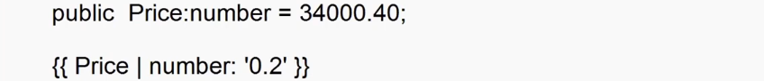

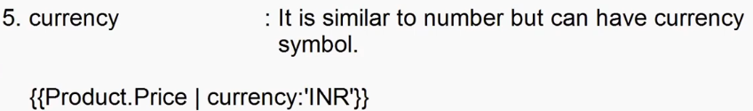

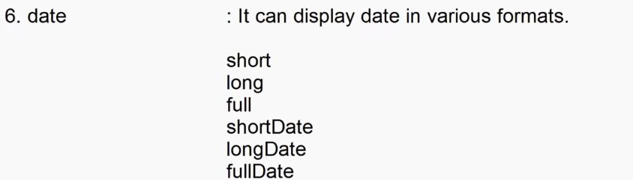



**Pipe-demo.component.ts**

import { Component } from '@angular/core';

@Component({

  selector: 'app-pipe-demo',

  templateUrl: './pipe-demo.component.html',

  styleUrl: './pipe-demo.component.css'

})

export class PipeDemoComponent {

  public Product:{Name:string, Price:number, Mfd:Date}={

    Name: 'Samsung Tv',

    Price: 34000.30,

    Mfd: new Date("2023-01-22")

  }

}

**Pipe-demo.component.html**

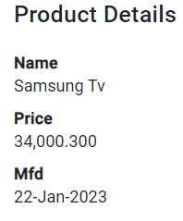<div class="container-fluid">

    <h2>Product Details</h2>

    <dl>

        <dt>Name</dt>

        <dd>{{Product.Name | titlecase}}</dd>

        <dt>Price</dt>

        <dd>{{Product.Price | number:'5.3'}}</dd>

        <dt>Mfd</dt>

        <dd>{{Product.Mfd | date : 'dd-MMM-yyyy'}}</dd>

    </dl>

</div>

